Ministry of Tourism and Antiquities

Upskilling-project





**Prepared by:**

Mahmoud AlZu’bi

**Prepared for:**

Dr. Jalal Kiswani

Ms. Hana Alrasheed

Ms. Jacquelyn Brown

Mr. William Smairat

**28-Sep-2020**

Table of contents

I. Introduction 6

II. Project details 7

1. Technology 7

a) Front-End 7

b) Back-End 8

c) Modeling 8

d) Version Control 9

2. Requirements 10

a) Users 10

b) Functional Requirements 11

c) Pages Description 11

3. Design 13

a) Wireframe 13

b) Sitemap 44

c) Mockup 45

d) ERD 68

4. Development 70

a) Backend Desc 70

b) Test Cases 71

5. Deployment 72

a) Domain 72

b) Hosting 72

III. Screenshots 72

IV. Source Code excerpt 96

V. Conclusion 97

VI. References 97

Figure 1: Front-End Technologies 7

Figure 2: Back-End Technologies 8

Figure 3: Version Control technologies 9

Figure 4: Homepage-Wireframe 14

Figure 5: About the Ministry wireframe 15

Figure 6: Minister’s office wireframe 16

Figure 7: Ministers wireframe 17

Figure 8:Ministry conventions wireframe 18

Figure 9:Ministry legislation wireframe 19

Figure 10:Ministry legislation- Laws wireframe 20

Figure 11:Ministry legislation- Systems wireframe 21

Figure 12: Ministry legislation- Instructions wireframe 22

Figure 13:Ministry legislation- Decisions made wireframe 23

Figure 14:National strategies page wireframe 24

Figure 15:organizational structure wireframe 25

Figure 16: Ministry bids Wireframe 26

Figure 17:Electronic services wireframe 27

Figure 18: Renew a hotel service wireframe 28

Figure 19: Tourist guide license requests wireframe 29

Figure 20: renew a restaurant service 30

Figure 21:Applying for licensing industry wireframe 31

Figure 22: Ministry’s projects wireframe 32

Figure 23:Statistics wireframe 33

Figure 24: News wireframe. 34

Figure 25:Upcoming Events Wireframe. 35

Figure 26: Advertisement wireframe. 36

Figure 27: Contact us wireframe 37

Figure 28: Suggestions and Compliance Wireframe 38

Figure 29: Suggestions wireframe 39

Figure 30: Compliances wireframe. 40

Figure 31:Sitemap wireframe 41

Figure 32: Privacy policy wireframe 42

Figure 33:Terms of use wireframe 43

Figure 34: Sitemap 44

Figure 35:Homepage Mockup 45

Figure 36: About the Ministry Mockup 46

Figure 37: Minister's office Mockup 47

Figure 38: Ministers Mockup 48

Figure 39: Conventions Mockup 49

Figure 40: Legislations Mockup. 50

Figure 41: Legislations - Laws Mockup. 51

Figure 42: Legislations - Instructions Mockup. 52

Figure 43: Legislations - Systems Mockup. 53

Figure 44: Legislations- Decisions made Mockup. 54

Figure 45: National Strategies Mockup. 55

Figure 46:Organizational structure Mockup. 56

Figure 47: Binding Mockup. 57

Figure 48: E-Services Mockup. 58

Figure 49: Service 1: Hotel Service Mockup. 59

Figure 50: Service 2: Tourist Guide service Mockup. 60

Figure 51: Service 3: Tourist restaurant Mockup. 61

Figure 52: Service 4: Traditional industry establishment Mockup 62

Figure 53: Ministry’s projects Mockup. 63

Figure 54: Contact us Mockup 64

Figure 55: Suggestions and Complaints Mockup. 65

Figure 56: Suggestions Mockup. 66

Figure 57: Complaints Mockup. 67

Figure 58: ERD for Suggestions and Complaints 68

Figure 59: ERD for E-Services 69

Figure 60: Success alert box for services 70

Figure 61: Test Cases 71

Figure 62: Namecheap Logo 73

Figure 63: 000Webhost logo 73

Figure 64: Screenshot for Homepage from the website. 74

Figure 65: Screenshot for About the Ministry page from the website. 75

Figure 66: Screenshot for Minister's office page from the website. 76

Figure 67: Screenshot for the Ministers page from the website. 77

Figure 68:Screenshot for the Conventions page from the website. 78

Figure 69: Screenshot for Legislations page from the website. 79

Figure 70: Screenshot for laws page from the website. 80

Figure 71: Screenshot for instruction page from the website. 81

Figure 72: Screenshot for Systems page from the website. 82

Figure 73: Screenshot for Decisions made page from the website. 83

Figure 74: Screenshot for National Strategies page from the website. 84

Figure 75: Screenshot for the Organizational Structure page from the website. 85

Figure 76: Screenshot for the Ministry Bids from the website. 86

Figure 77: Screenshot for the E-Services page from the website. 87

Figure 78: Screenshot for the Hotels service page from the website. 88

Figure 79: Screenshot for the Touris Guide service page from the website. 89

Figure 80: Screenshot for the Tourist Restaurant service page from the website. 90

Figure 81: Screenshot for the traditional industry establishment service page from the website. 91

Figure 82: Screenshot for the Ministry's projects page from the website. 92

Figure 83: Screenshot for Contact us page from the website. 93

Figure 84: Screenshot for the Suggestions and Complaints page from the website. 94

Figure 85: Screenshot for the Suggestion page from the website. 95

Figure 86: Screenshot for the Complaints page from the website. 96

Figure 87: Embedded Tweet Timeline 97

Figure 88: Snippet code for website feedback section. 97

# Introduction

Going to government departments and moving from department to department and taking various signatures, documents, and waiting for hours, etc. all these processes consume time, effort, and money for both citizens and the government department. So, developing a website that represents an interactive portal for the citizens who are served by this governmental department and replace paper transactions with electronic ones has become necessary.

This website is created for the Ministry of Tourism and Antiquities and provides four E-Services divided into:

* Request to renew a hotel establishment of all categories.
* Tourist guide license requests.
* Request to renew a tourist restaurant of all categories
* Applying for licensing a traditional industry establishment and an oriental antique store

The content of these services is prepared to be dynamic content. Thus, it can be modified easily based on the preferences of the ministry.

Also, it can send complaints and suggestions electronically with anonymity advantage (i.e., without including any personal details in the form.).

Moreover, this website has a User-friendly design so, the user can navigate it without it being complicated, and it supports a wide range of languages. Thus, anyone can use it and understand its content (The Main language is Arabic). Plus, it is a fully responsive website which means, it can adapt to different screen sizes (e.g., Smartphones, Tablets, Laptops, etc.) and it provides general information about the Ministry, Ministry bids, Ministry projects, statistics, Ministry news, upcoming events, contact information, and summary of tourist sites.

# Project details

## Technology

### Front-End

This website designed using the following technologies as a Front-End:

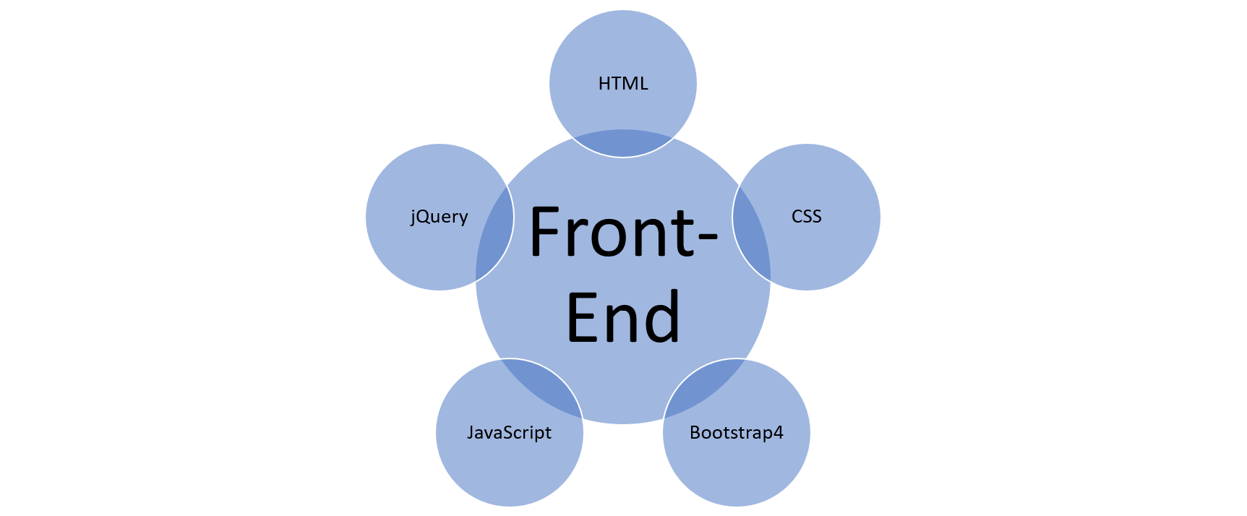

Figure : Front-End Technologies

* **HTML5:**  is a markup language used for structuring and presenting content on the World Wide Web. It is the fifth and latest major version of HTML that is a World Wide Web Consortium (W3C) recommendation.
* **CSS3:** is a style sheet language used for describing the presentation of a document written in a markup language such as HTM.
* **JavaScript:** is a programming language that conforms to the ECMAScript specification. JavaScript is high-level, often just-in-time compiled, and multi-paradigm. It has curly-bracket syntax, dynamic typing, prototype-based object-orientation, and first-class functions.
* **jQuery:** is a JavaScript library designed to simplify HTML DOM tree traversal and manipulation, as well as event handling, CSS animation, and Ajax.
* **Bootstrap4:** is a free and open-source CSS framework directed at responsive, mobile-first front-end web development. It contains CSS- and (optionally) JavaScript-based design templates for typography, forms, buttons, navigation, and other interface components.

### Back-End

This website developed using the following technologies as a Back-End:

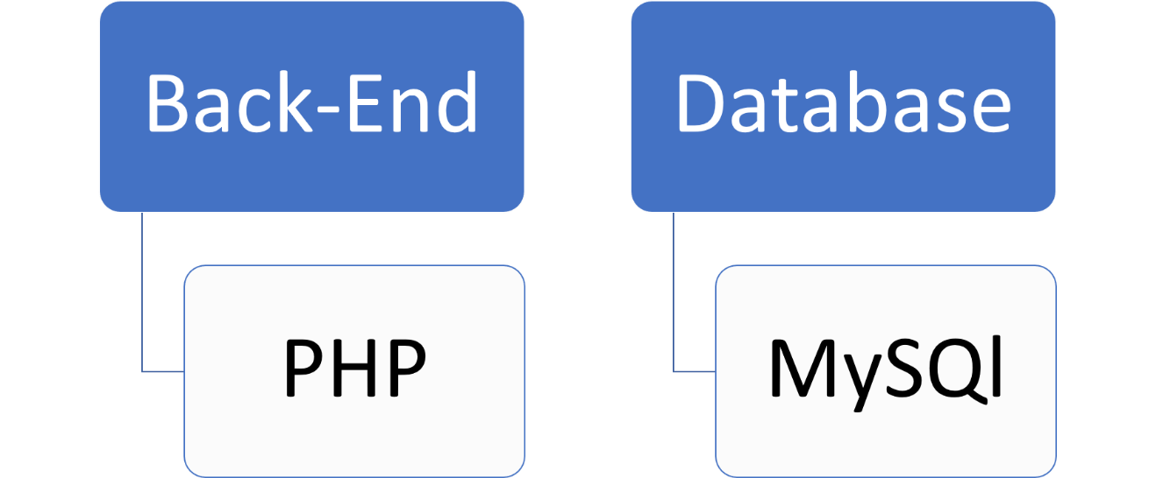

Figure : Back-End Technologies

* **PHP**: is a general-purpose scripting language especially suited to web development. It’s code usually processed on a web server by a PHP interpreter.

### Modeling

For modeling an entity-relationship diagram (ERD), I used Draw.io software.

* + **Draw.io:** diagrams.net is free online diagram software for making flowcharts, process diagrams, org charts, UML, ER and network diagrams.

### Version Control

Git, GitHub and TortoiseGit are used as a version control in developing this project.

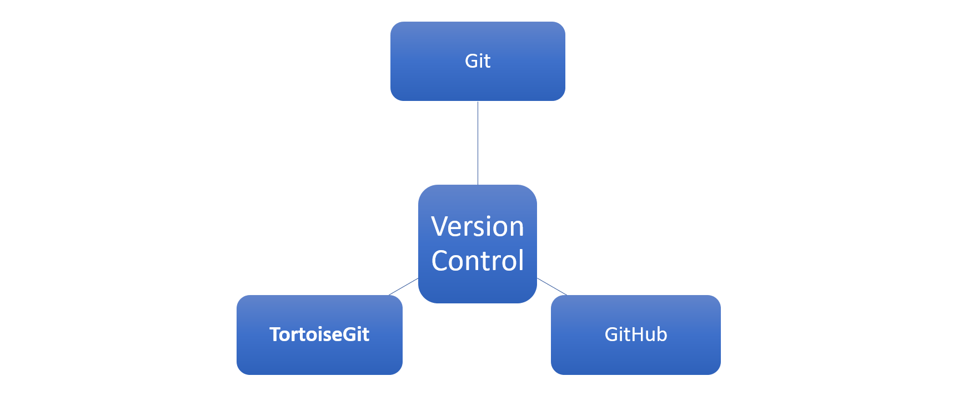

Figure : Version Control technologies

* **Git**: Git is a free and open source distributed version control system designed to handle everything from small to very large projects with speed and efficiency.
* **GitHub**: is an American multinational corporation that provides hosting for software development and version control using Git. It offers the distributed version control and source code management (SCM) functionality of Git, plus its own features.
* **TortoiseGit**: TortoiseGit is a Windows Shell Interface to Git and based on TortoiseSVN. It's open source and can fully be built with freely available software.

## Requirements

### Users

|  |  |
| --- | --- |
|  | **Requirement** |
| 1. | The user shall be able to send compliments with anonymity advantage. |
| 2. | The user shall be able to send suggestions with anonymity advantage. |
| 3. | The user shall be able to make a request to renew a hotel establishment of all categories electronically. |
| 4. | The user shall be able to Request to renew a tourist restaurant of all categories electronically. |
| 5. | The user shall be able to make a Tourist guide license requests. electronically. |
| 6. | The user shall be able to make a request to renew a hotel establishment of all categories electronically. |
| 7. | The user shall be able to apply for licensing a traditional industry establishment and an oriental antique store electronically. |
| 8. | The user shall be able to check the request status electronically. |
| 9. | The user shall be able to send a website experience review. |
| 10. | The user shall be able to change the language of the website. |

### Functional Requirements

|  |  |
| --- | --- |
|  | **Requirements** |
| 1. | The system shall be able to adapt to different screen sizes. |
| 2. | The system shall be able to send requests information to database. |
| 3. | The system shall be able to retrieve requests status from database. |
| 4. | The system shall be able to retrieve content of E-services dynamically. |
| 5. | The system shall be able to send complains information to database. |
| 6. | The system shall be able to send suggestions information to database. |
| 7. | The system shall be able to send user experience feedback to database. |
| 8. | The system shall be able to check the validity of request information before sending it to database. |

### Pages Description

This website contains the following web pages:

* Homepage: is the main page of the website and it contains a summary of tourist sites, Latest news of the Ministry, Upcoming events and Latest tweet of Ministry.
* About the Ministry: provides a brief information about the Ministry, Vision, The message, The mission, and Fundamentals of tourism.
* Minister's Office: which provides a brief information about the Minister, Qualifications, and Minister’s word.
* Ministers: which provides a group of ministers who held the position of Minister of Tourism since 2007.
* Conventions: which provides a list of Ministry agreements.
* Legislation: which provides four legislation for the Ministry divided into:
  + Laws: contains a list of Ministry laws.
  + Instructions: contains a list of Ministry instructions.
  + Systems: contains a list of Ministry systems.
  + Decisions made: contains a list of Ministry decisions.
* National strategies: which provides a list of Ministry strategies.
* Organizational structure: which provides a Ministry of Tourism's organizational structure.
* Ministry Bids: which provides a table of Ministry bids.
* Electronic services: which provides four E-services for the Ministry divided into:
  + Request to renew a hotel establishment of all categories: This service provides the ability to hotel owners to renew their hotel establishments electronically, and to check the status of their request.
  + Tourist guide license requests: This service provides the ability to tourist guide to apply for license requests electronically, and to check the status of his request.
  + Request to renew a tourist restaurant of all categories: This service provides the ability to restaurant owners to renew their tourist restaurant electronically, and to check the status of their request.
  + Applying for licensing a traditional industry establishment and an oriental antique store: This service provides the ability to industry establishment owners to apply for licensing electronically, and to check the status of their request.
* Ministry projects: which provides a list of ministry’s projects divided by years.
* Statistics: Which provide a list of Statistical Bulletin for the ministry divided by years.
* News: Which provides a set of news of the ministry sorted by publish date.
* Events and Conference: Which provides a set of events and conference dates.
* Advertisement: Which provides a set of ads of the ministry sorted by publish date.
* Contact Information: Which provides a contact information to the ministry, location, works date, social media, and a map that determine the exact location of the ministry.
* Sitemap: Which provide a quick links to the all of pages. Thus, the users can navigate it without it being complicated.
* Suggestions and complaints: which provides access to the following pages:
  + Suggestions: This page provide the ability to users to send their suggestions with anonymity advantage (i.e., without including any personal details in the form.).
  + Complaints: This page provide the ability to users to send their complaints with anonymity advantage.
* Privacy policy: Which provides a brief information about the privacy policy of the ministry to the website users.
* Terms of use: Which explain the terms of use to the website users.

## Design

For the drawing wireframe and Mockup, I used software called **Adobe XD**.

* **Adobe XD**: is a [vector-based](https://en.wikipedia.org/wiki/Vector_graphics_editor) [user experience design tool](https://en.wikipedia.org/wiki/User_experience_design) for [web apps](https://en.wikipedia.org/wiki/Web_app) and [mobile apps](https://en.wikipedia.org/wiki/Mobile_app), developed and published by [Adobe Inc](https://en.wikipedia.org/wiki/Adobe_Inc.).

### Wireframe

**Wireframe**: A website wireframe, also known as a page schematic or screen blueprint, is a [visual guide](https://en.wikipedia.org/wiki/Visual_guide) that represents the skeletal framework of a [website](https://en.wikipedia.org/wiki/Website).

* Home page wireframe.

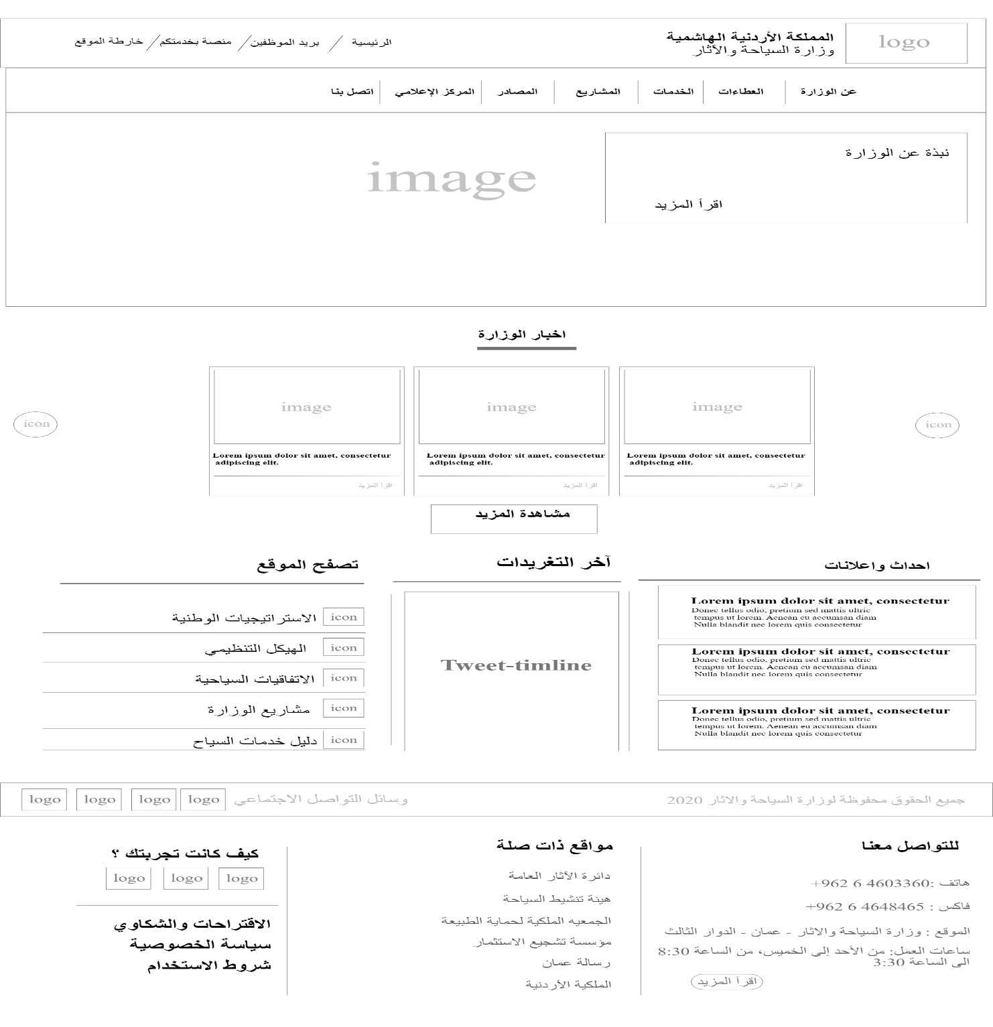

Figure : Homepage-Wireframe

* About the Ministry page wireframe.

Figure : About the Ministry wireframe

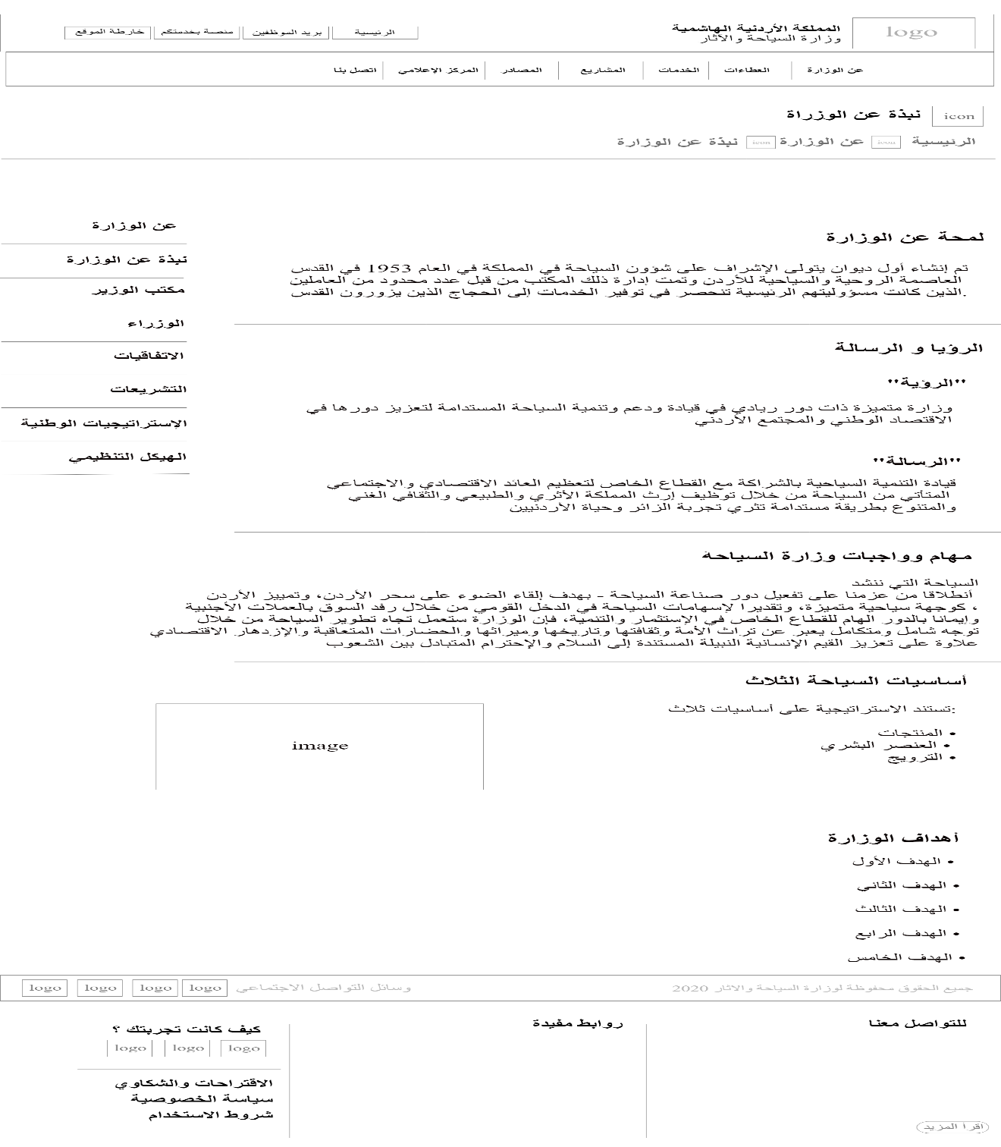

* Minister’s office page wireframe.

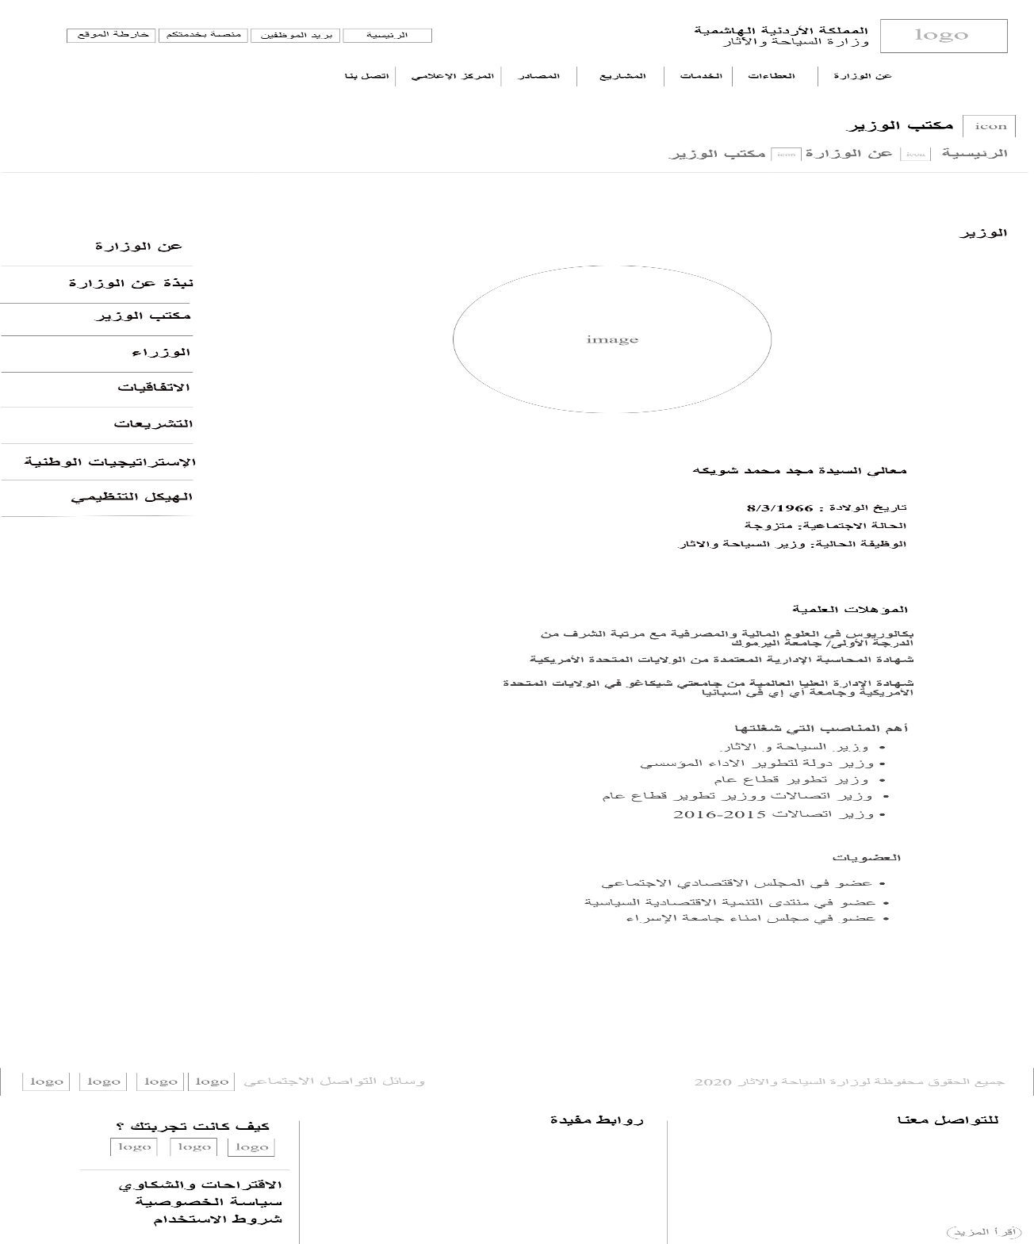

Figure : Minister’s office wireframe

* Ministers page wireframe.

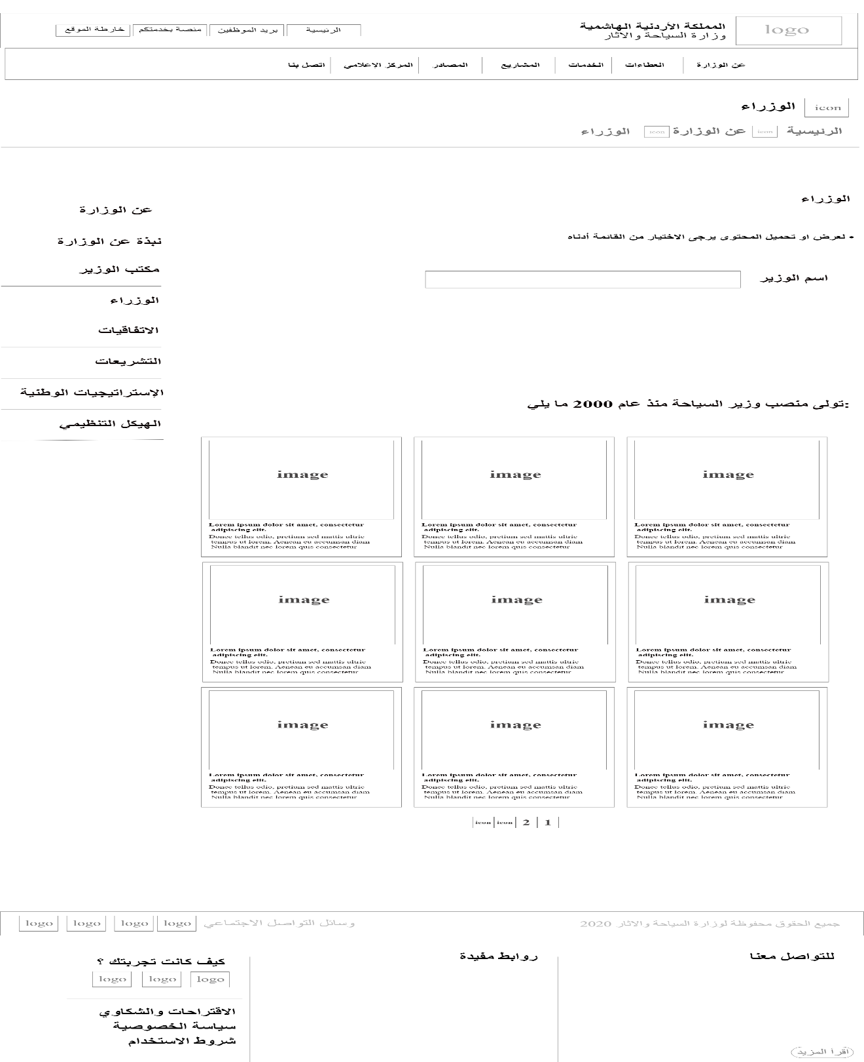

Figure : Ministers wireframe

* Ministry conventions page wireframe.

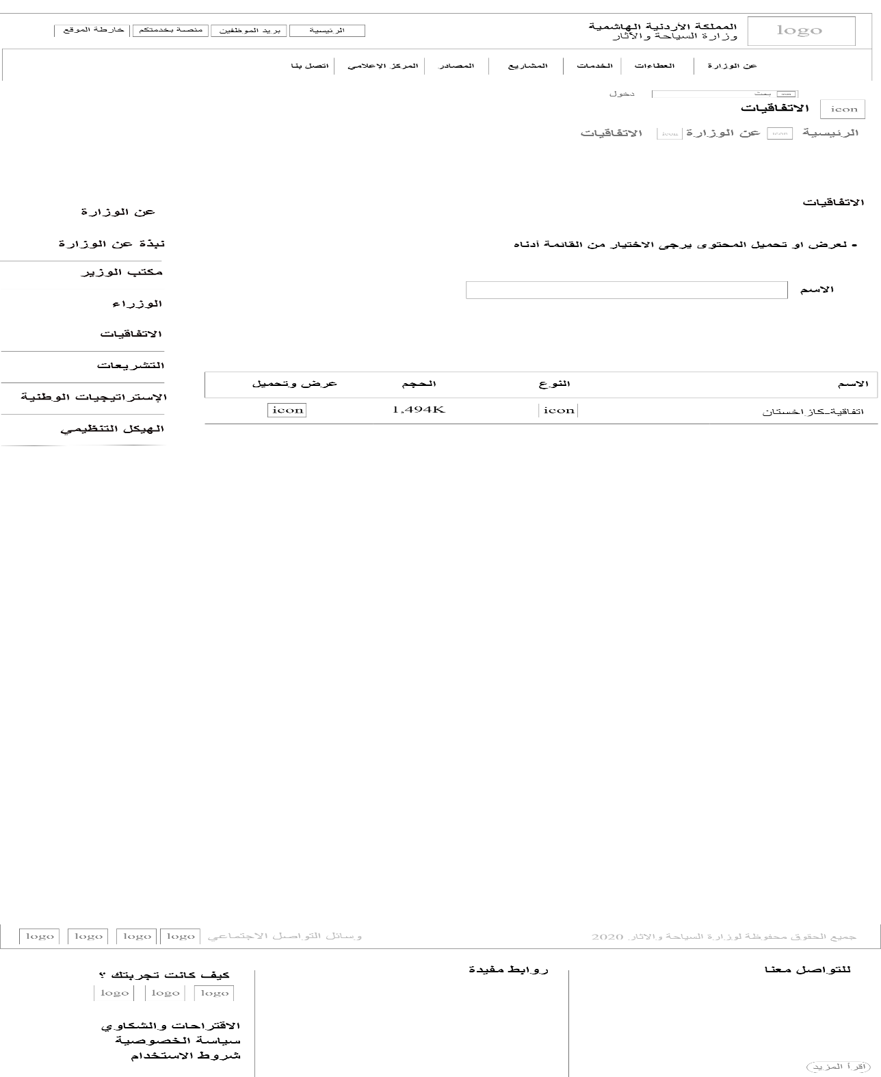

Figure :Ministry conventions wireframe

* Ministry legislation page wireframe.

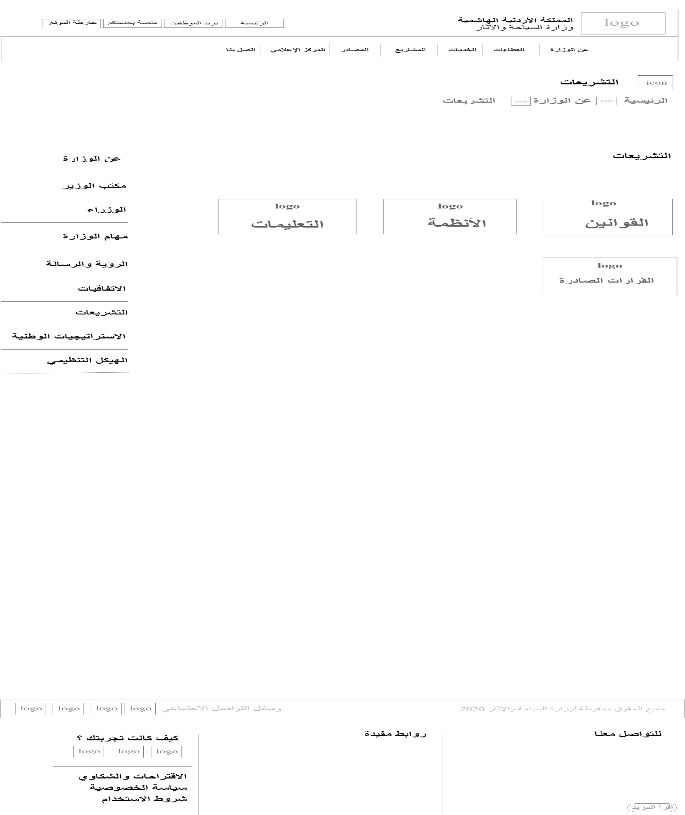

Figure :Ministry legislation wireframe

* Ministry legislation- Laws page wireframe.

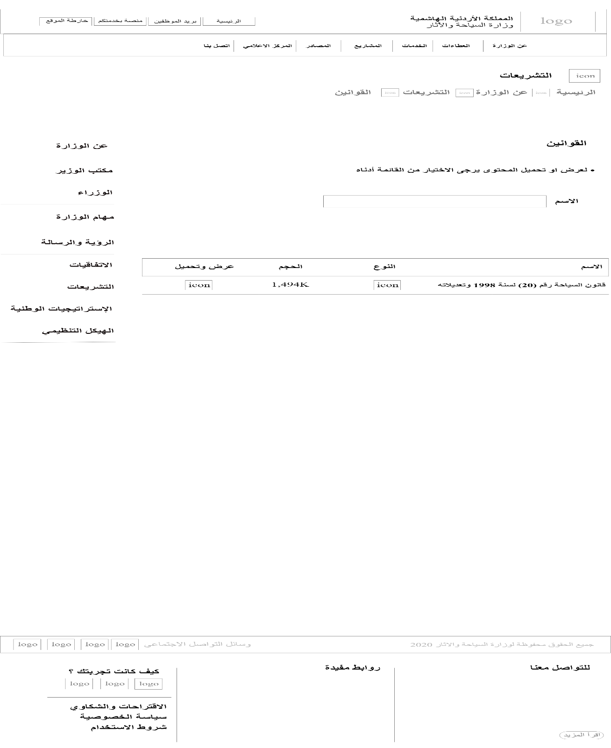

Figure :Ministry legislation- Laws wireframe

* Ministry legislation- Systems page wireframe.

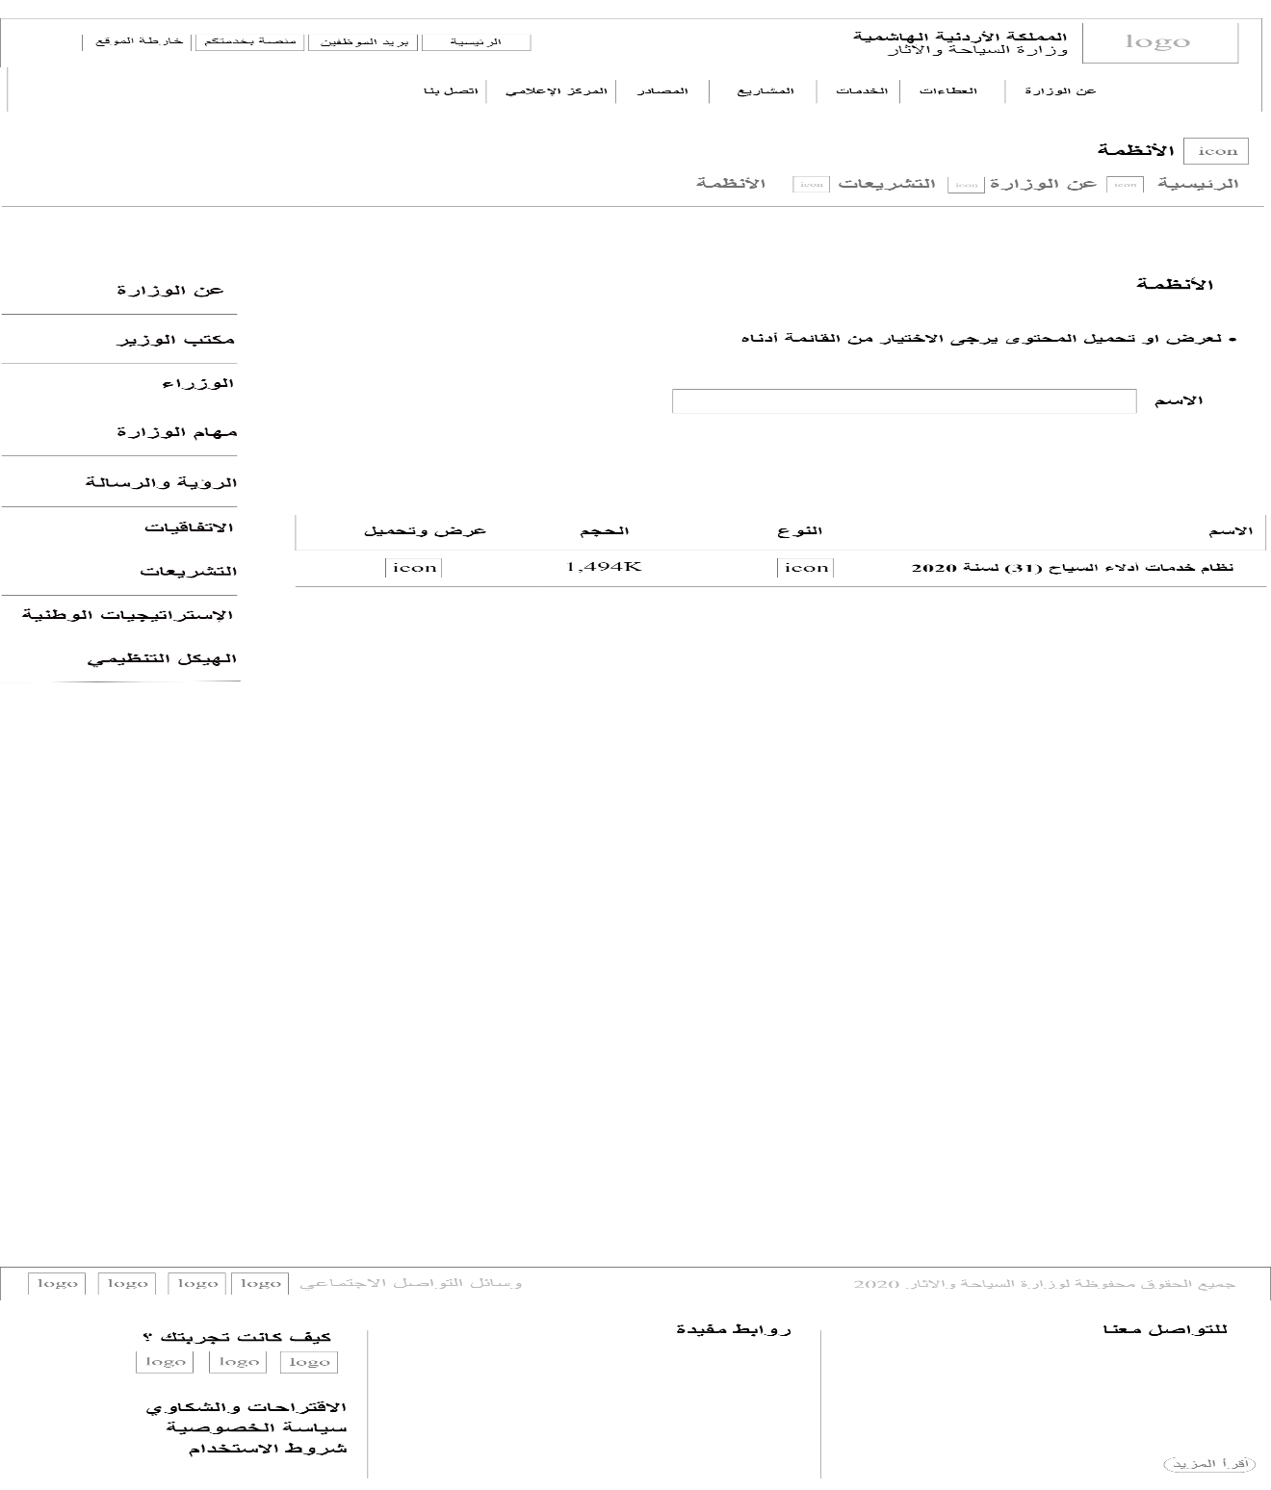

Figure :Ministry legislation- Systems wireframe

* Ministry legislation- Instructions page wireframe.

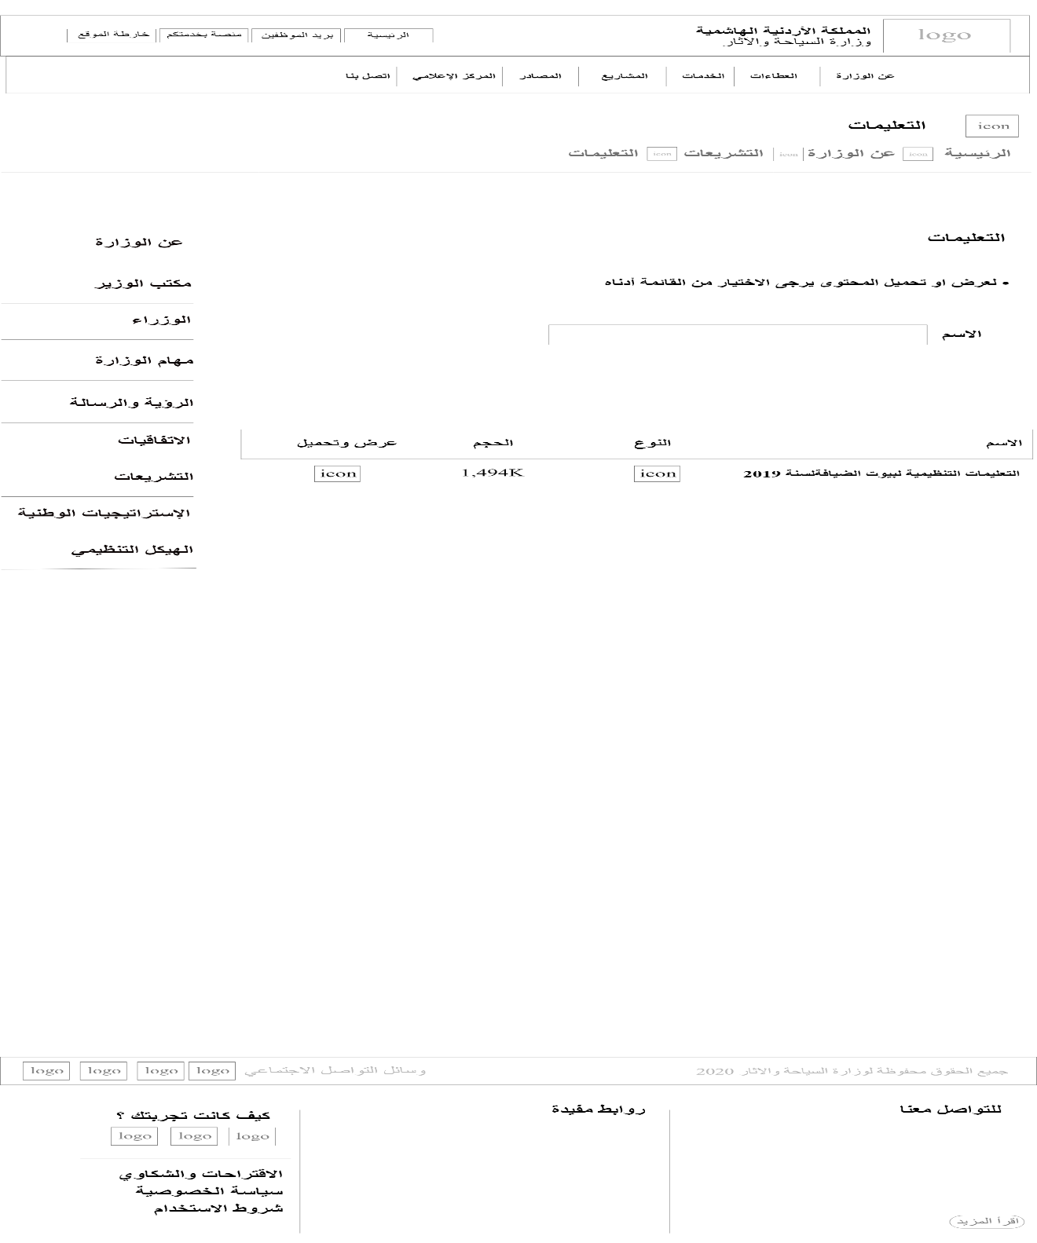

Figure : Ministry legislation- Instructions wireframe

* Ministry legislation- Decisions made page wireframe.

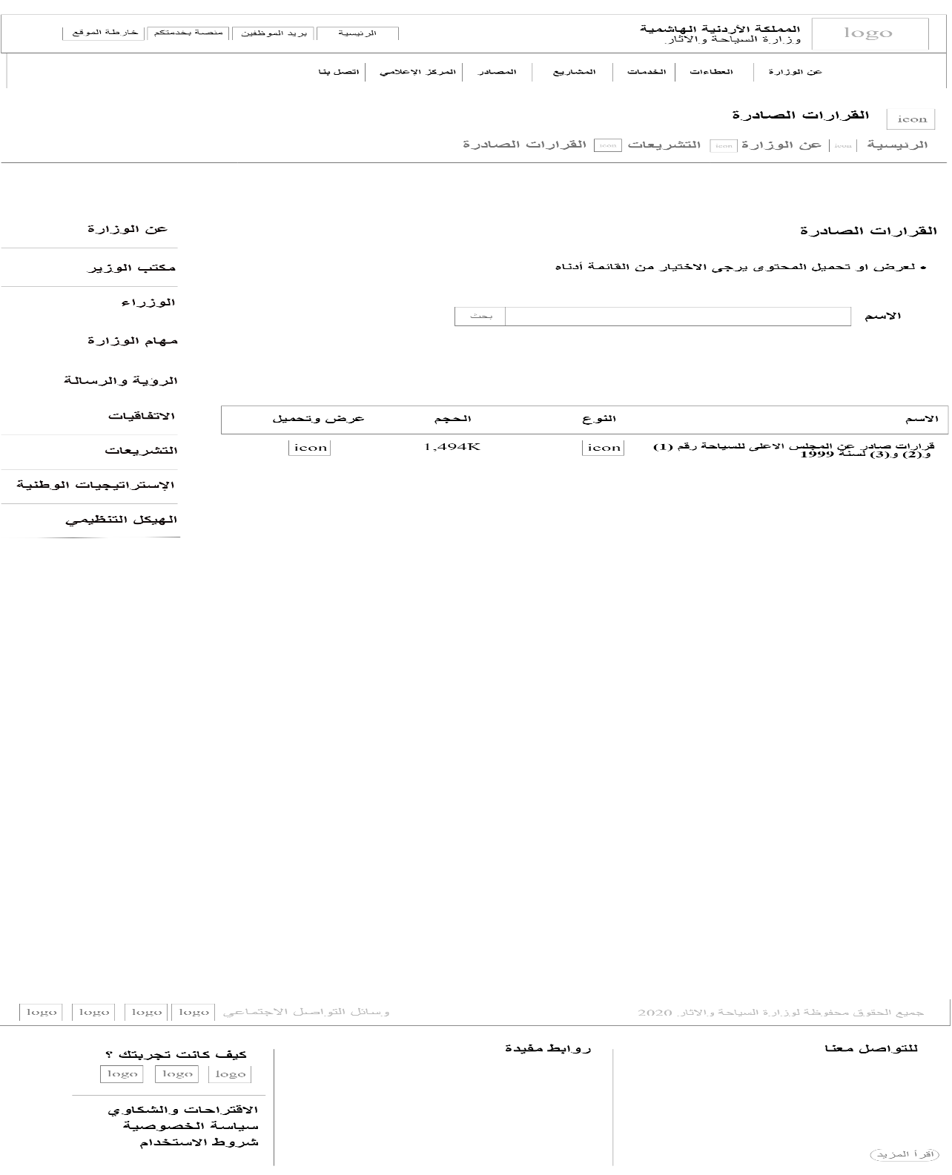

Figure :Ministry legislation- Decisions made wireframe

* National strategies for the ministry page wireframe.

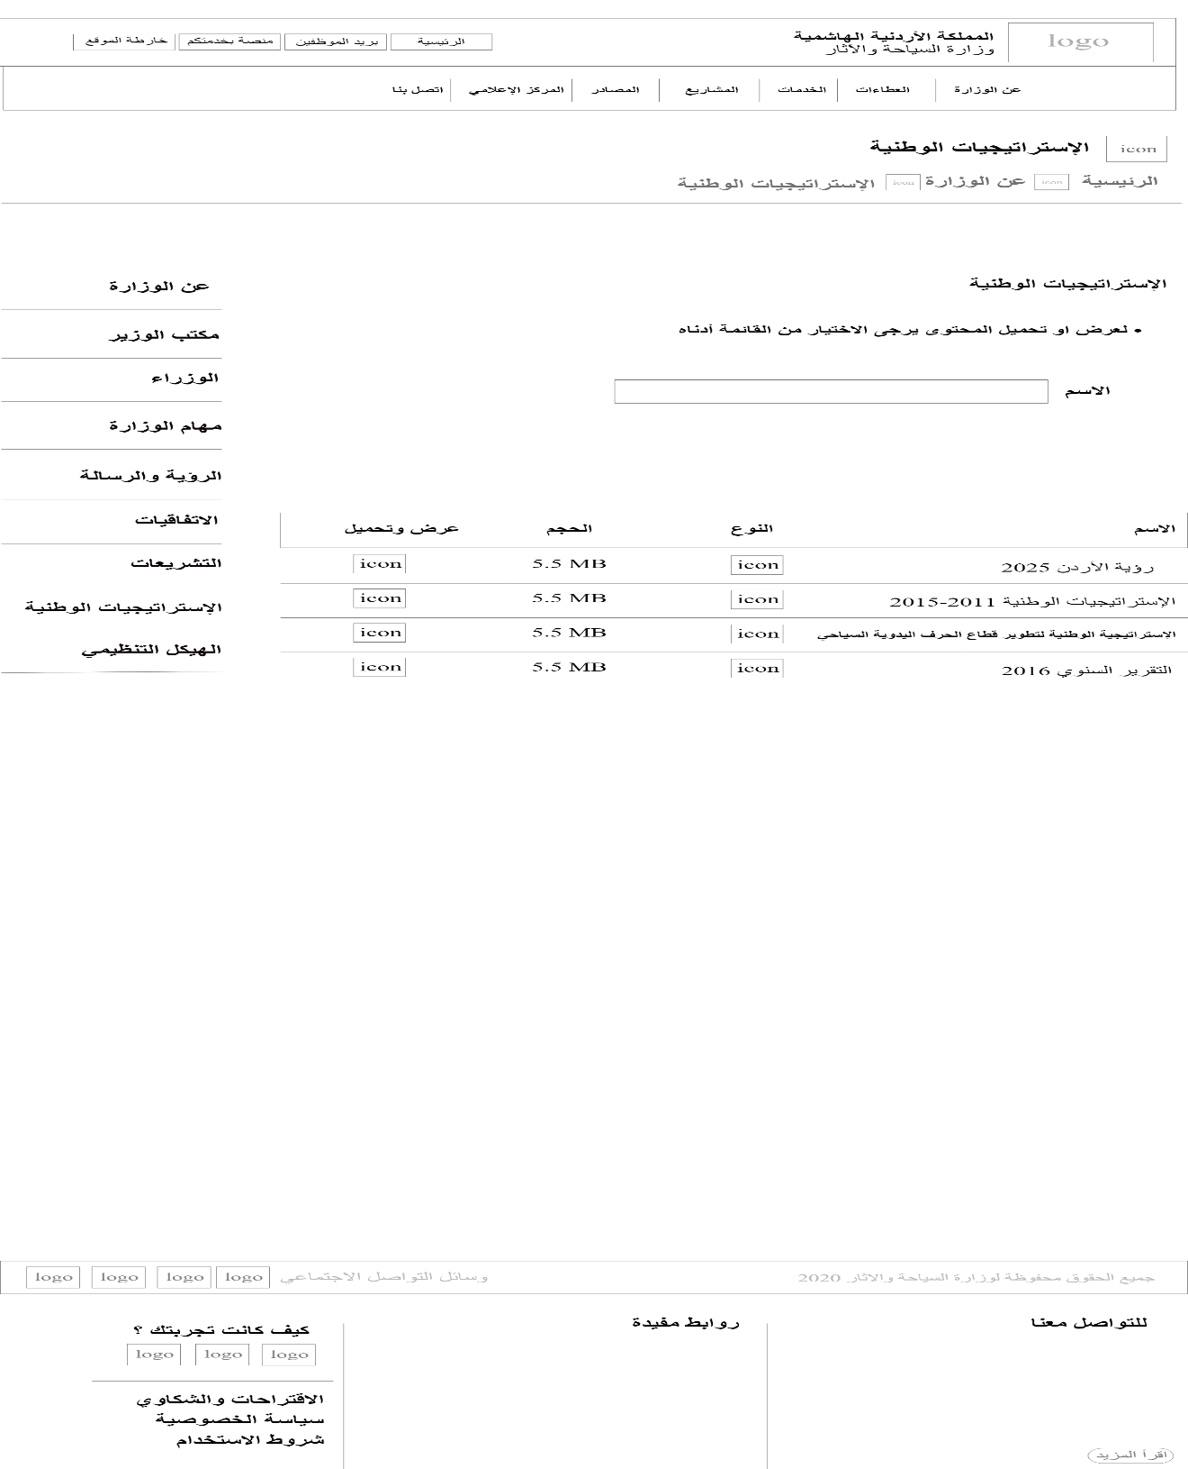

Figure :National strategies page wireframe

* Ministry organizational structure page wireframe.

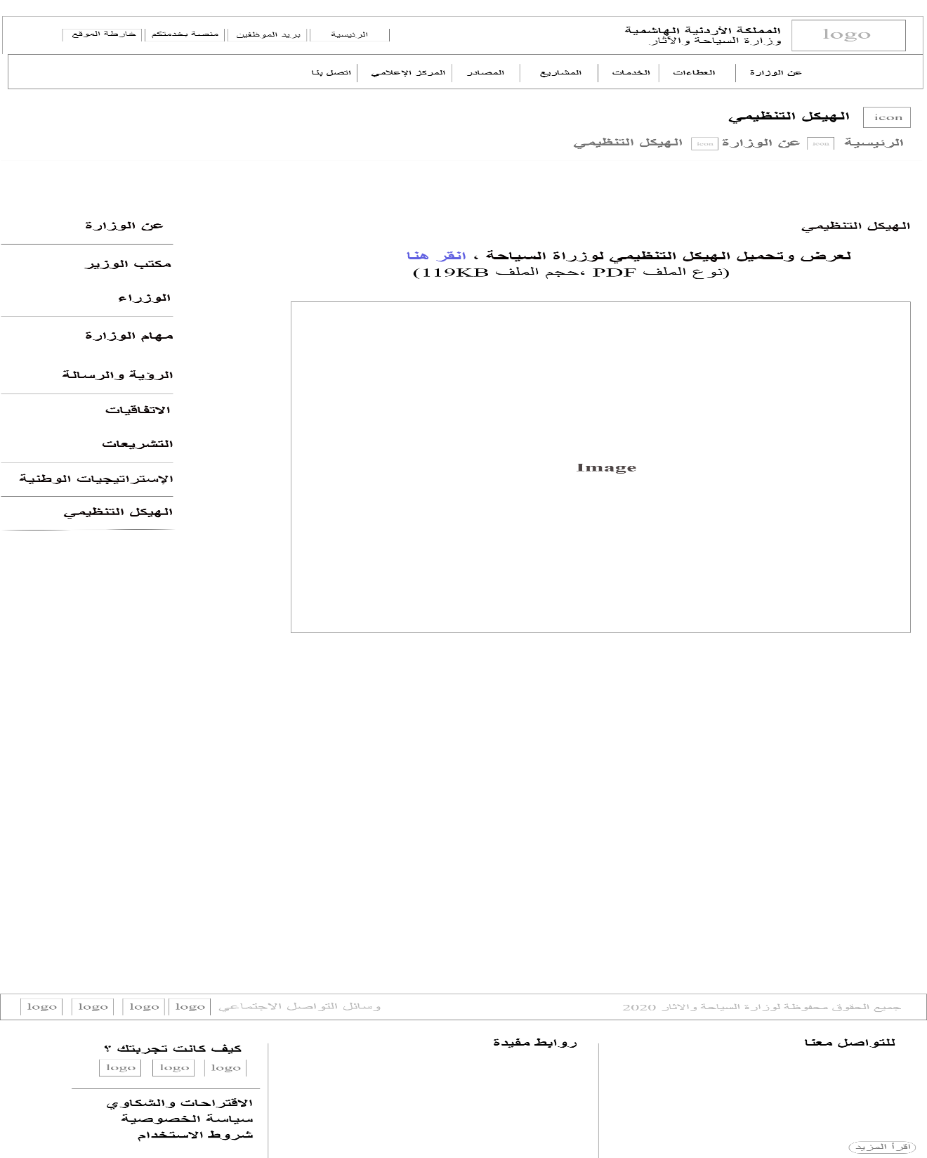

Figure :organizational structure wireframe

* Ministry bids page wireframe.

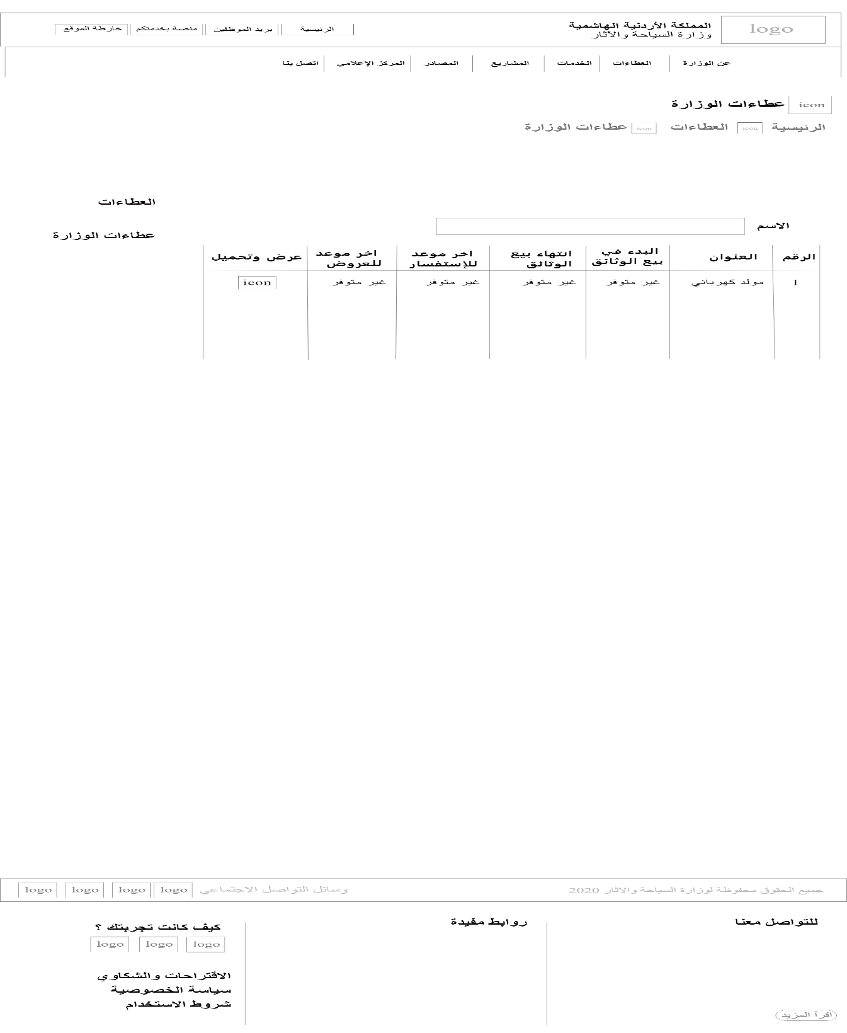

Figure : Ministry bids Wireframe

* Electronic services page wireframe.

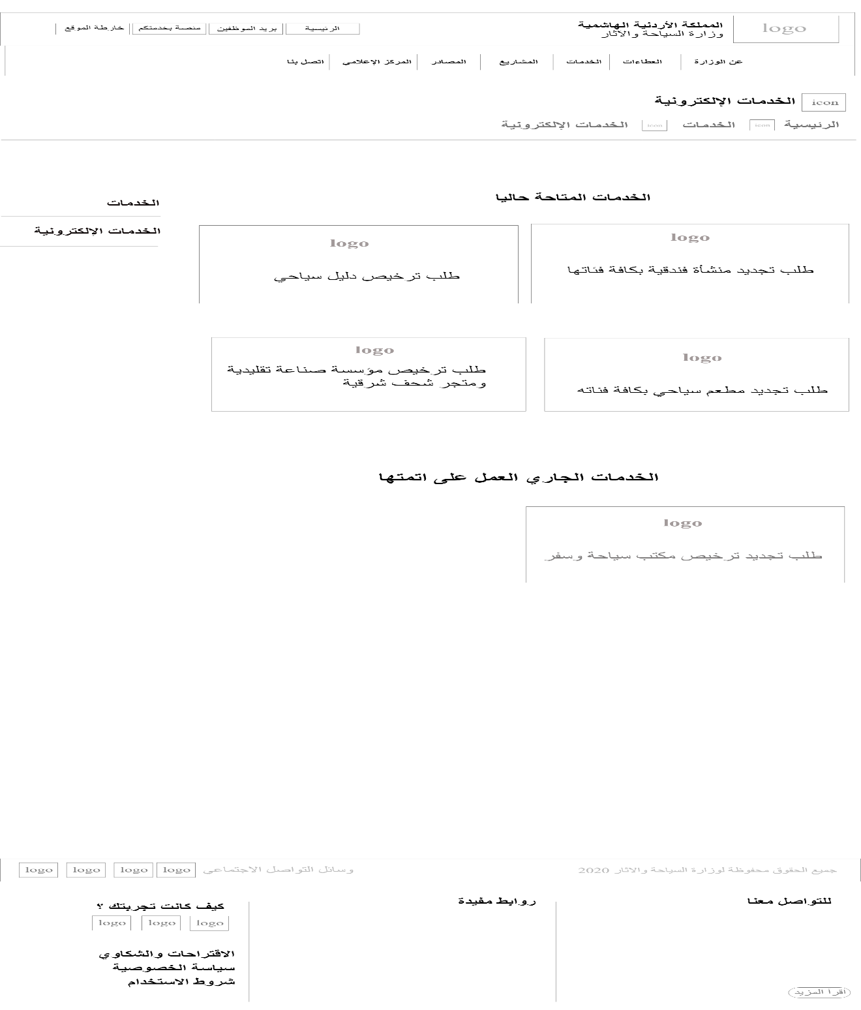

Figure :Electronic services wireframe

* Service 1: Request to renew a hotel establishment of all categories page wireframe.

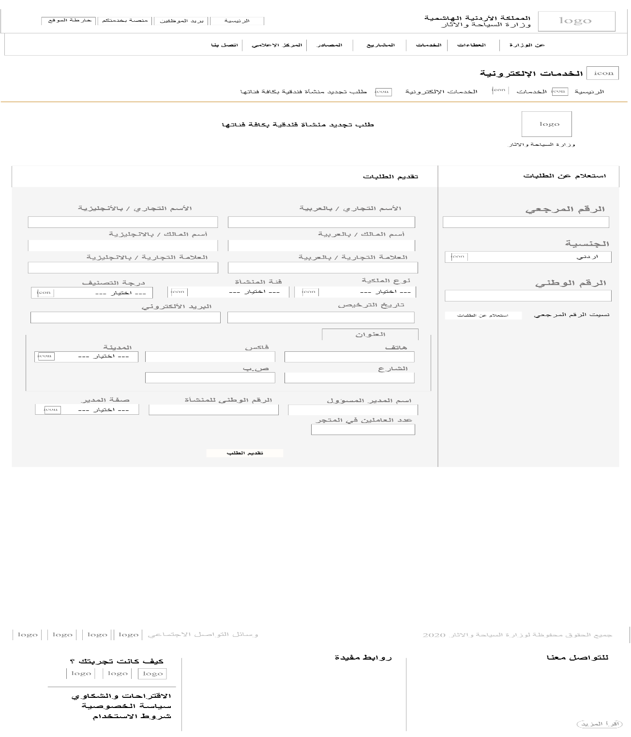

Figure : Renew a hotel service wireframe

* Service 2: Tourist guide license requests page wireframe.

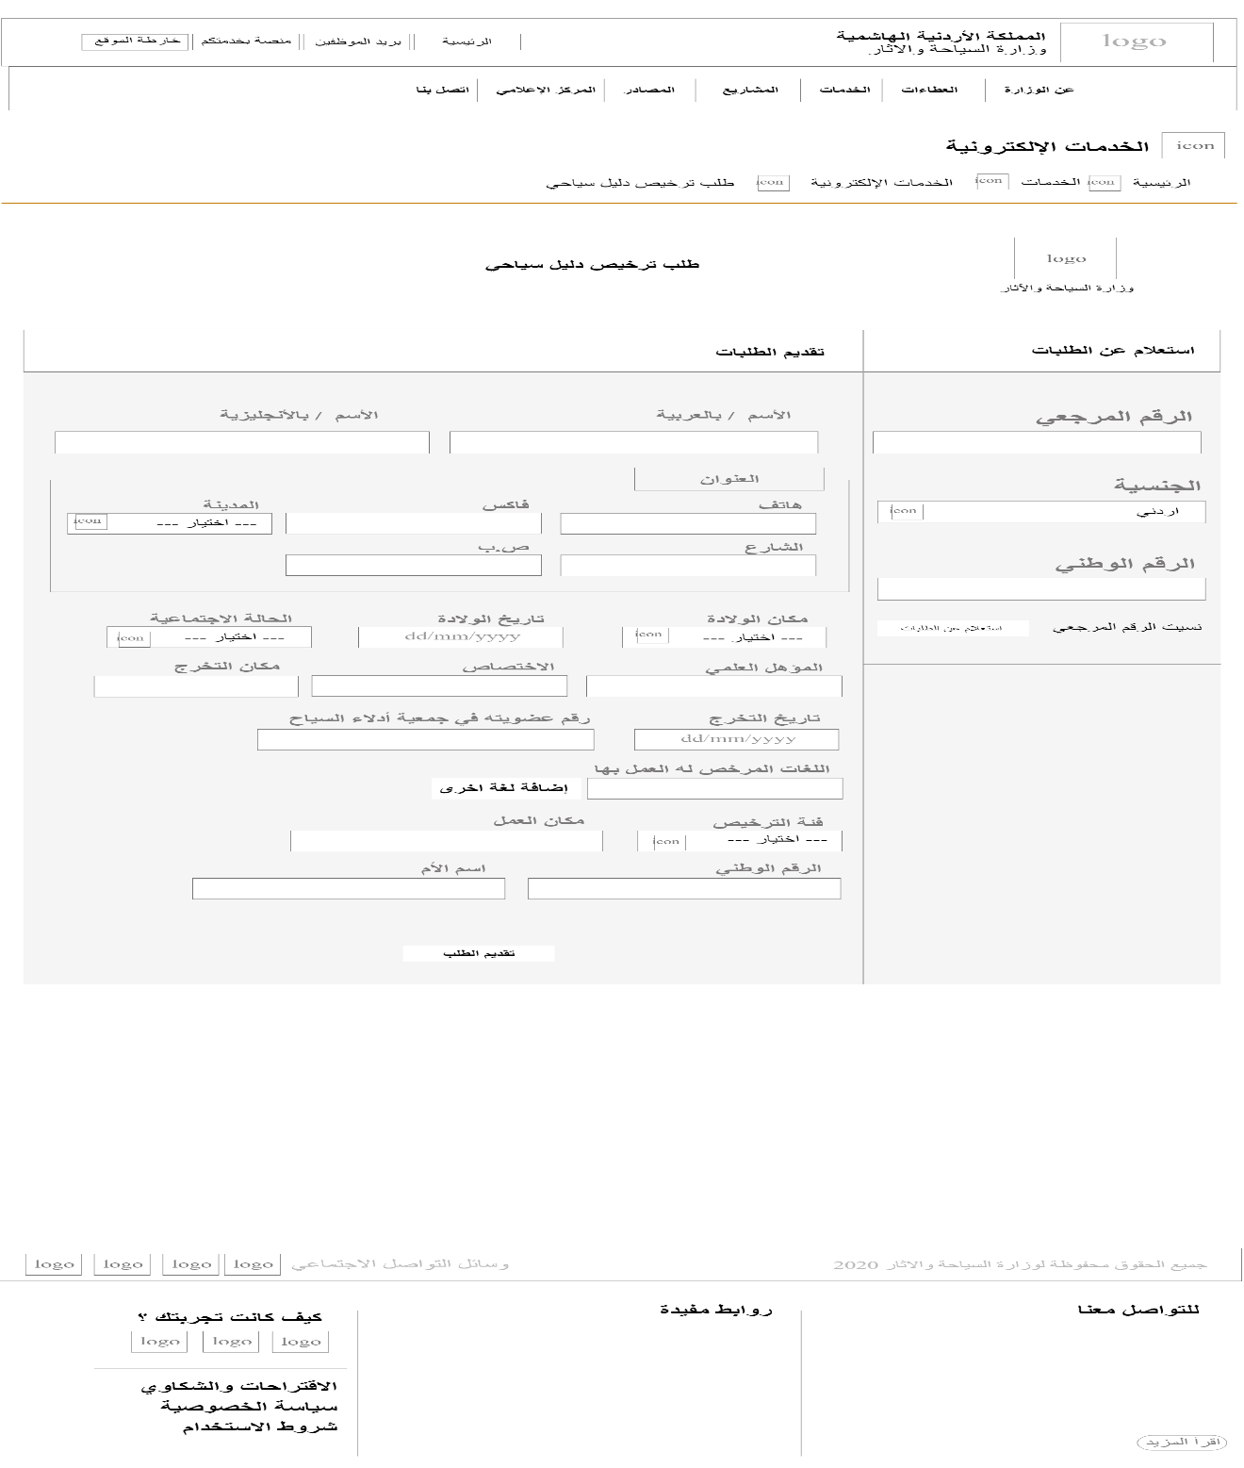

Figure : Tourist guide license requests wireframe

* Service 3: Request to renew a tourist restaurant of all categories page wireframe.

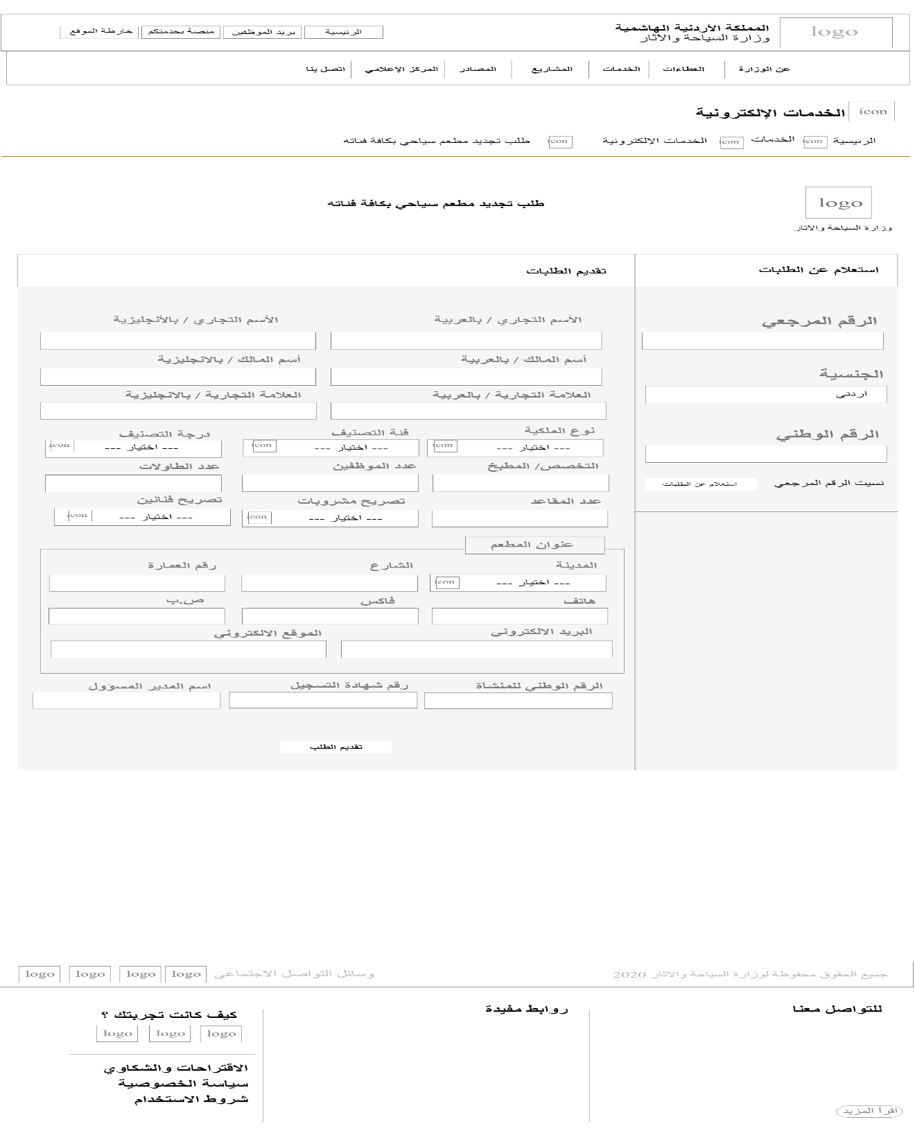

Figure : renew a restaurant service

* Service 4: Applying for licensing a traditional industry establishment and an oriental antique store page wireframe.

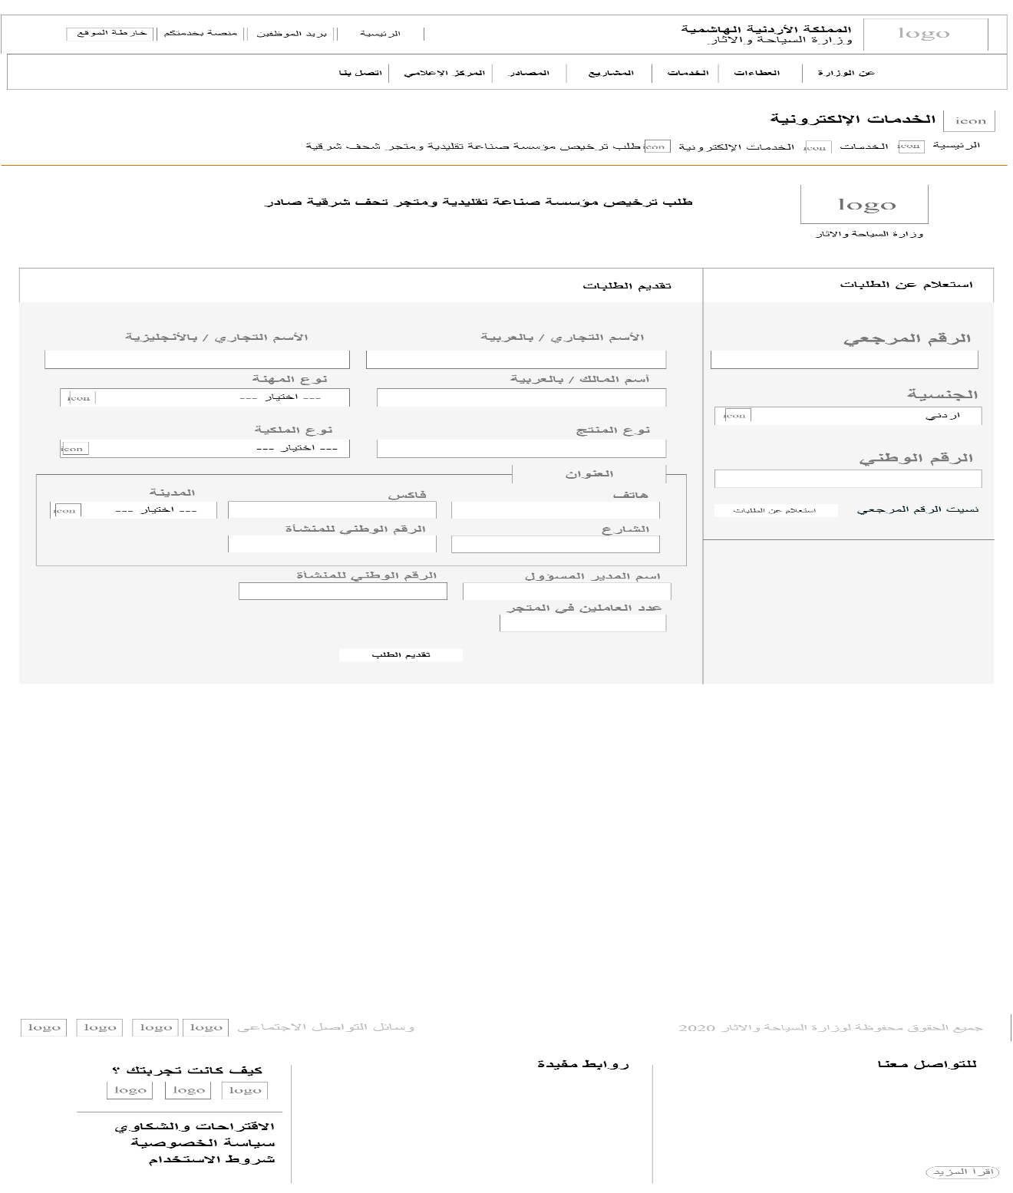

Figure :Applying for licensing industry wireframe

* Ministry’s projects page wireframe.

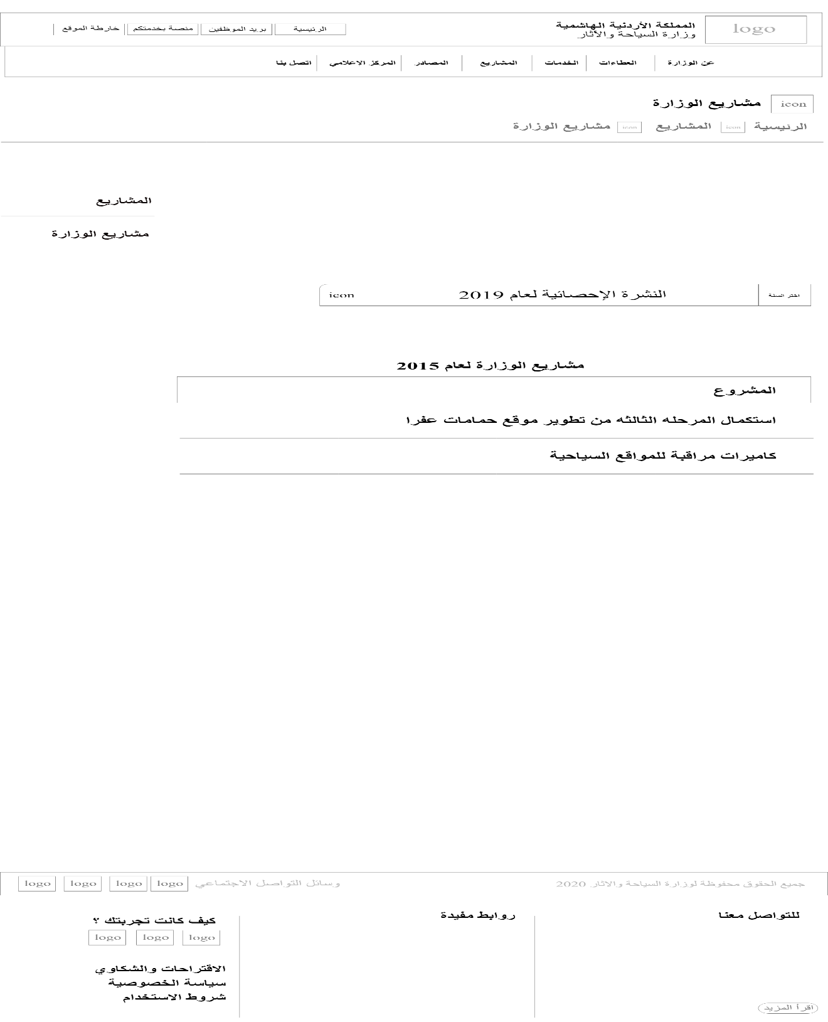

Figure : Ministry’s projects wireframe

* Statistics page wireframe.

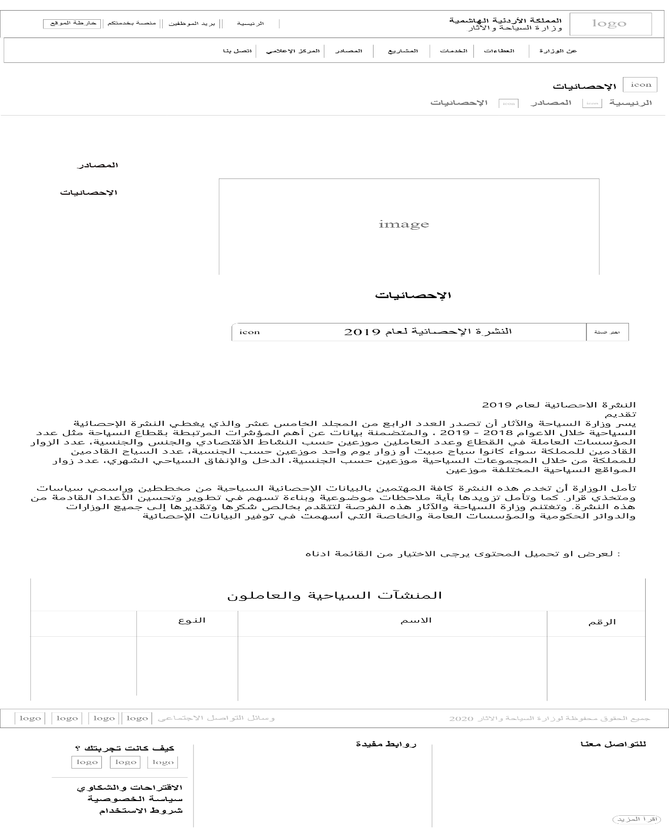

Figure :Statistics wireframe

* News page wireframe.

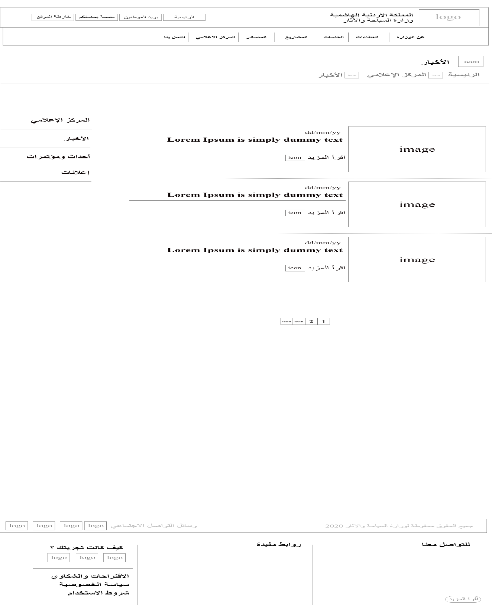

Figure : News wireframe.

* Upcoming Events and Conferences page wireframe.

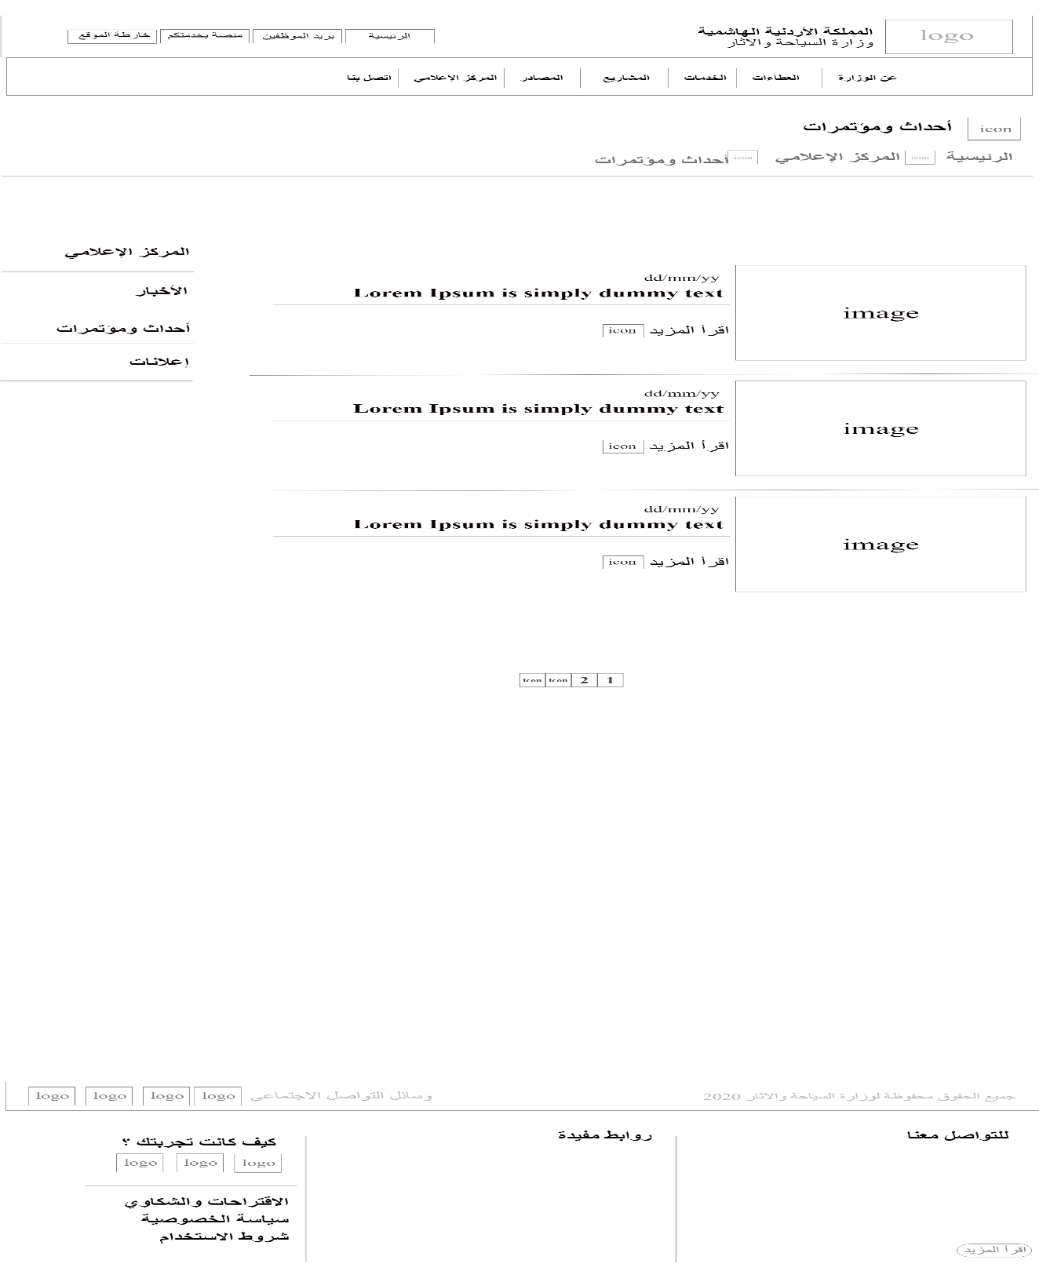

Figure :Upcoming Events Wireframe.

* Advertisement page wireframe.

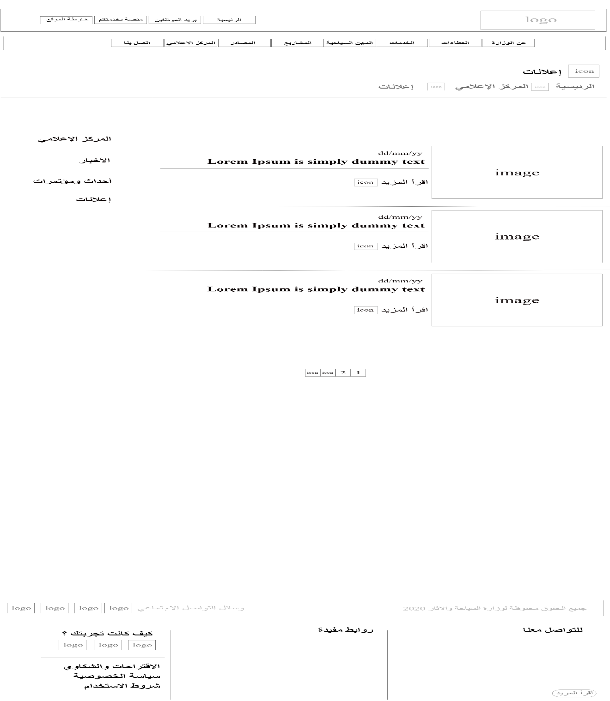

Figure : Advertisement wireframe.

* Contact us page wireframe.

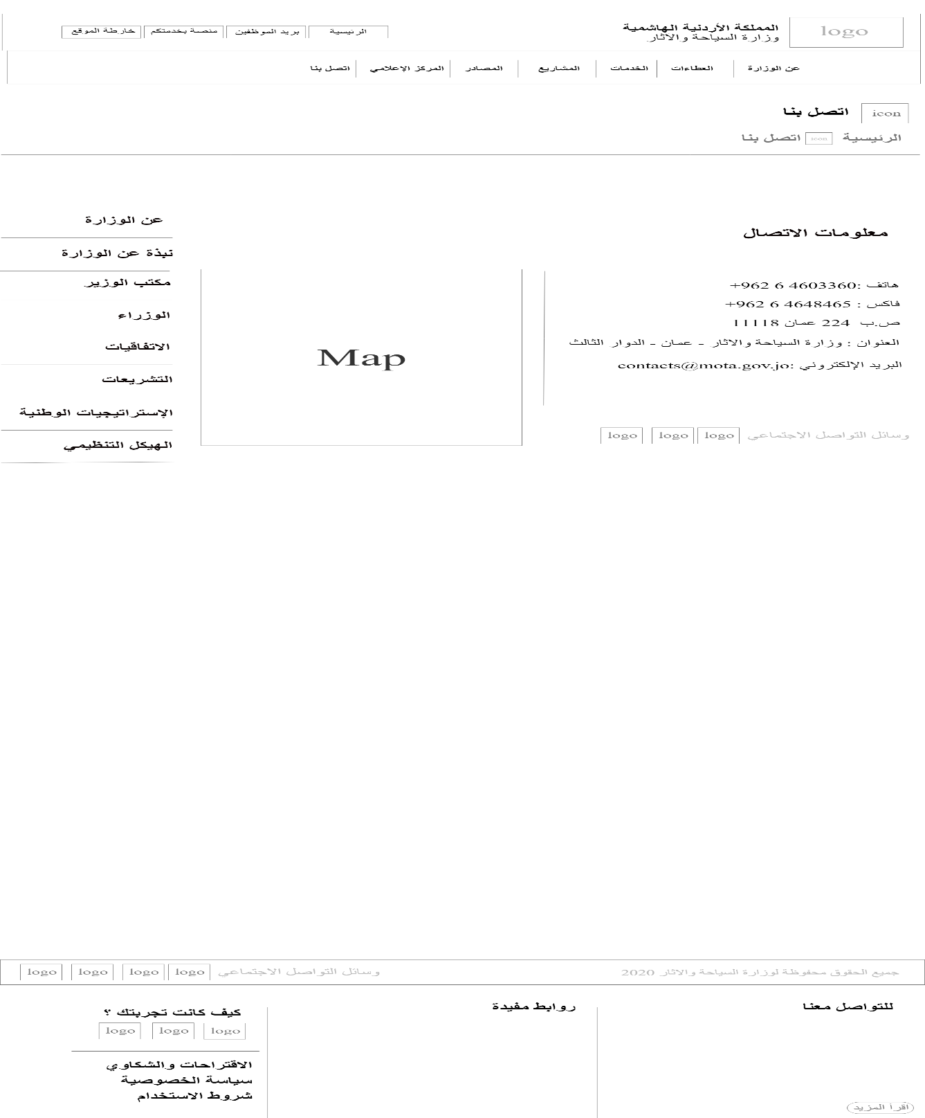

Figure : Contact us wireframe

* Suggestions and Compliance page wireframe.

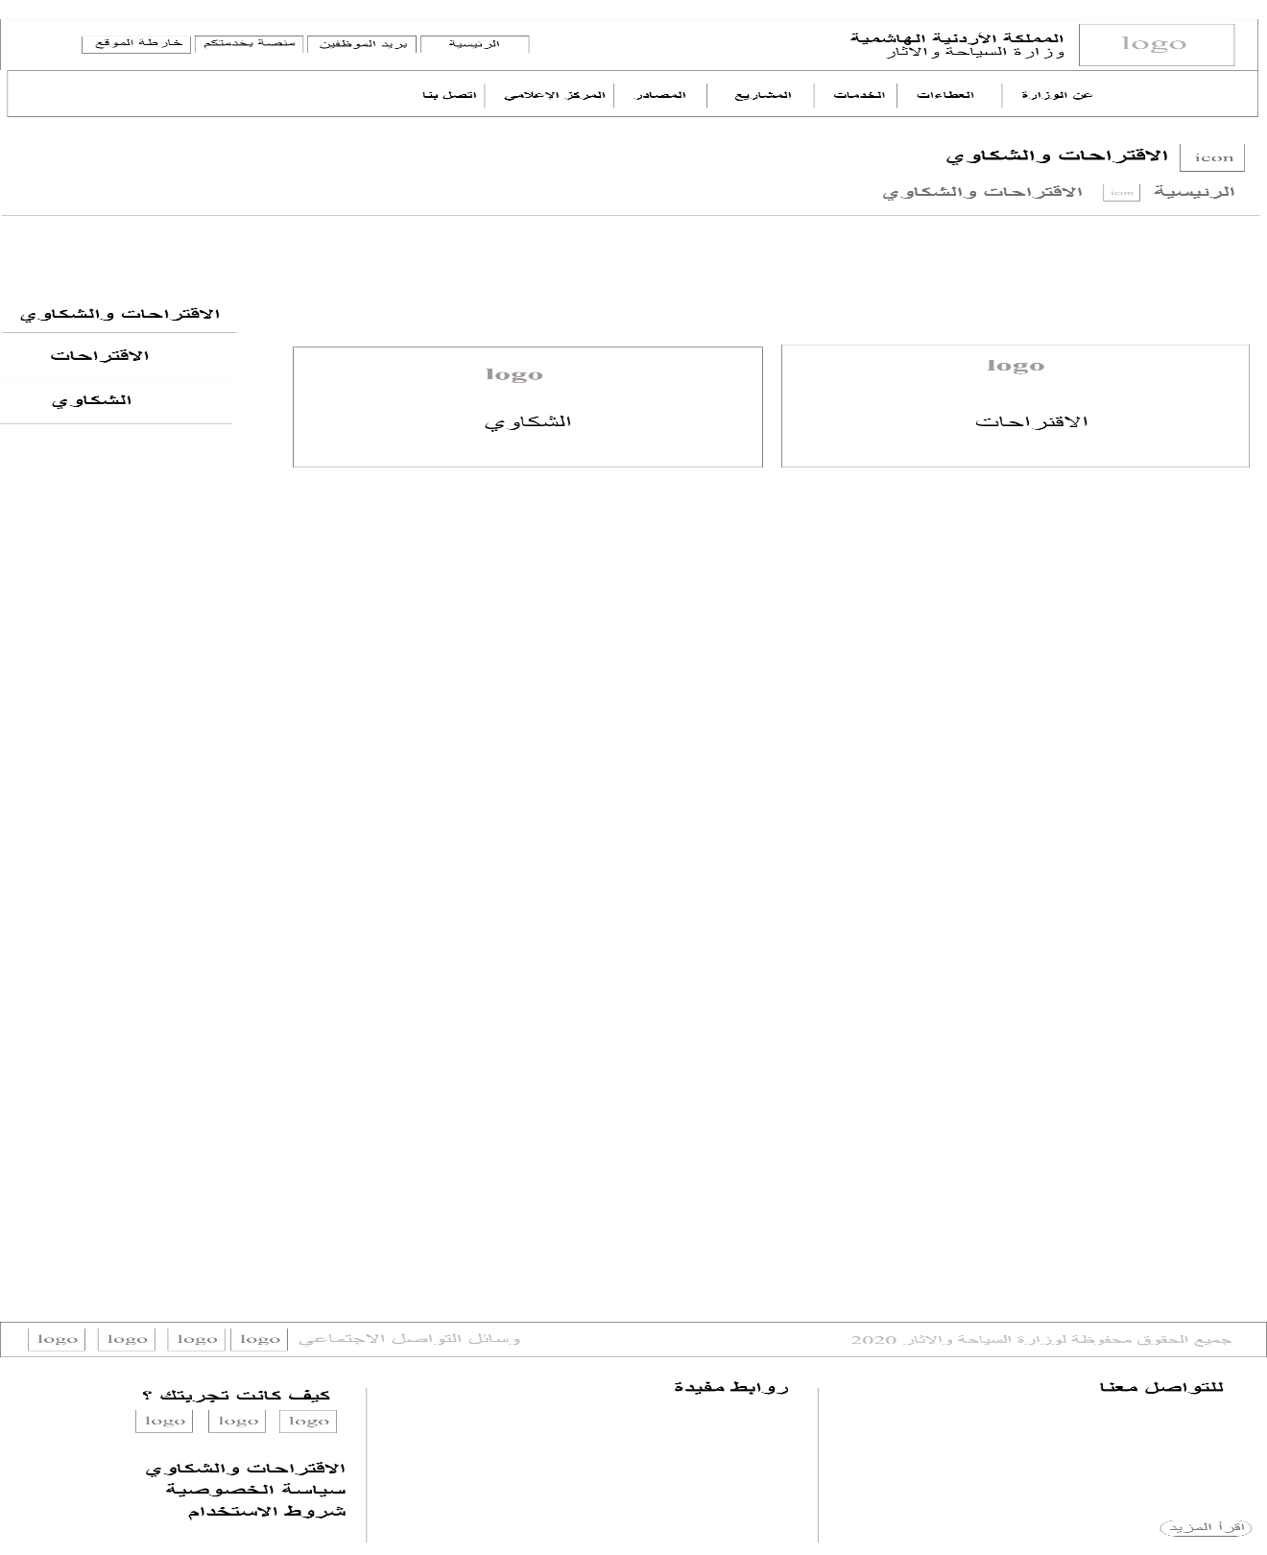

Figure : Suggestions and Compliance Wireframe

* Suggestions page wireframe.

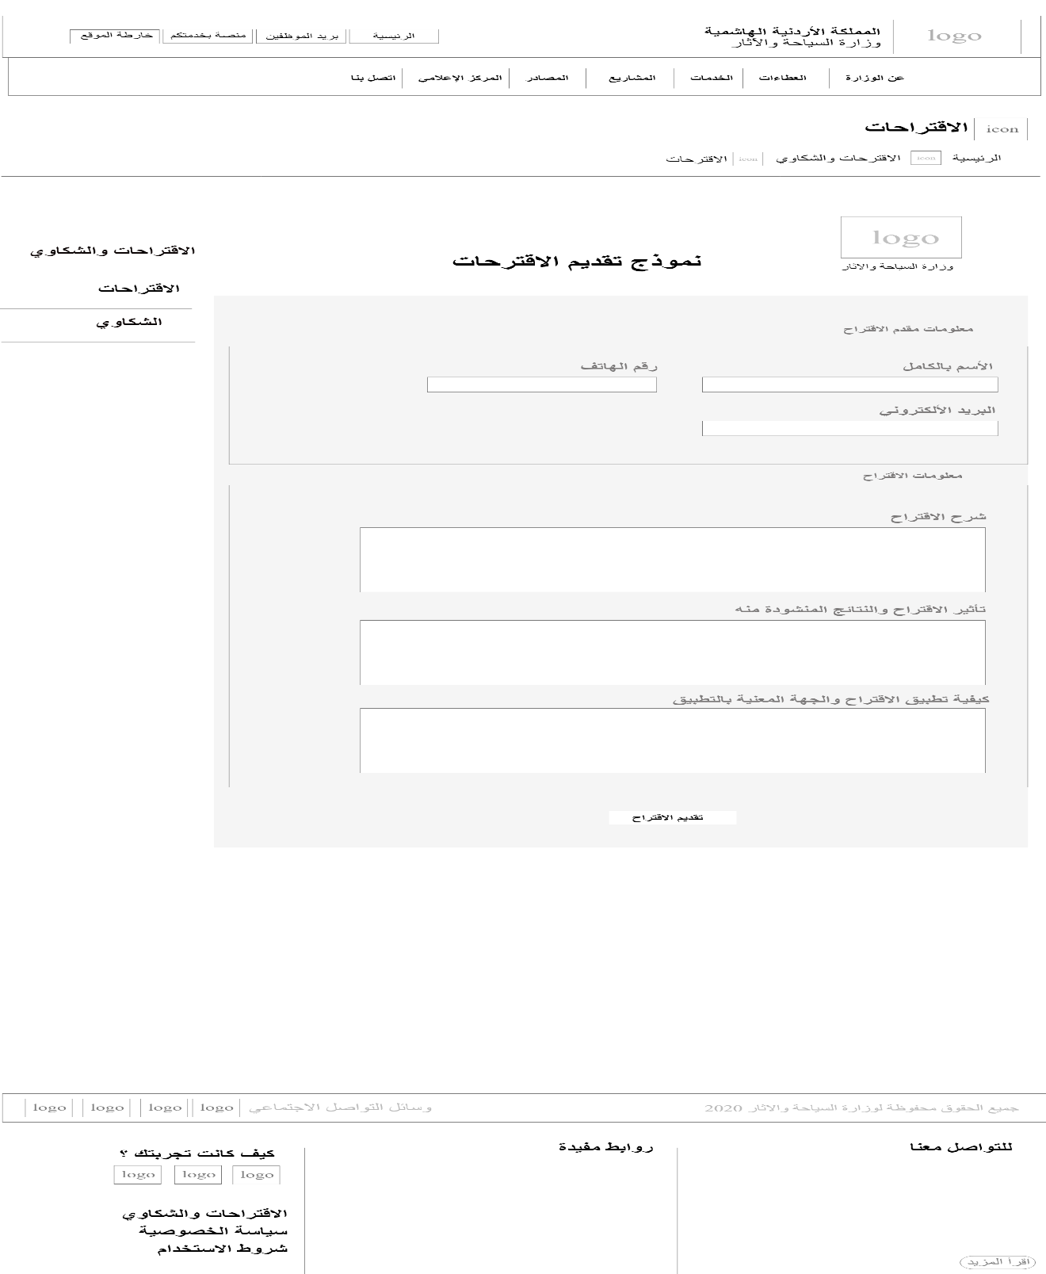

Figure : Suggestions wireframe

* Compliances page wireframe.

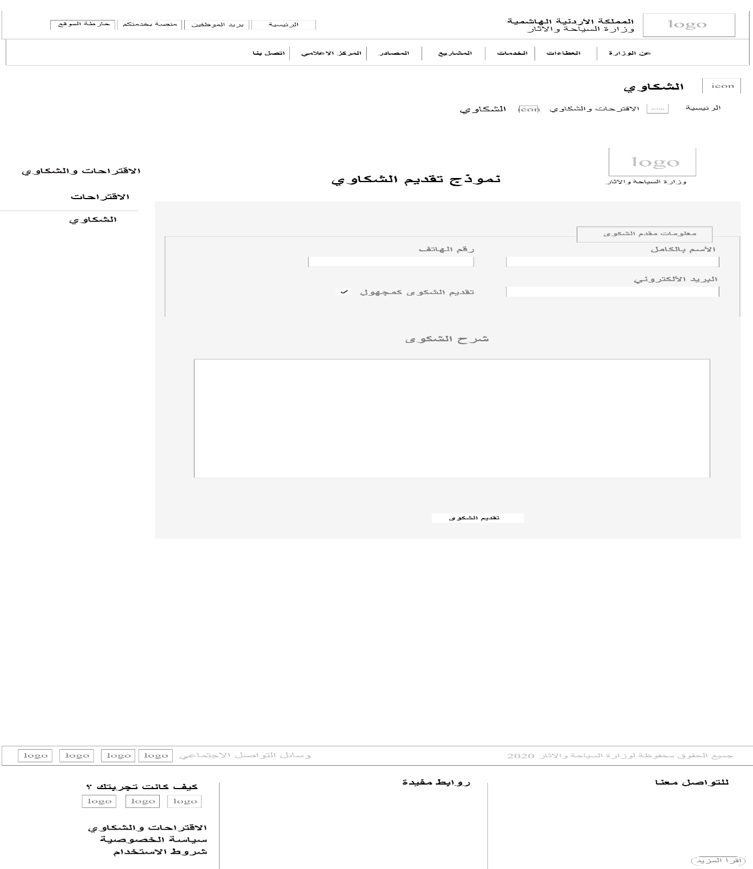

Figure : Compliances wireframe.

* Sitemap page wireframe.

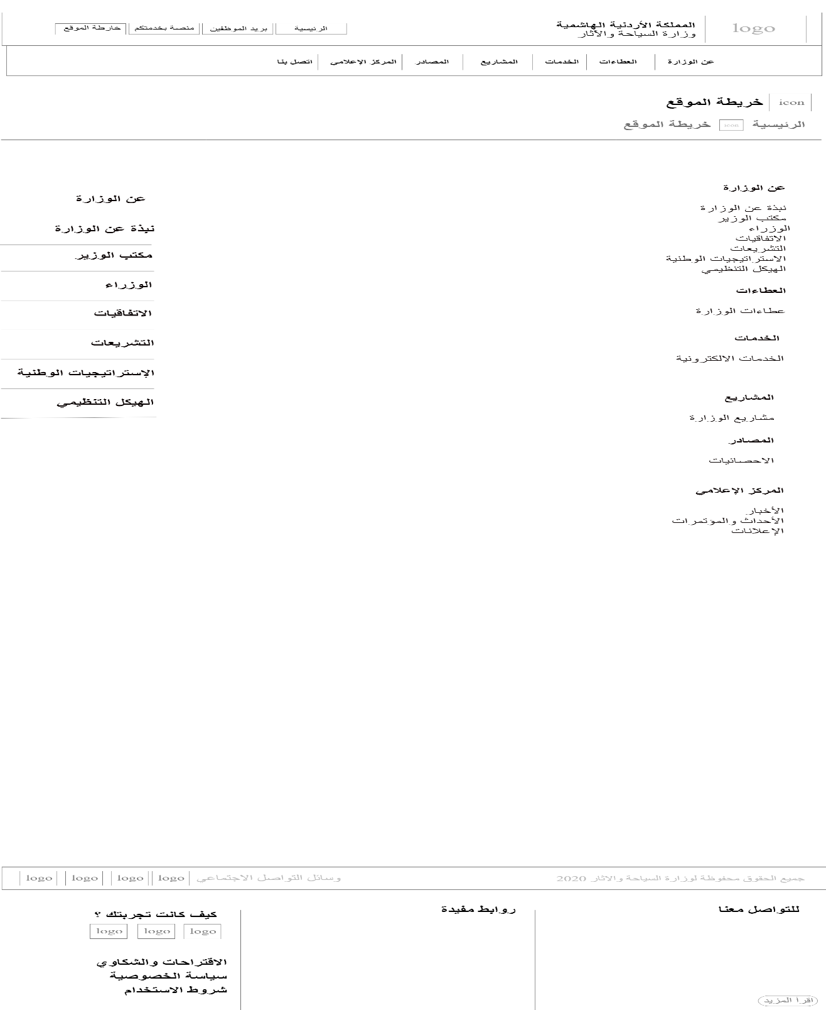

Figure :Sitemap wireframe

* Privacy policy page wireframe.

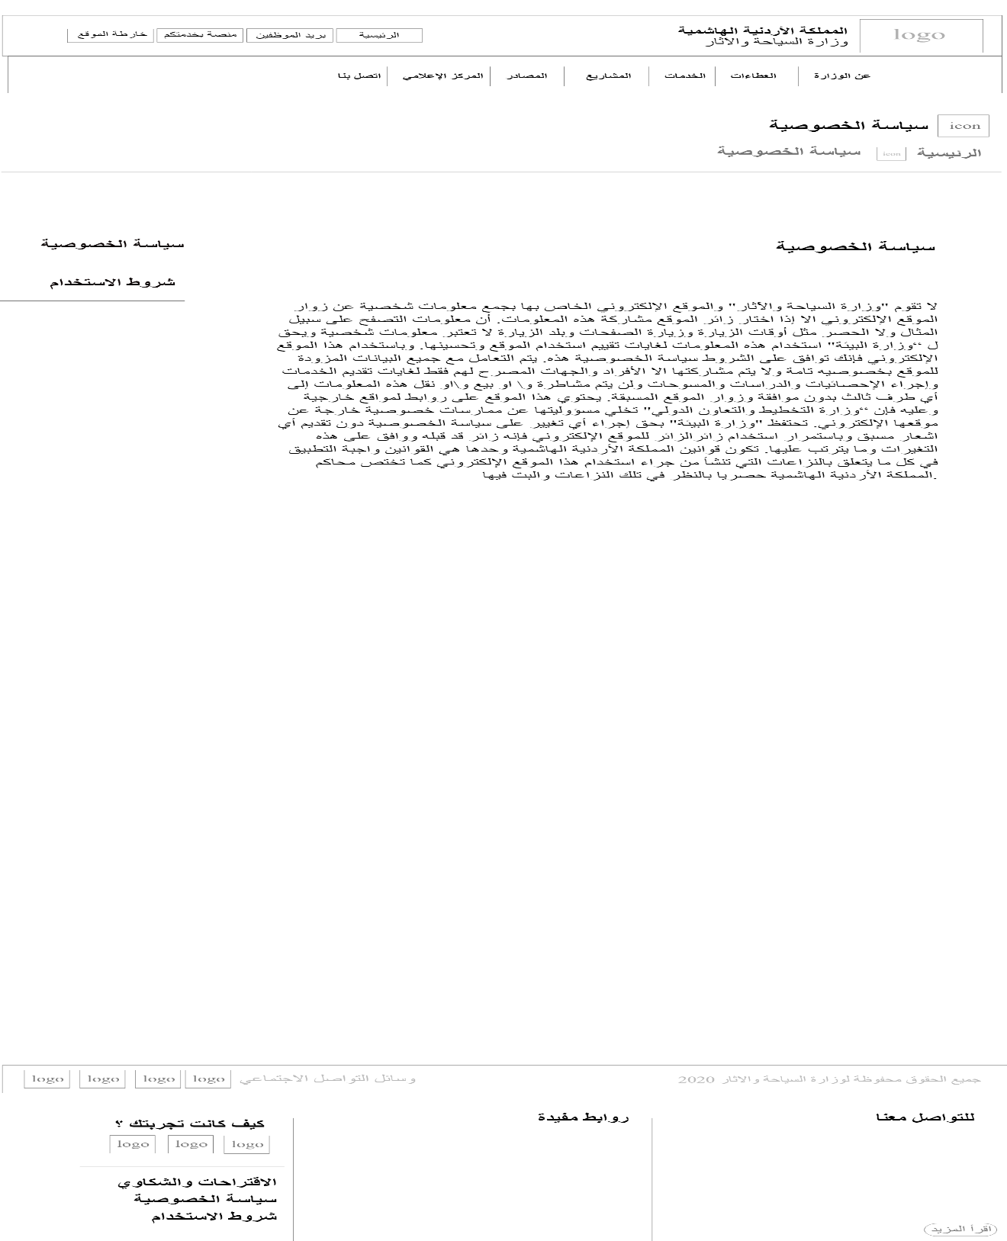

Figure : Privacy policy wireframe

* Terms of use page wireframe.

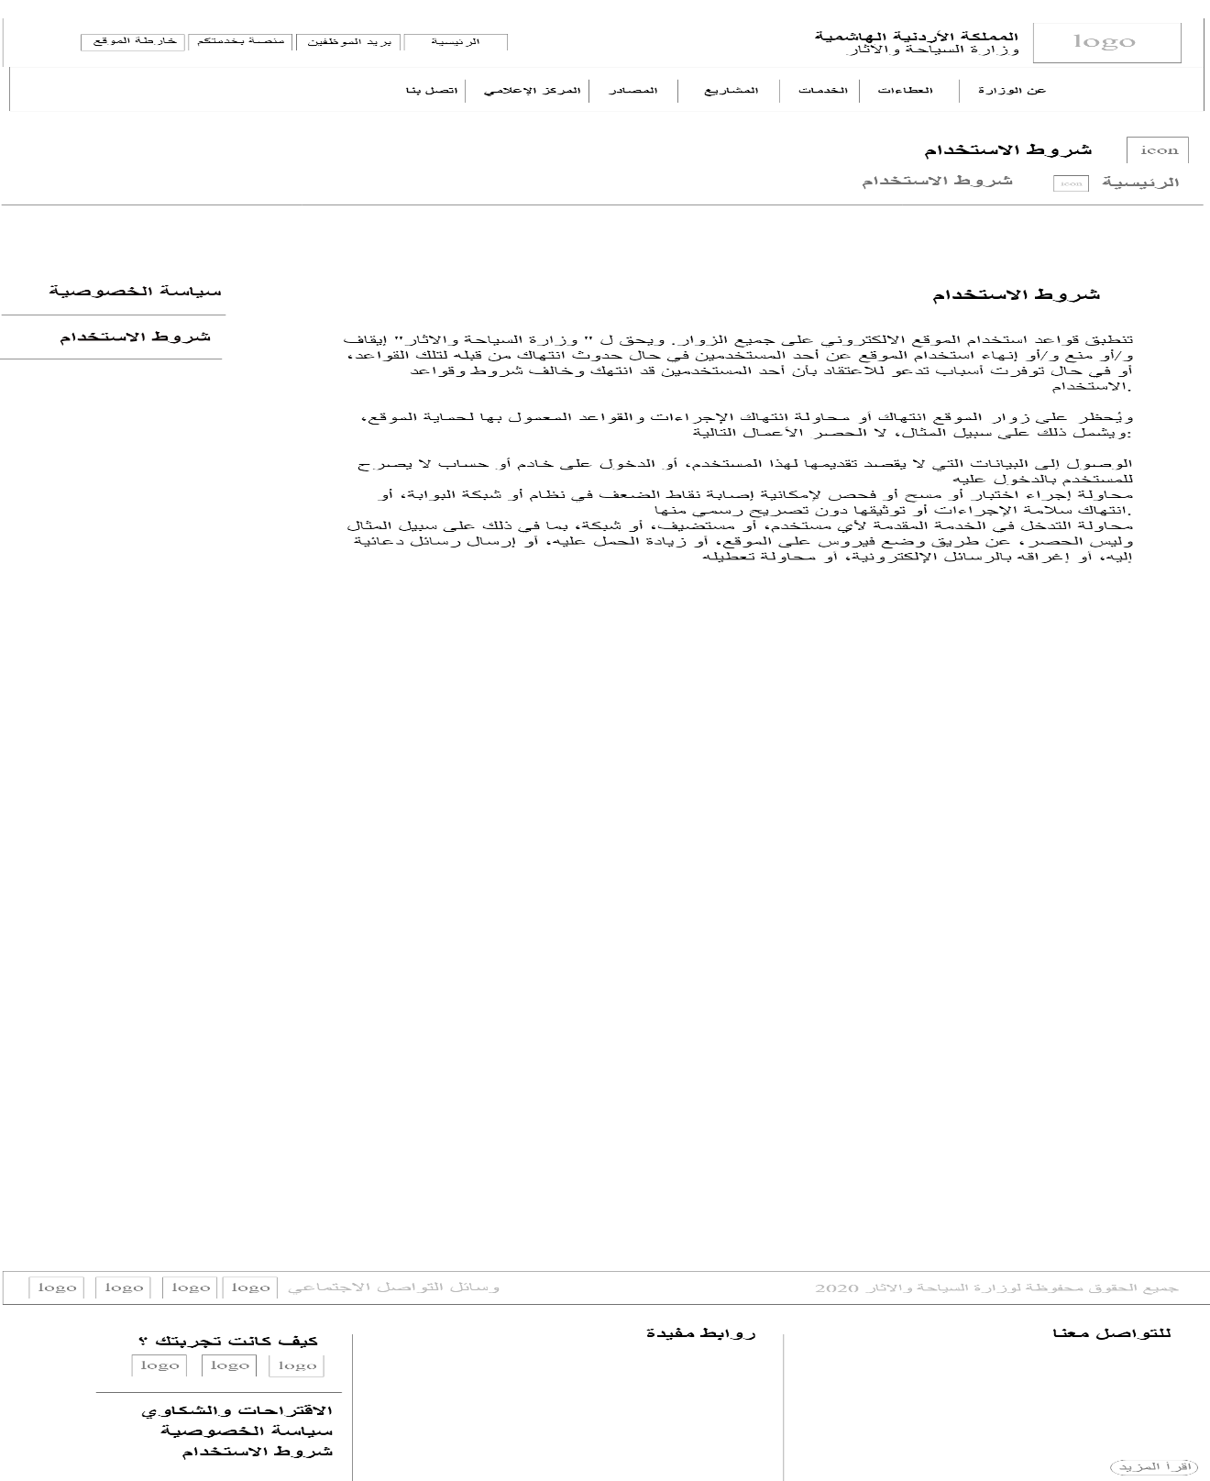

Figure :Terms of use wireframe

### Sitemap

**Sitemap**: A site map (or sitemap) is a list of [pages](https://en.wikipedia.org/wiki/Web_page) of a [web site](https://en.wikipedia.org/wiki/Web_site).

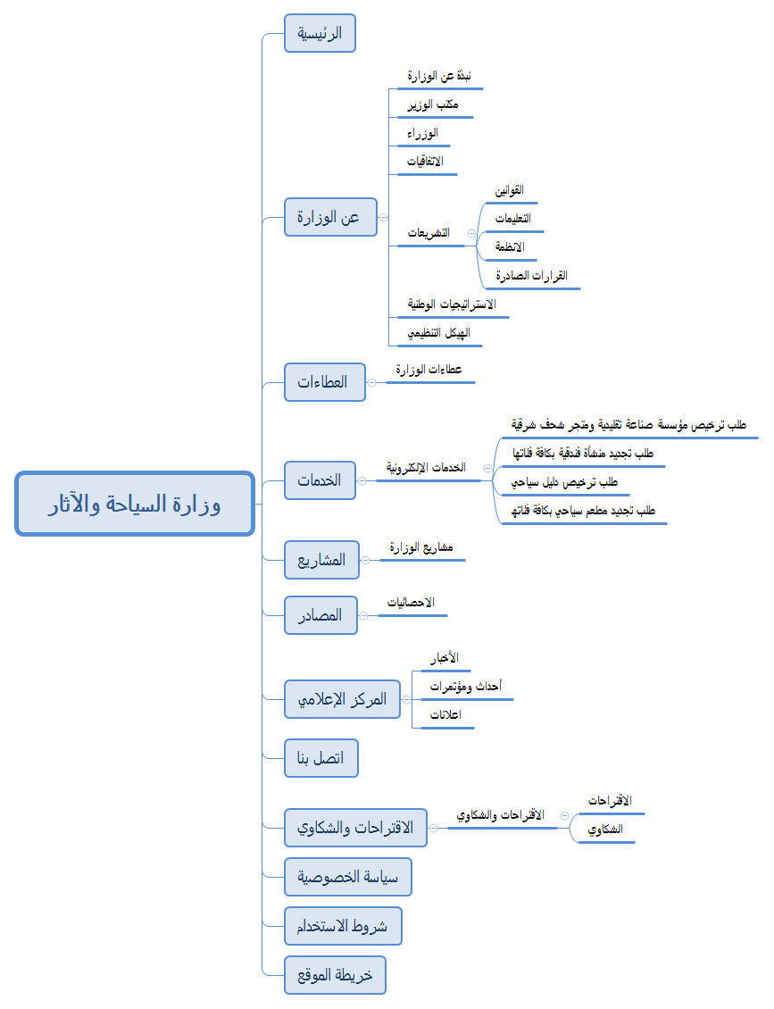

Figure : Sitemap

### Mockup

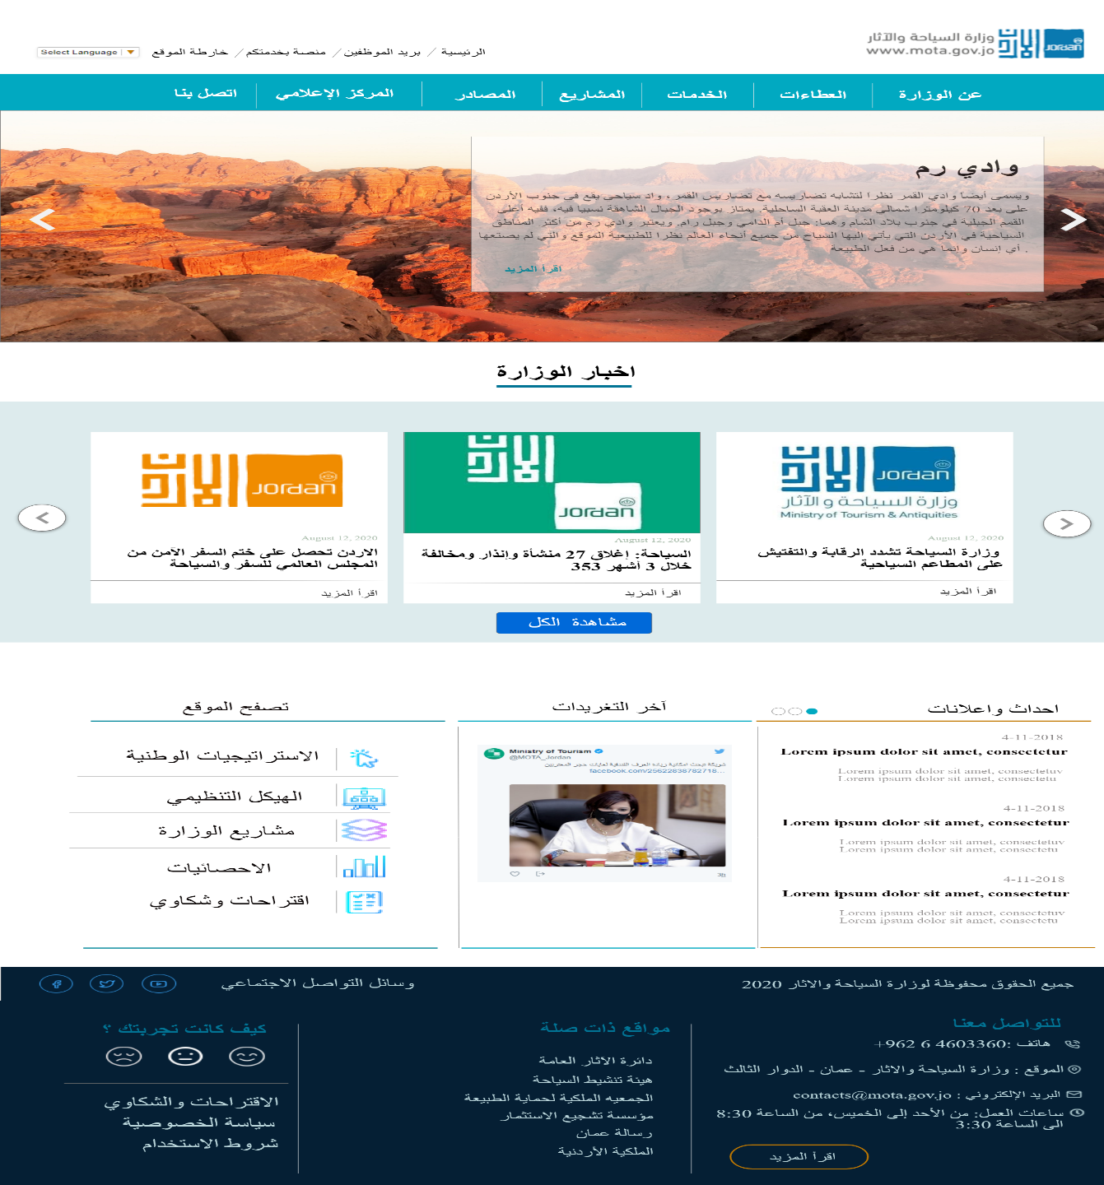**Mockup**: a website mockup is a high-fidelity simulation of how a website will look.

Figure :Homepage Mockup

* Homepage Mockup.
* About the Ministry page Mockup.

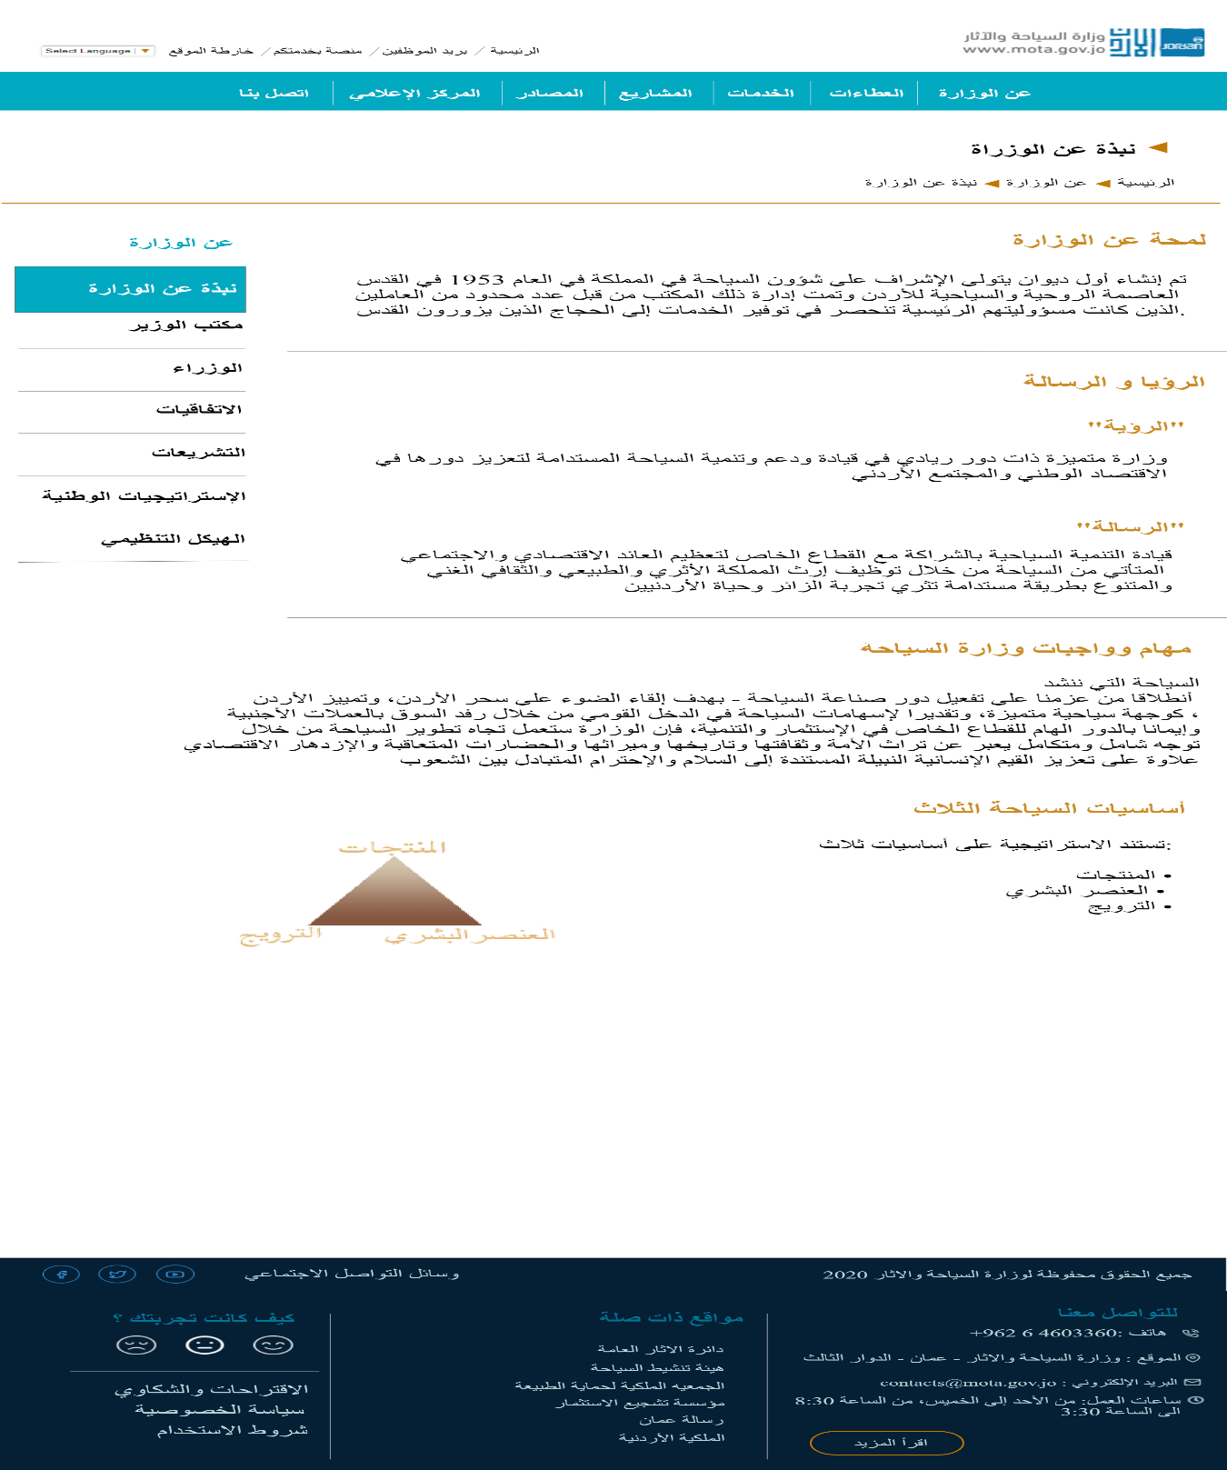

Figure : About the Ministry Mockup

* 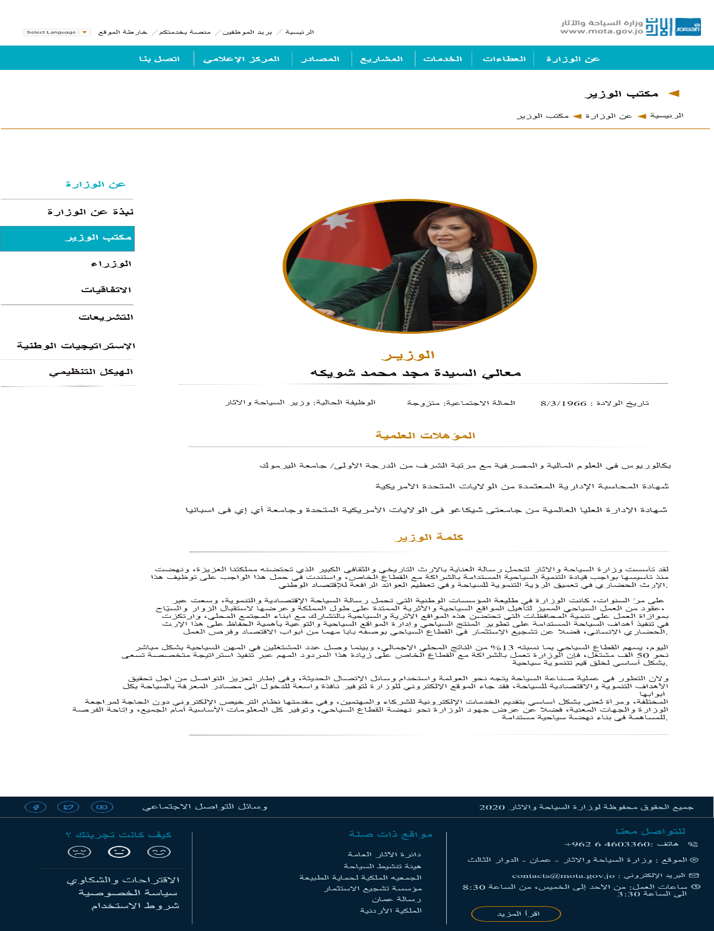Minister’s office page Mockup.

Figure : Minister's office Mockup

* 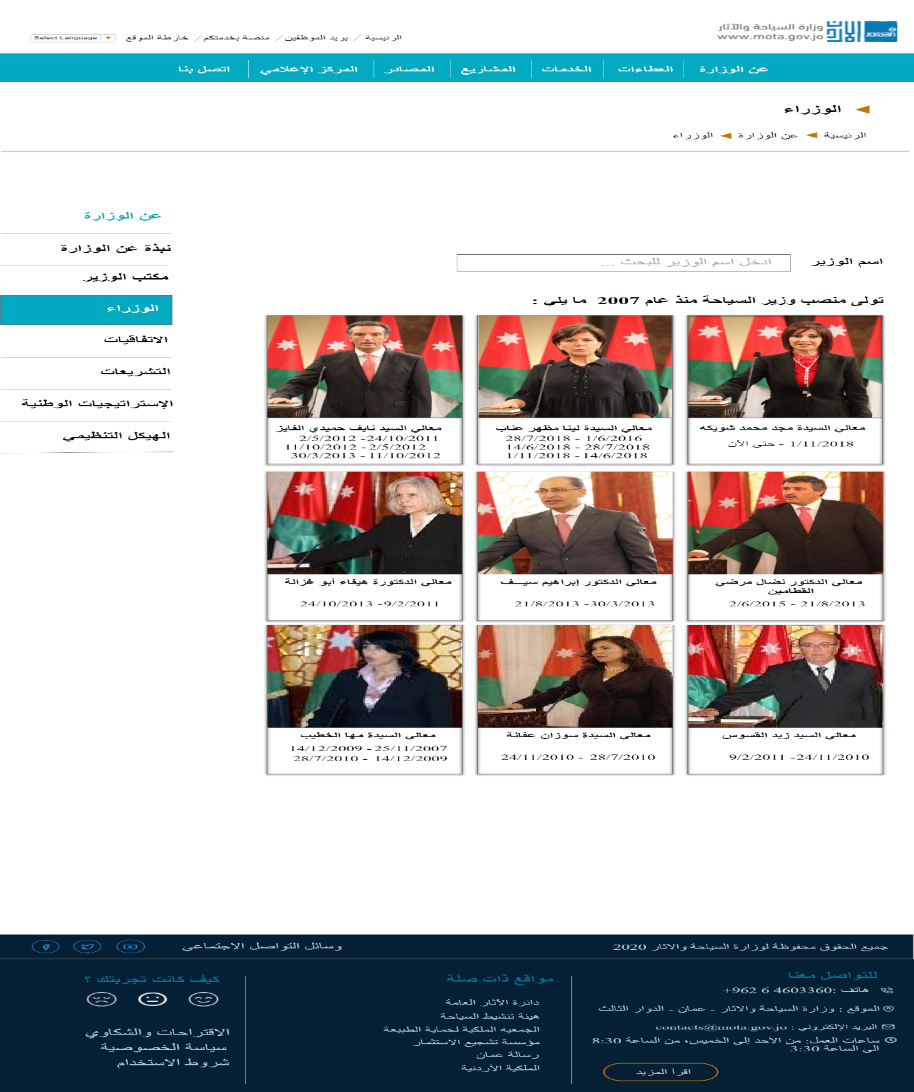Ministers page Mockup.

Figure : Ministers Mockup

* 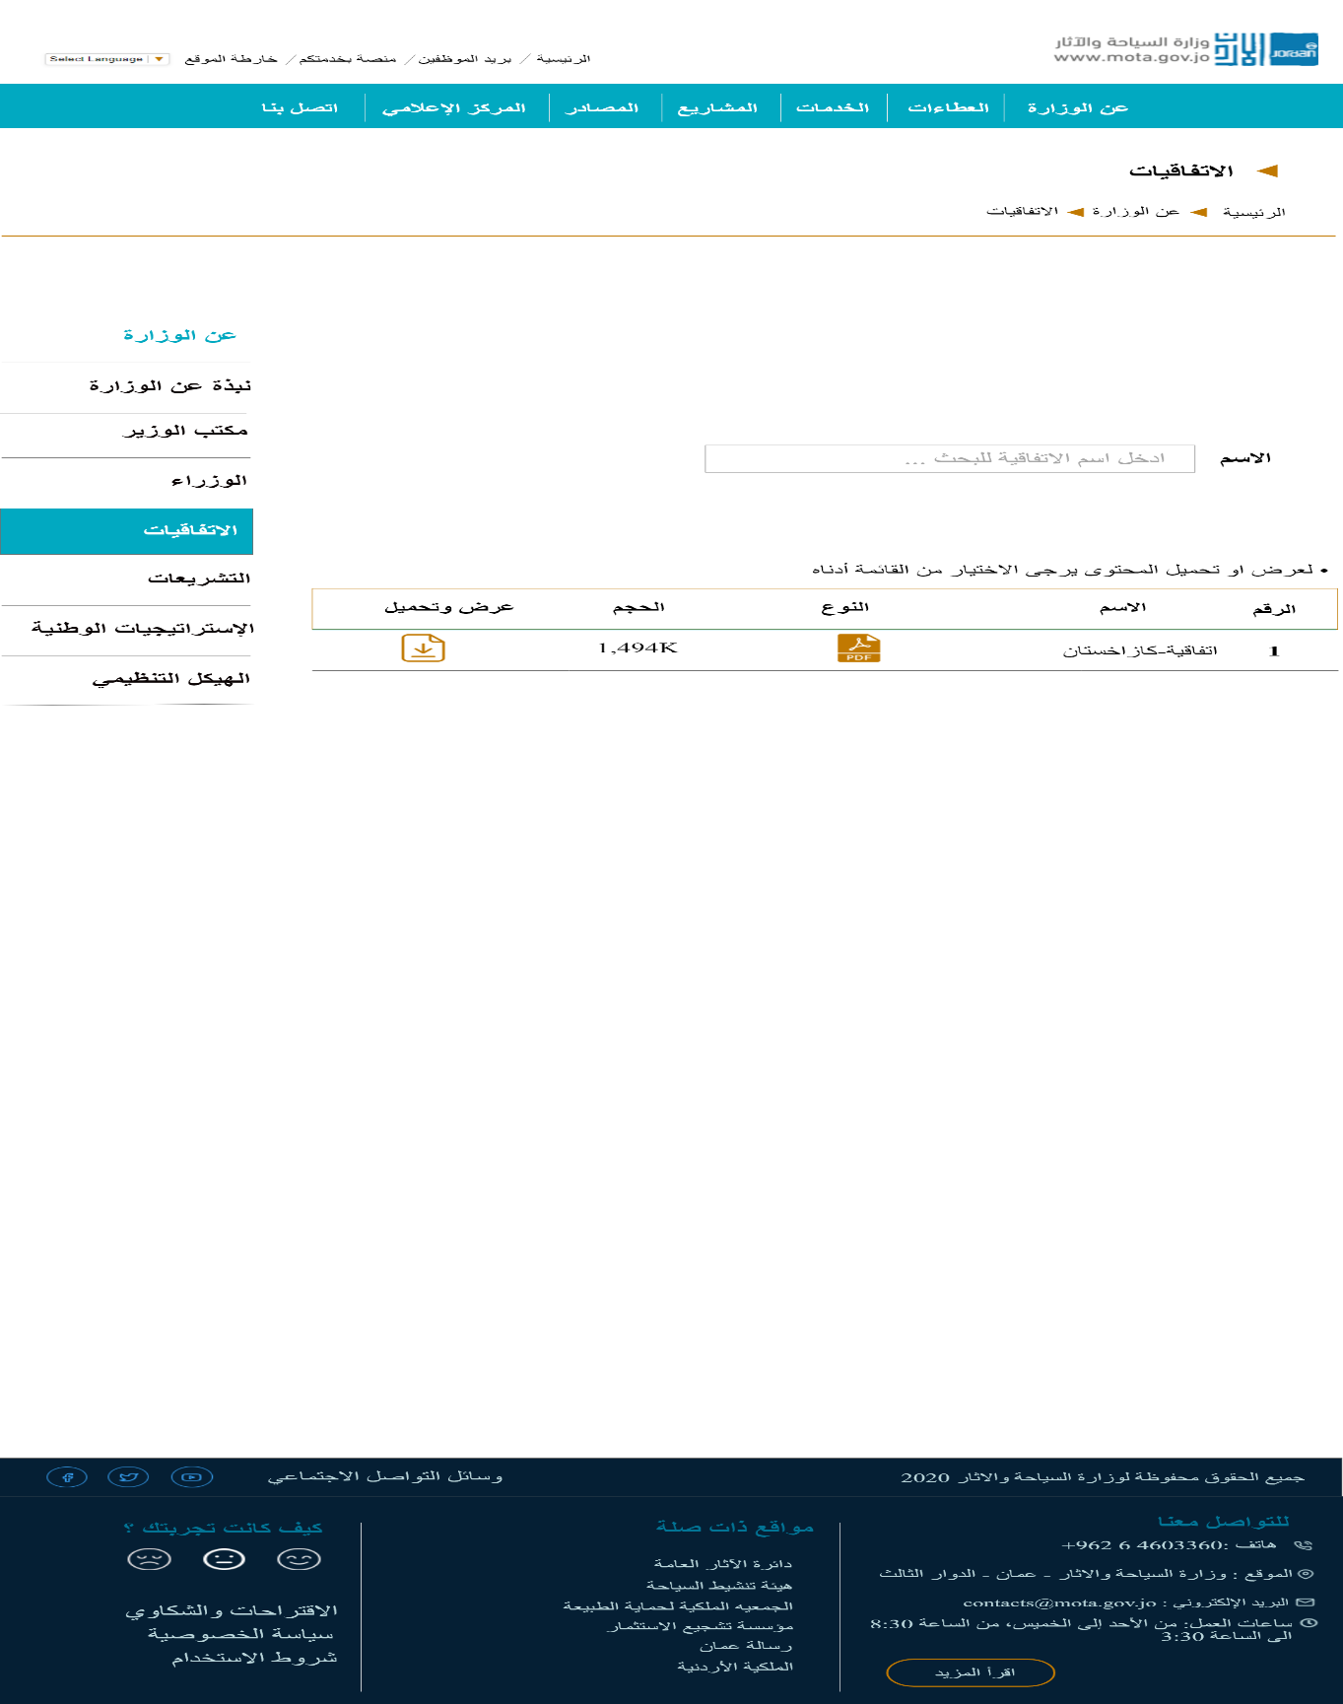Conventions page mockup.

Figure : Conventions Mockup

* 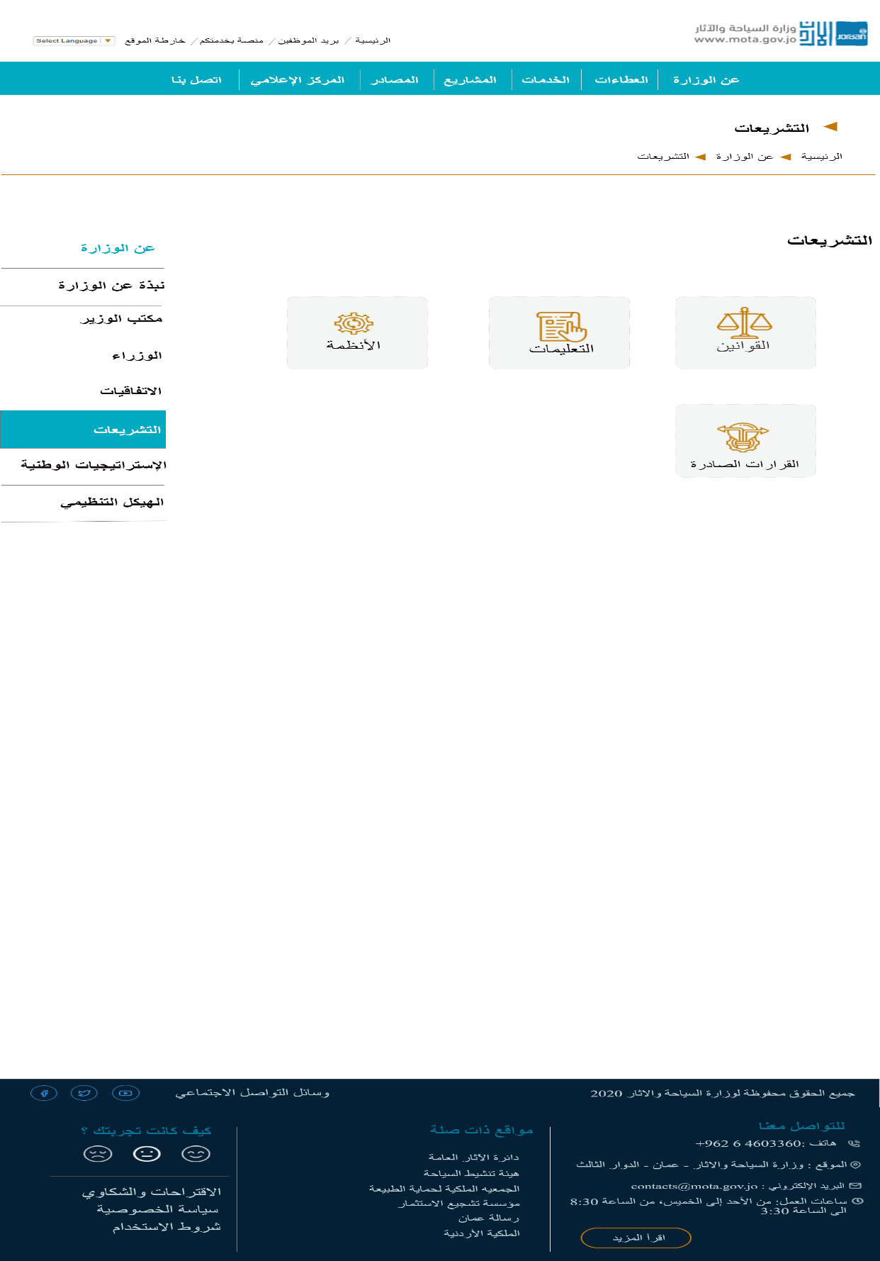Legislations page Mockup.

Figure : Legislations Mockup.

* 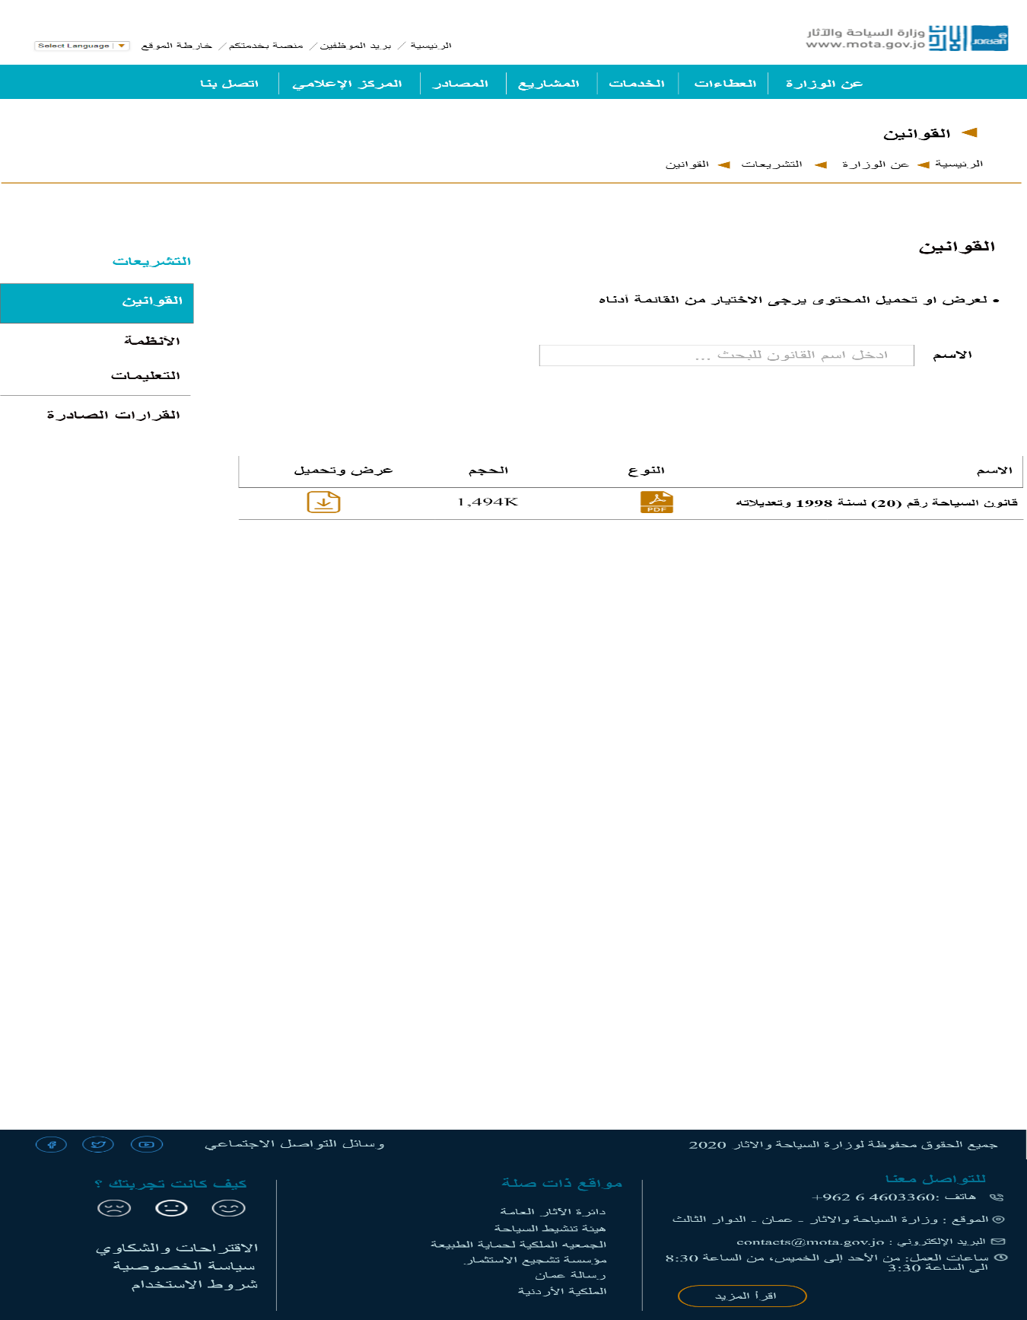Legislations- Laws page Mockup.

Figure : Legislations - Laws Mockup.

* 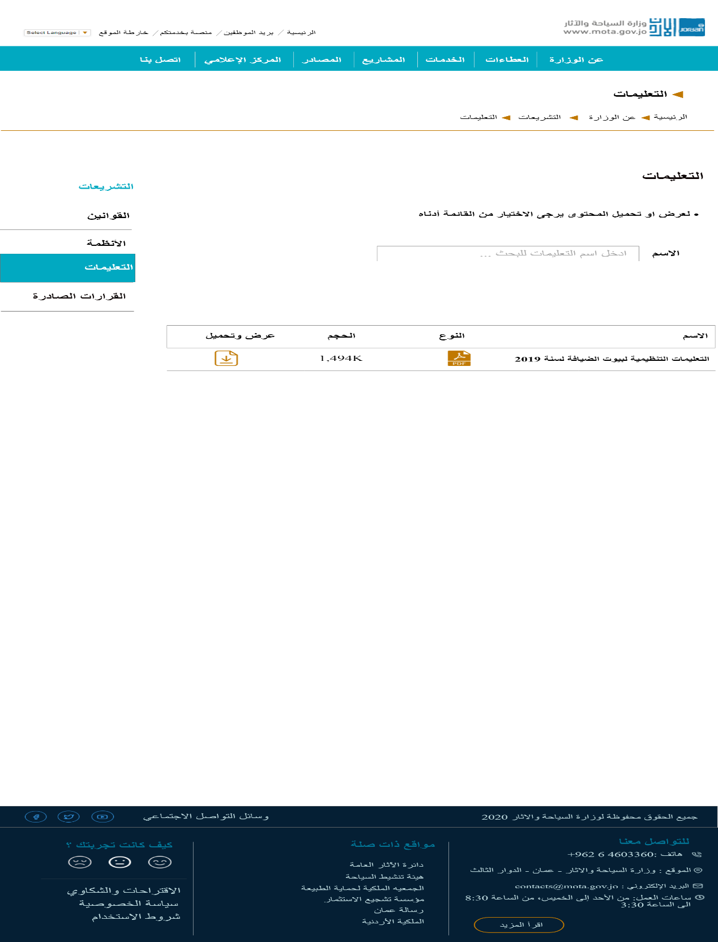Legislations- Instructions page Mockup.

Figure : Legislations - Instructions Mockup.

* 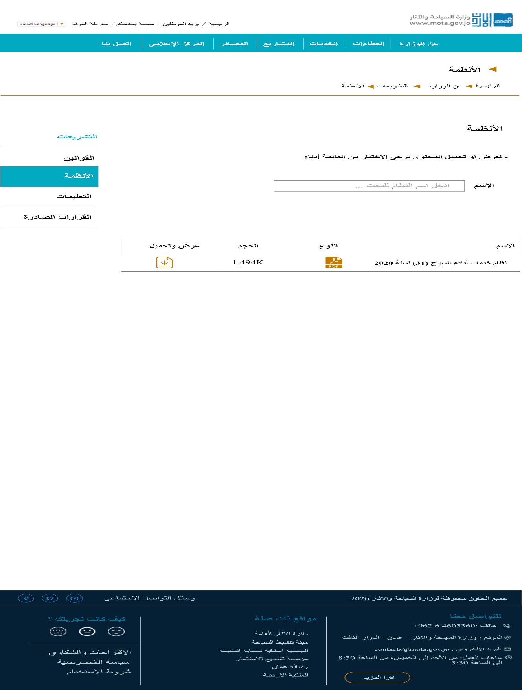Legislations- Systems page Mockup.

Figure : Legislations - Systems Mockup.

* 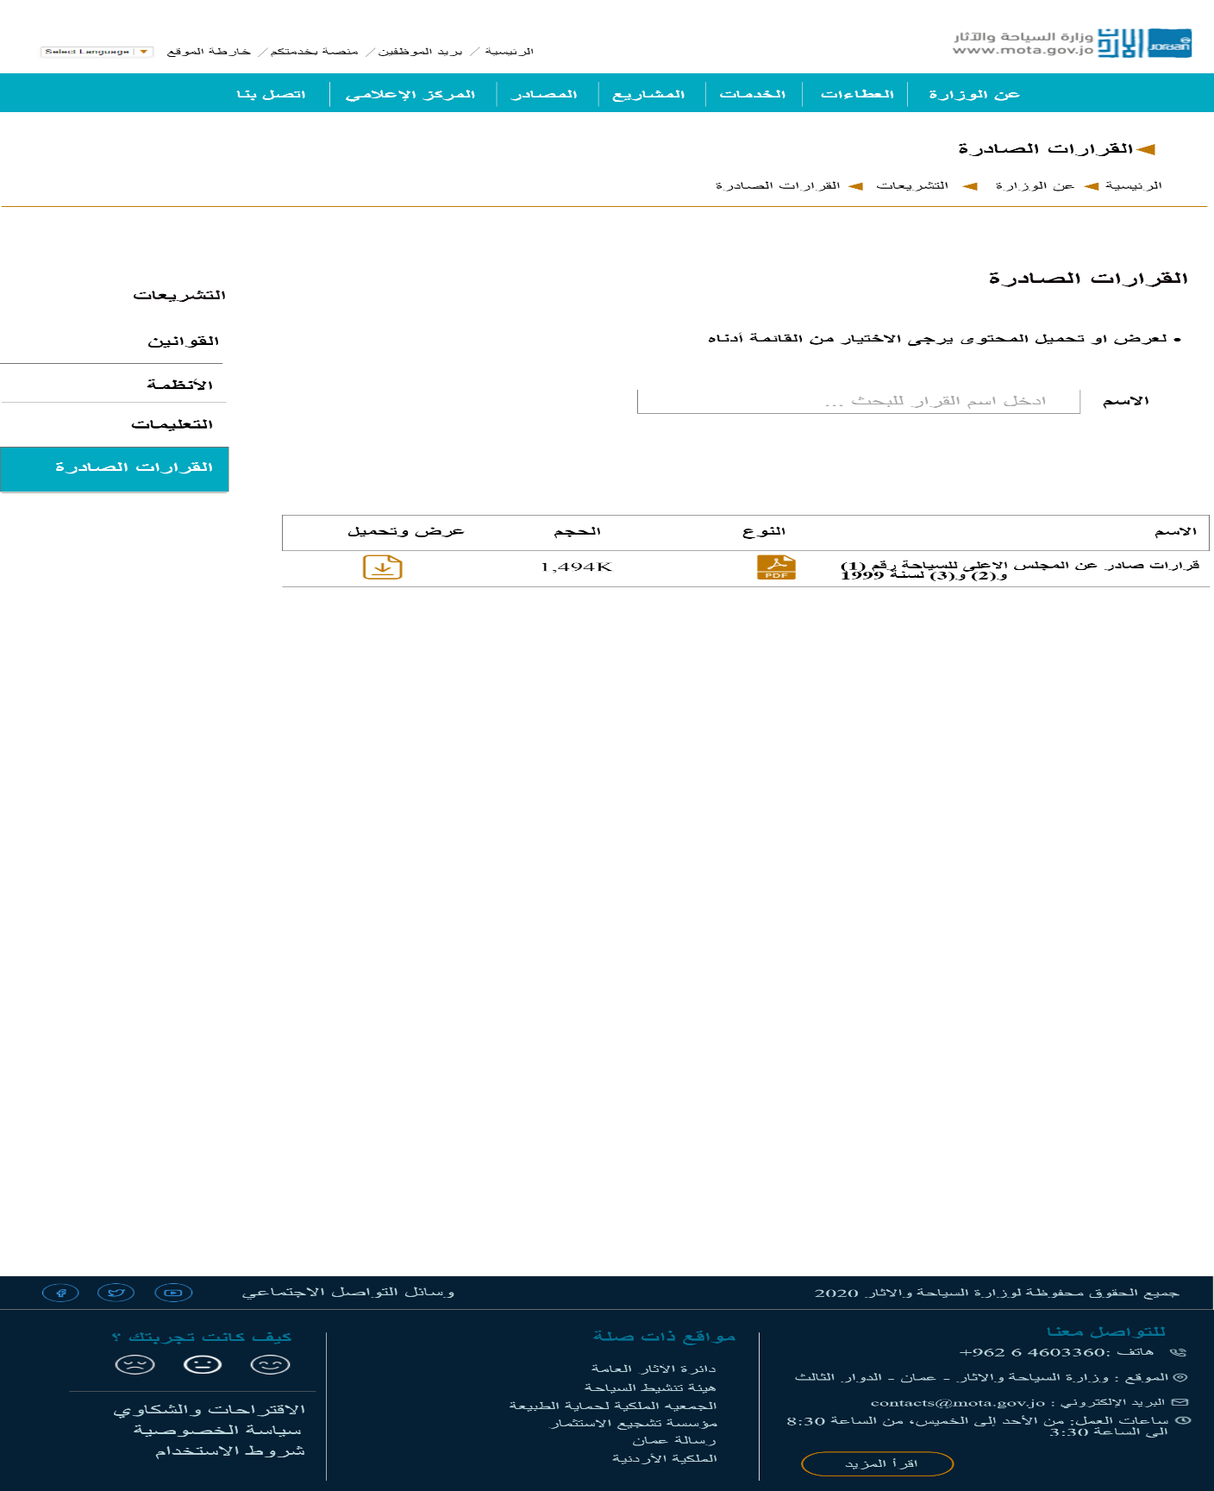Legislations – Decisions made page Mockup.

Figure : Legislations- Decisions made Mockup.

* 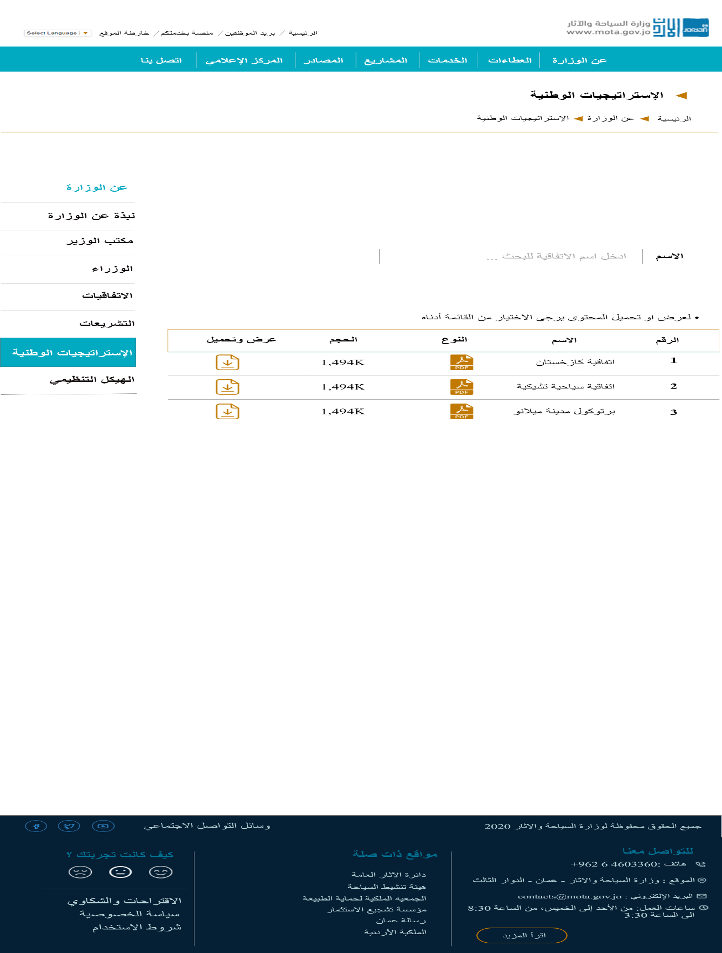National Strategies page Mockup.

Figure : National Strategies Mockup.

* 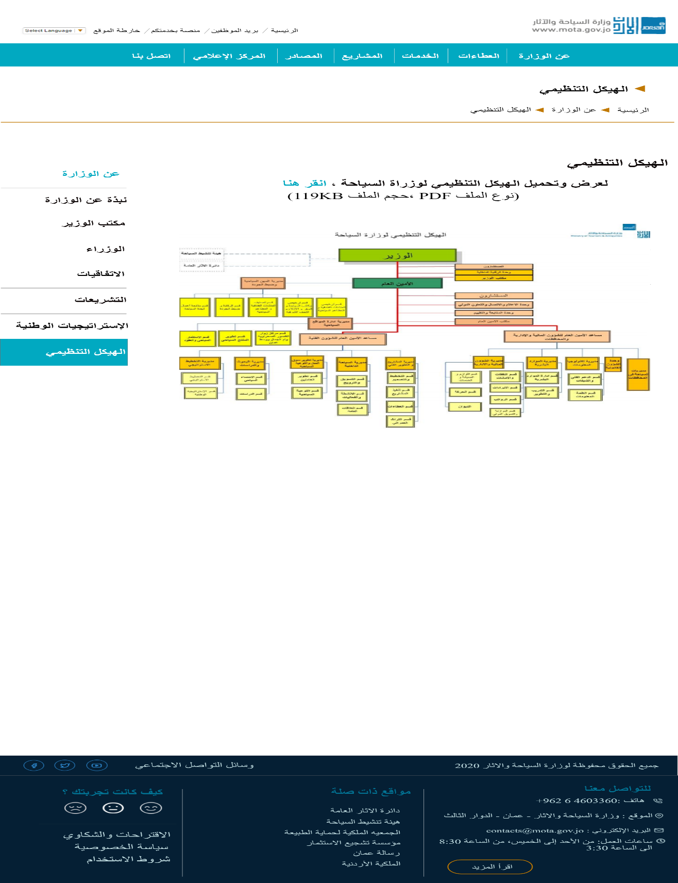Organizational structure page mockup.

Figure :Organizational structure Mockup.

* 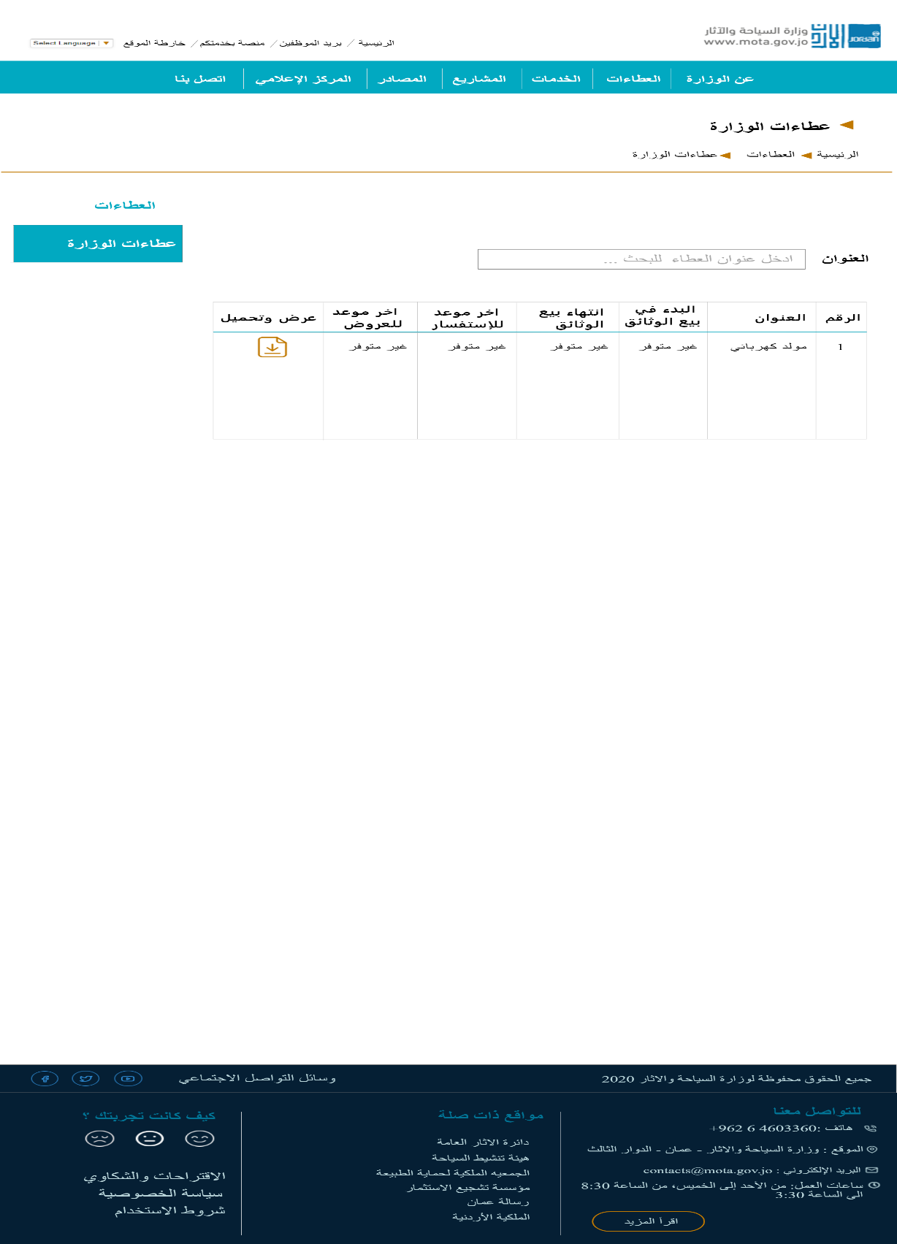Binding page Mockup.

Figure : Binding Mockup.

* 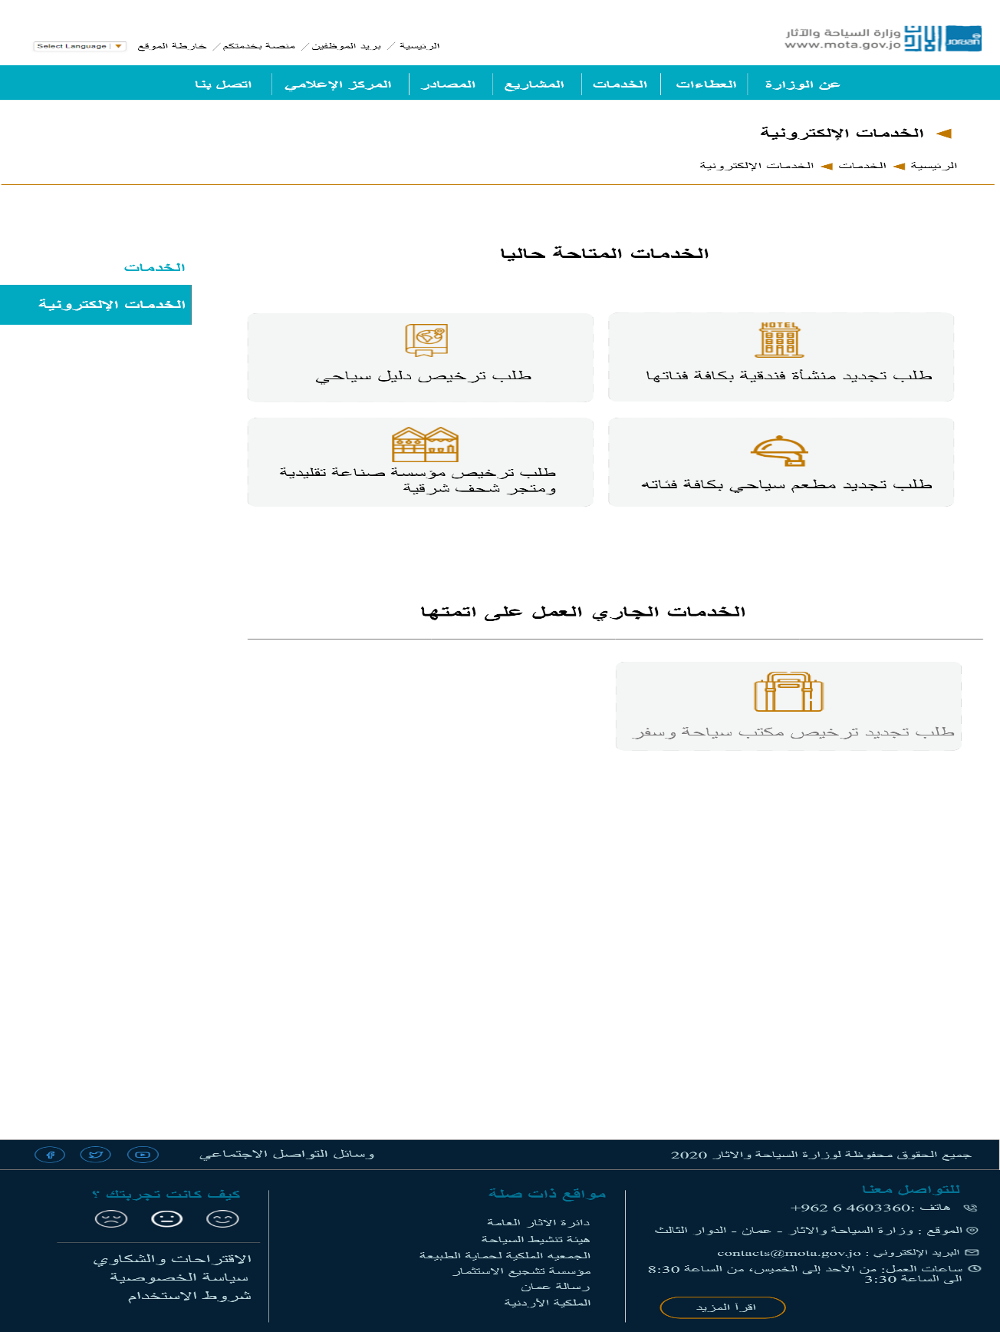E- Services page Mockup.

Figure : E-Services Mockup.

* 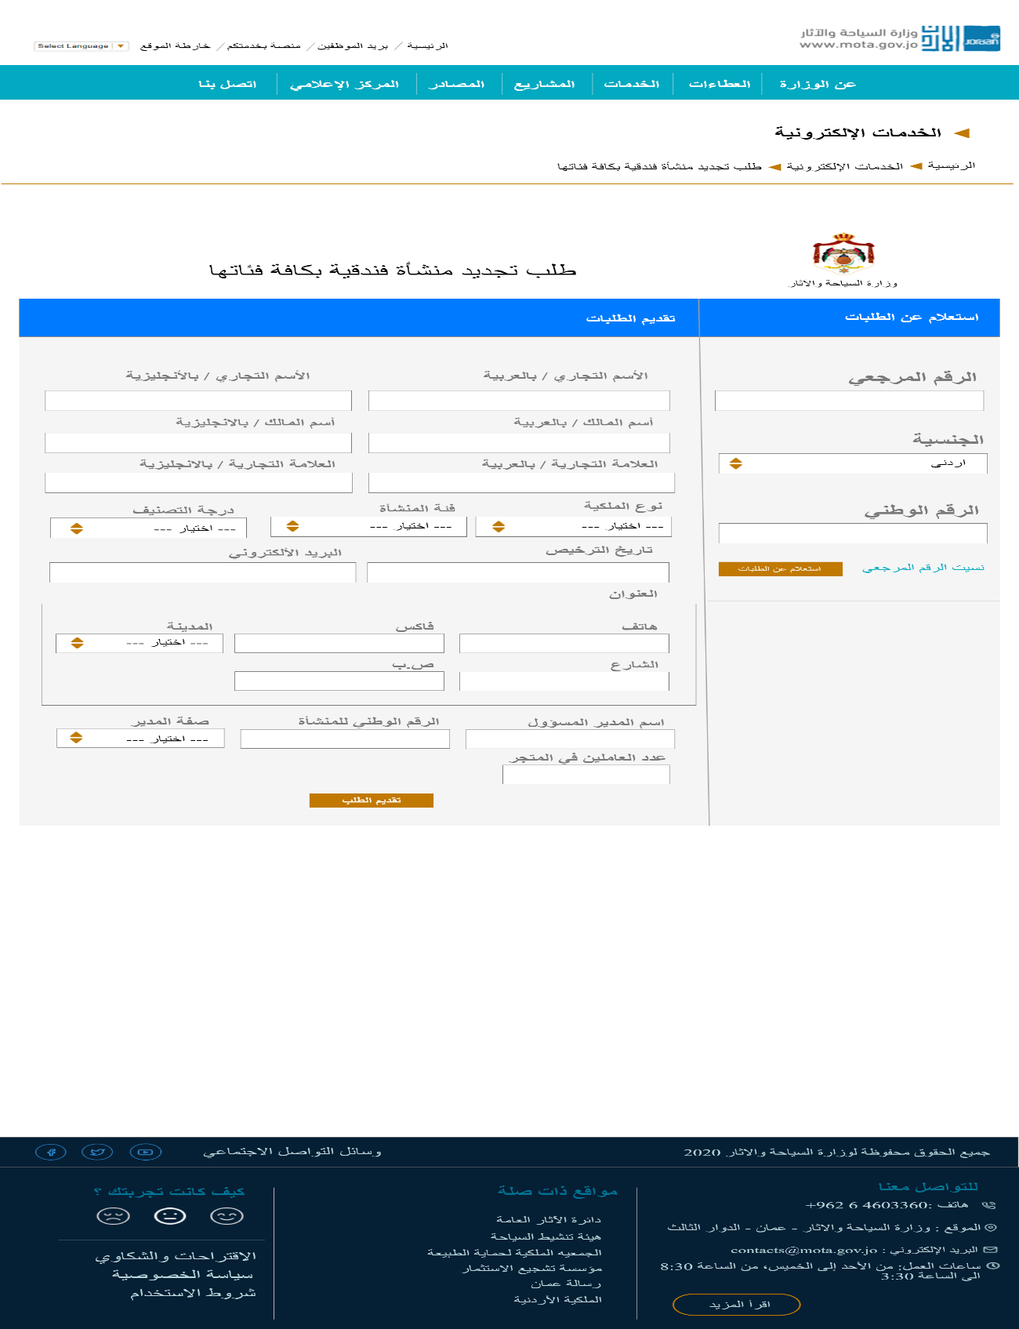Service 1: Request to renew a hotel establishment of all categories page Mockup.

Figure : Service 1: Hotel Service Mockup.

* 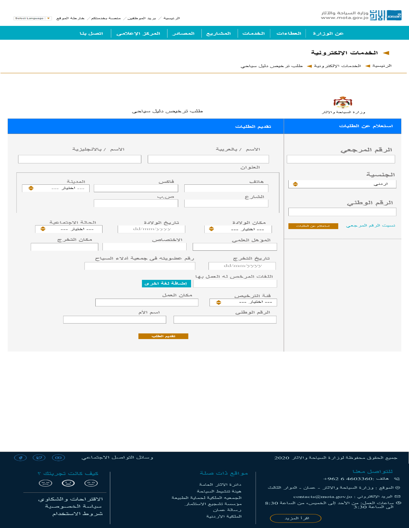Service 2: Tourist guide license requests page Mockup.

Figure : Service 2: Tourist Guide service Mockup.

* 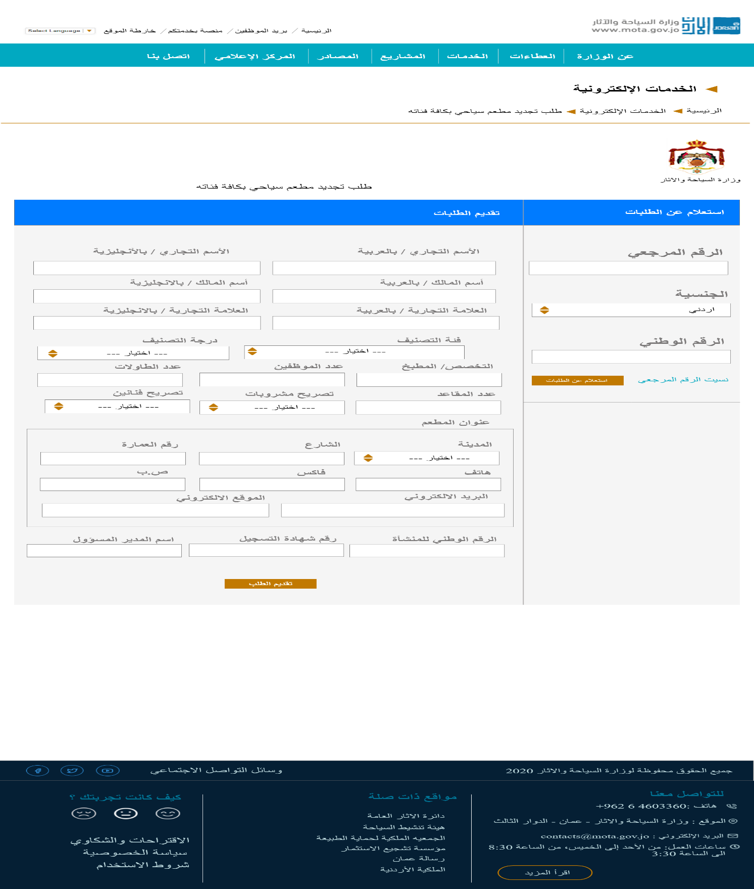Service:3 Request to renew a tourist restaurant of all categories page Mockup.

Figure : Service 3: Tourist restaurant Mockup.

* 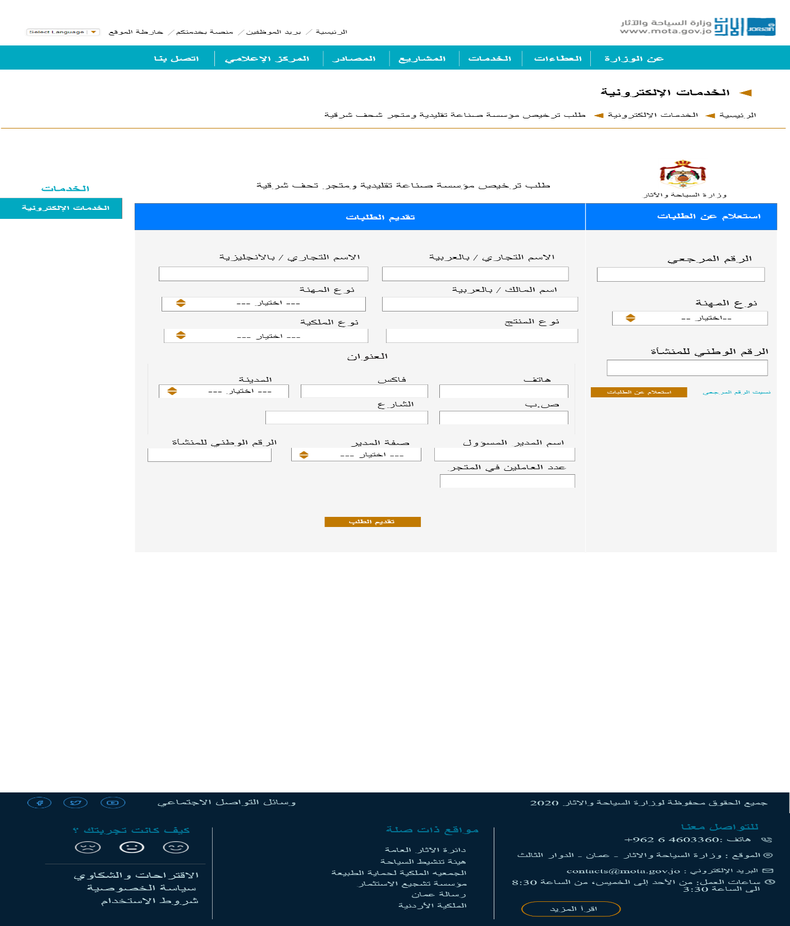Service 4: Applying for licensing a traditional industry establishment and an oriental antique store page Mockup.

Figure : Service 4: Traditional industry establishment Mockup

* 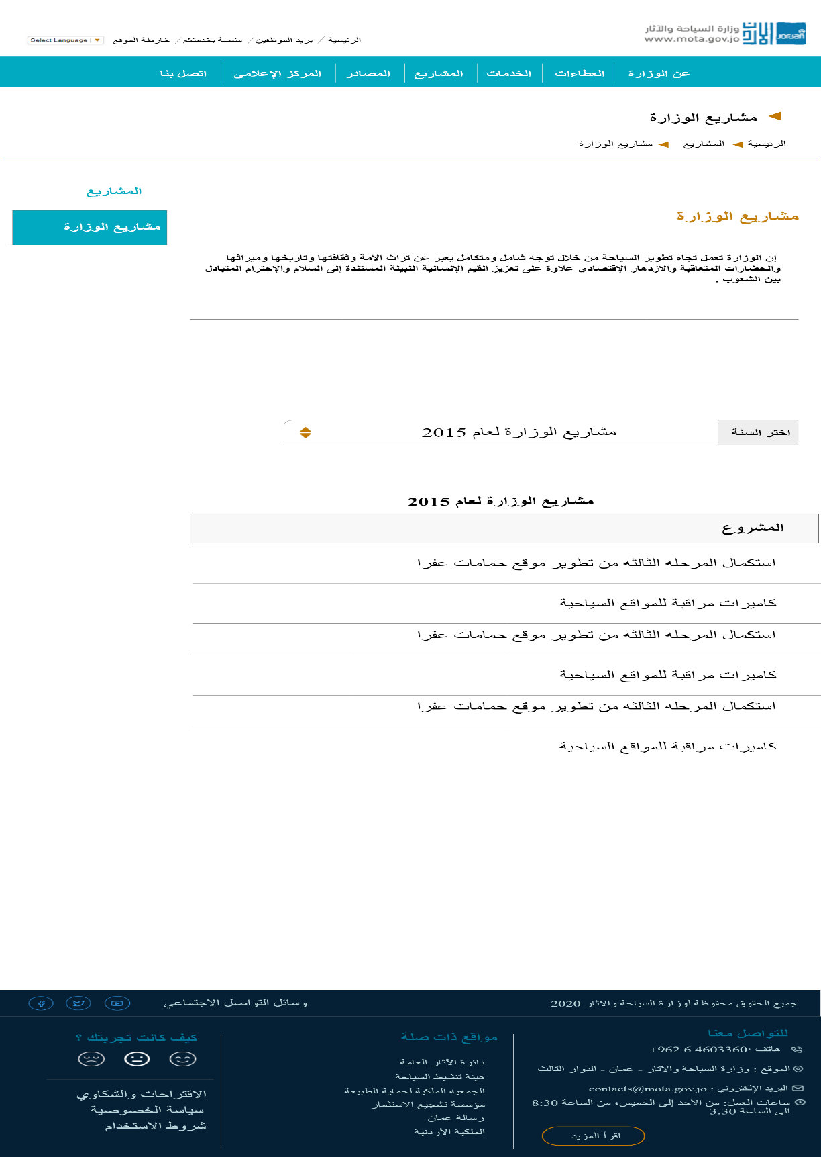Ministry’s projects page Mockup.

Figure : Ministry’s projects Mockup.

* 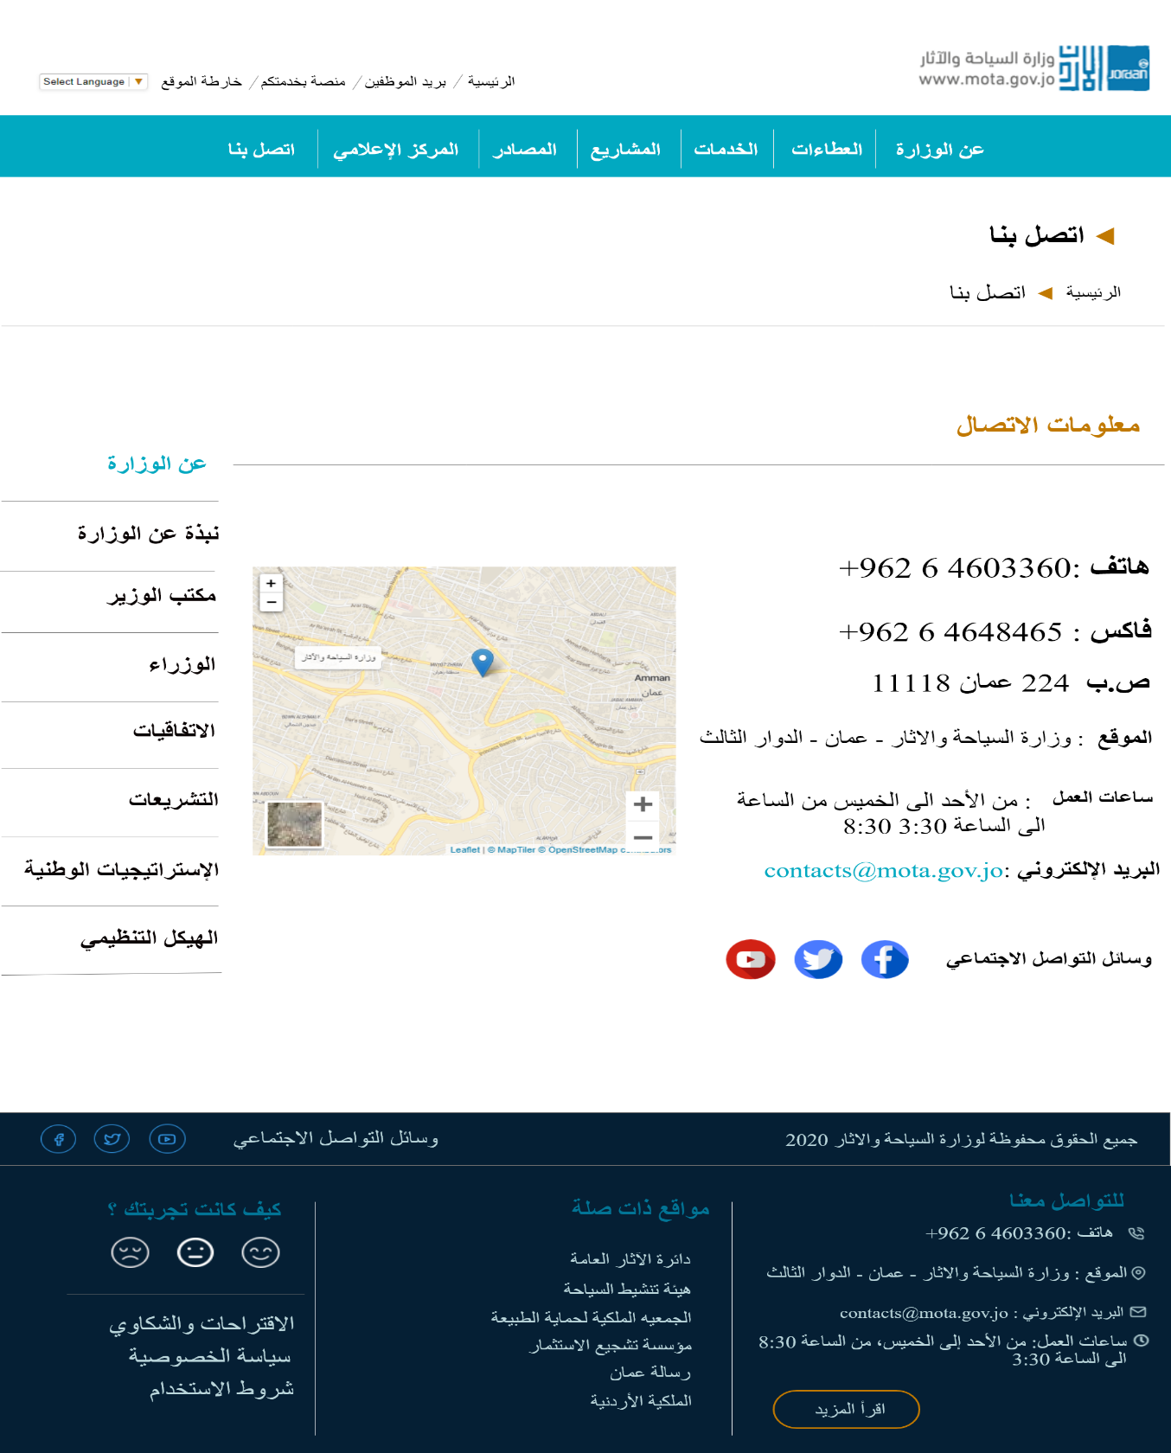Contact us page Mockup.

Figure : Contact us Mockup

* 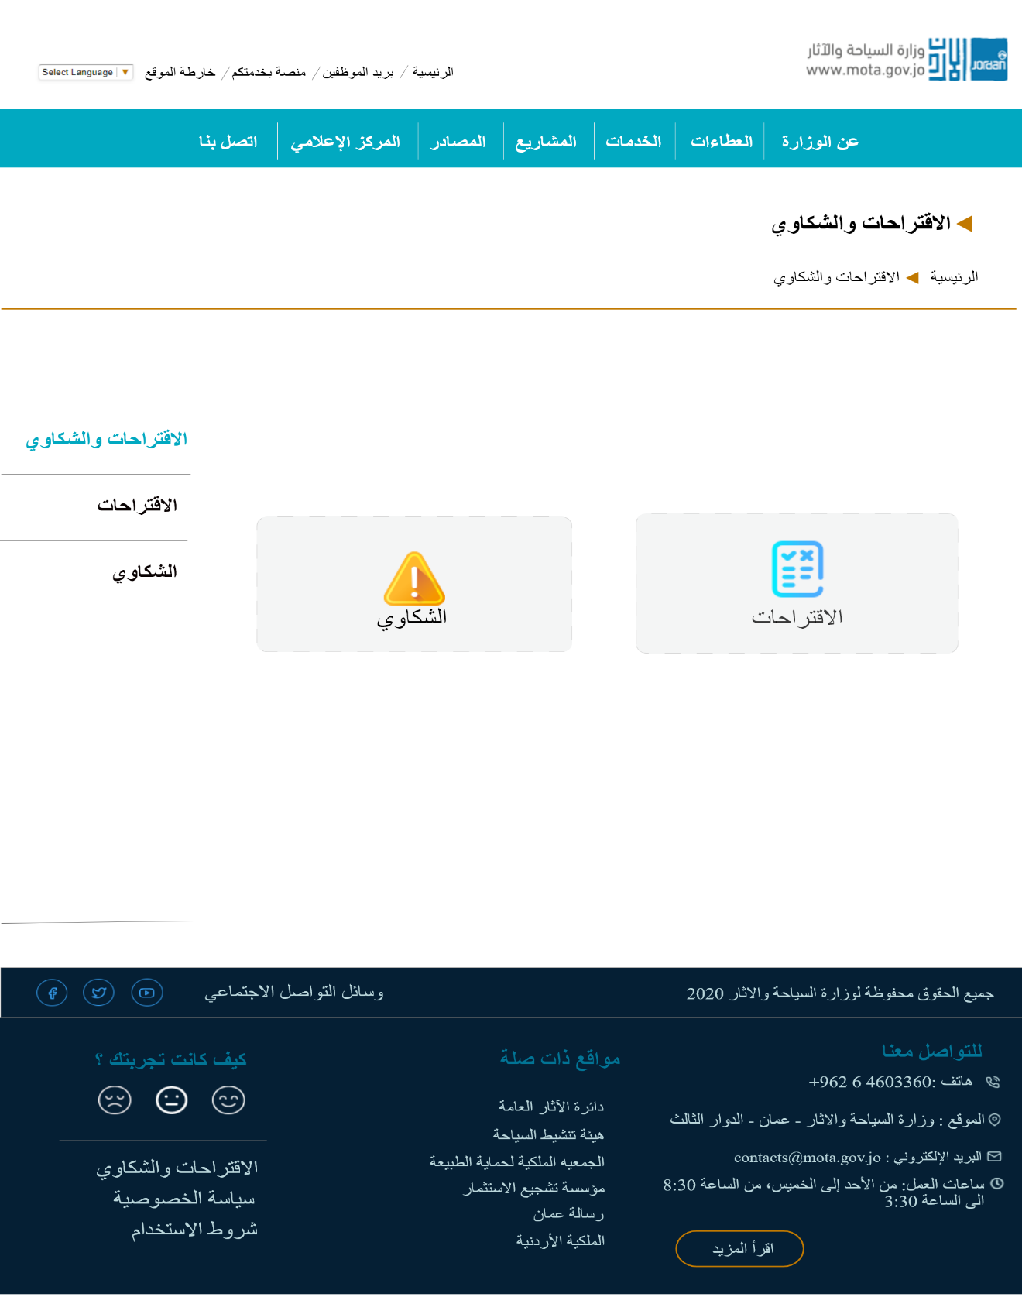Suggestions and Complaints page Mockup.

Figure : Suggestions and Complaints Mockup.

* 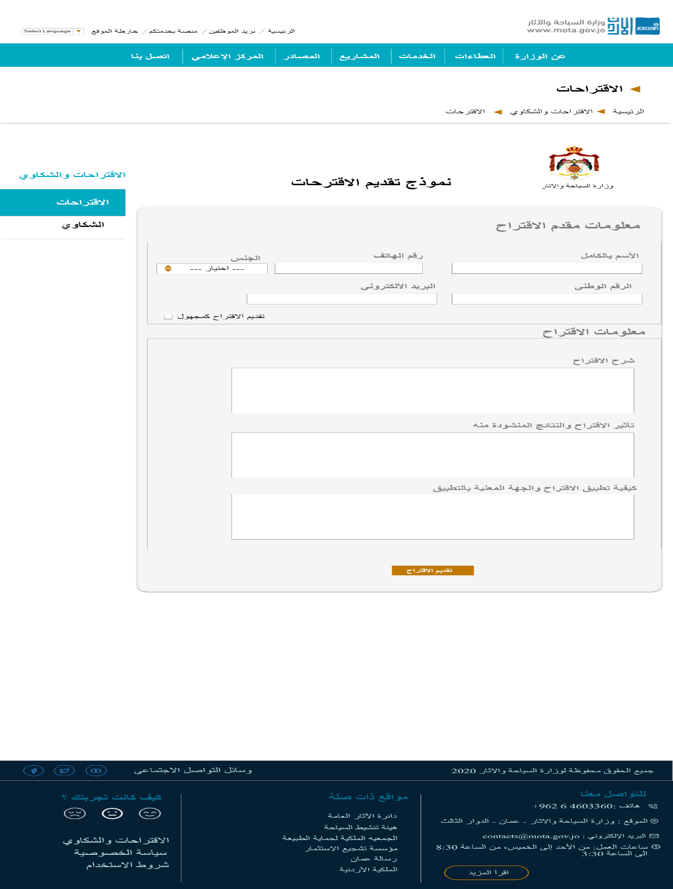 Suggestions page Mockup.

Figure : Suggestions Mockup.

* 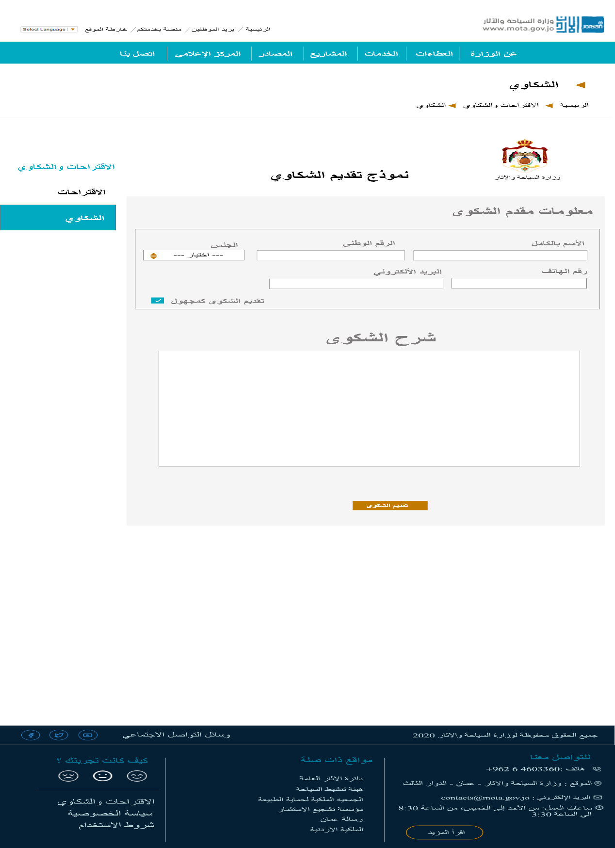 Complaints page Mockup.

Figure : Complaints Mockup.

### ERD

**ERD:** An entity relationship diagram (ERD) shows the relationships of entity sets stored in a database.

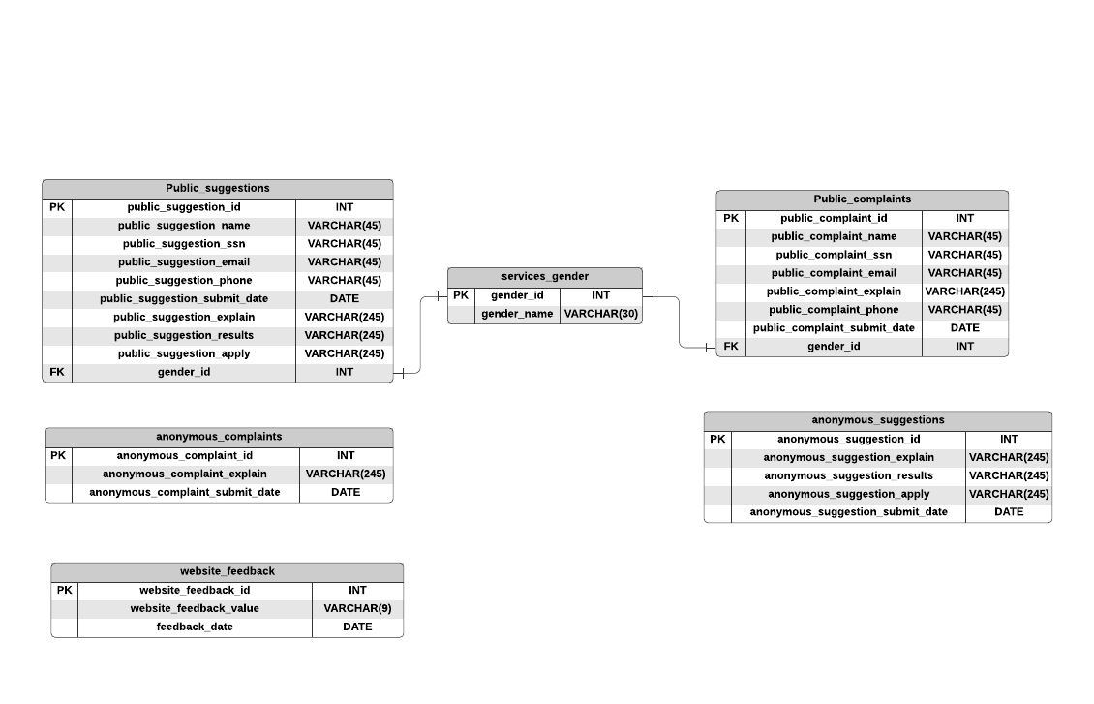

Figure : ERD for Suggestions and Complaints

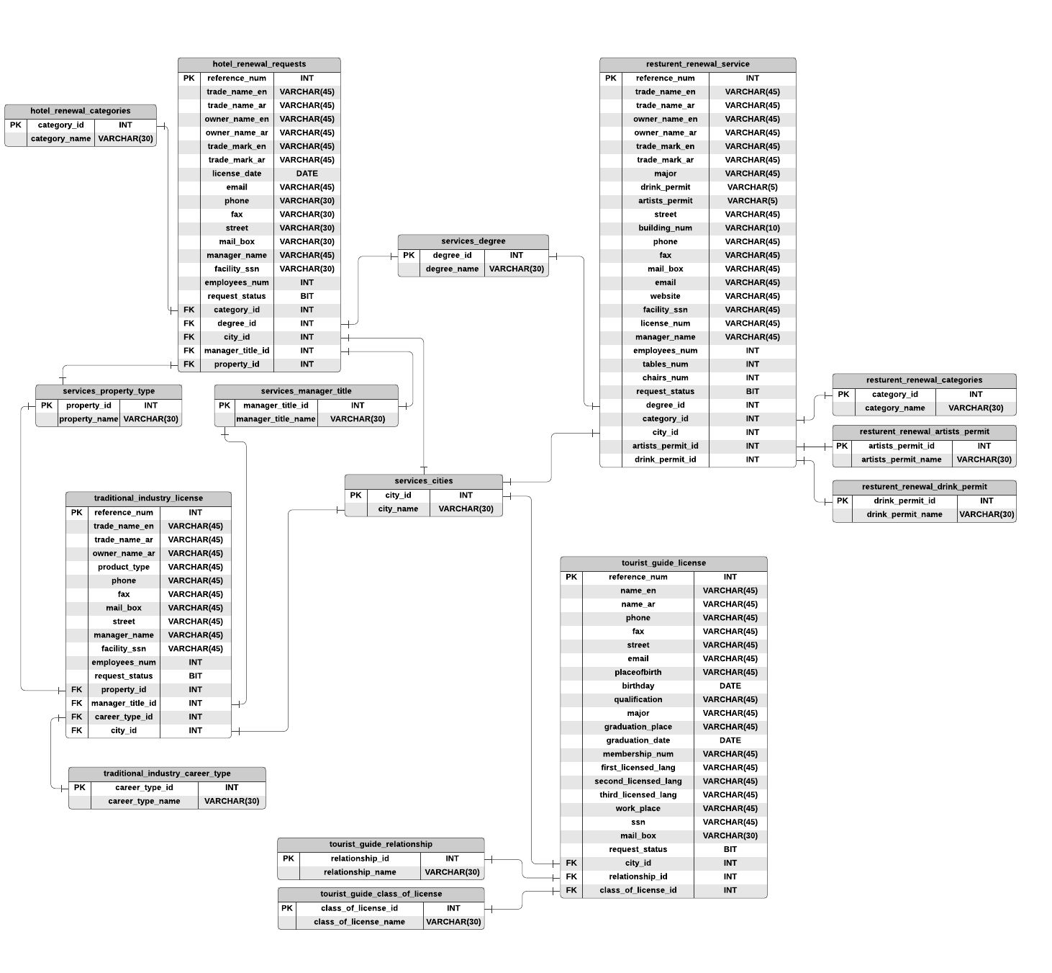

Figure : ERD for E-Services

## Development

### Backend Desc

This website allows tourist restaurants, hotels, traditional industry owners, and a tourist guide to submit a renewal or a license request electronically by visiting the E-service page, choosing the appropriate service, and filling all the required information on the submit request form. (E.g., owner's name, property type, license date, E-mail, city, phone, etc.) and then they can submit their requests by clicking on the submit button. After that,

All the data will be sent to the database using PHP and MySQL. If all the data sent successfully the user will notify with a success alert box contains essential information to check the request status of the transaction. Such as reference number and SSN.

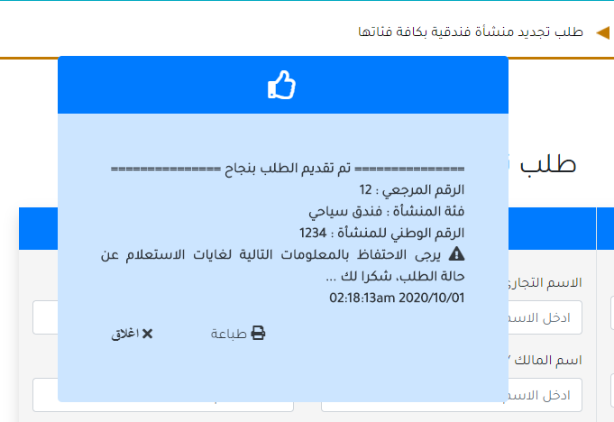

Figure : Success alert box for services

To review the request status, users must fill the required data on the inquiry form and click the submit button. The system will check if the data exists in the database and the request status. In case the transaction is ready, the system will inform the user of that and vice versa.

On the other hand, users can send complaints and suggestions by visiting the suggestions and complaints page, choosing the appropriate option, and filling in all the required information such as the name, gender, and the ID number. The user can choose to submit the complaint or suggestion anonymously. Thus, personal information is not required. After that, the user can write an explanation for its complaint/suggestion on the text area box and then click the submit button to send the form. The system will send all the information to the database and inform the user that the transaction done successfully.

Moreover, the user can send a website feedback about their experience by clicking the right button in the footer of the page. The system will perform an ajax function to call a PHP page, and then the user feedback will send to the database. The system will alert the user with a success message.

### Test Cases

Figure : Test Cases

* 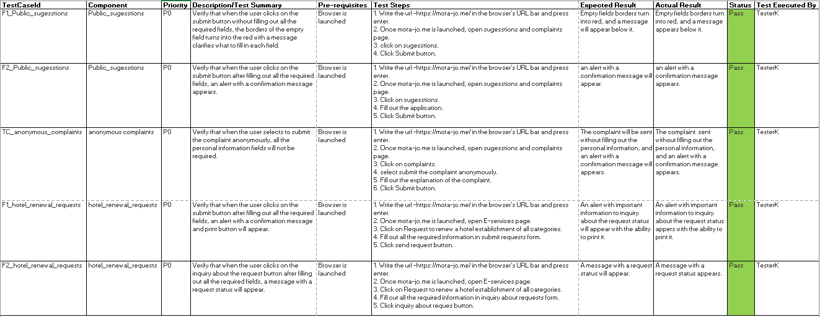 **Test Case**: In software engineering, a test case is a specification of the inputs, execution conditions, testing procedure, and expected results that define a single test to be executed to achieve a particular software testing objective.

## Deployment

### Domain

The Domain name used for this project is: <http://mota-jo.me> and it was obtained from [Namecheap](https://www.namecheap.com/).

* **Namecheap:** is an ICANN-accredited domain name registrar, which provides domain name registration and web hosting, based in Phoenix, Arizona, US. Namecheap is a budget hosting provider with 11 million registered users and 10 million domains.

Figure : Namecheap Logo

### Hosting

The Hosting used for this project is from **000webhost.**

* **000webhost:** Free Web Hosting with PHP, MySQL, cPanel.

Figure : 000Webhost logo

# Screenshots

This section contains screenshots for the actual work from the website.

* 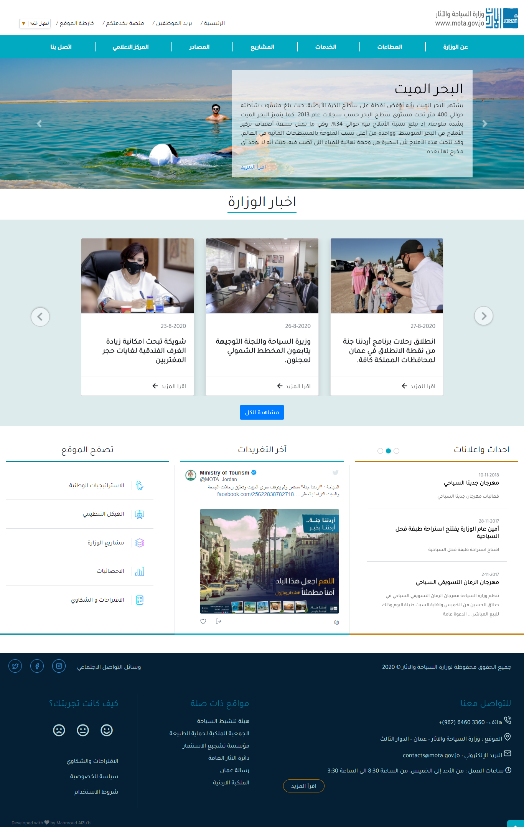Homepage.

Figure : Screenshot for Homepage from the website.

* About the Ministry page.

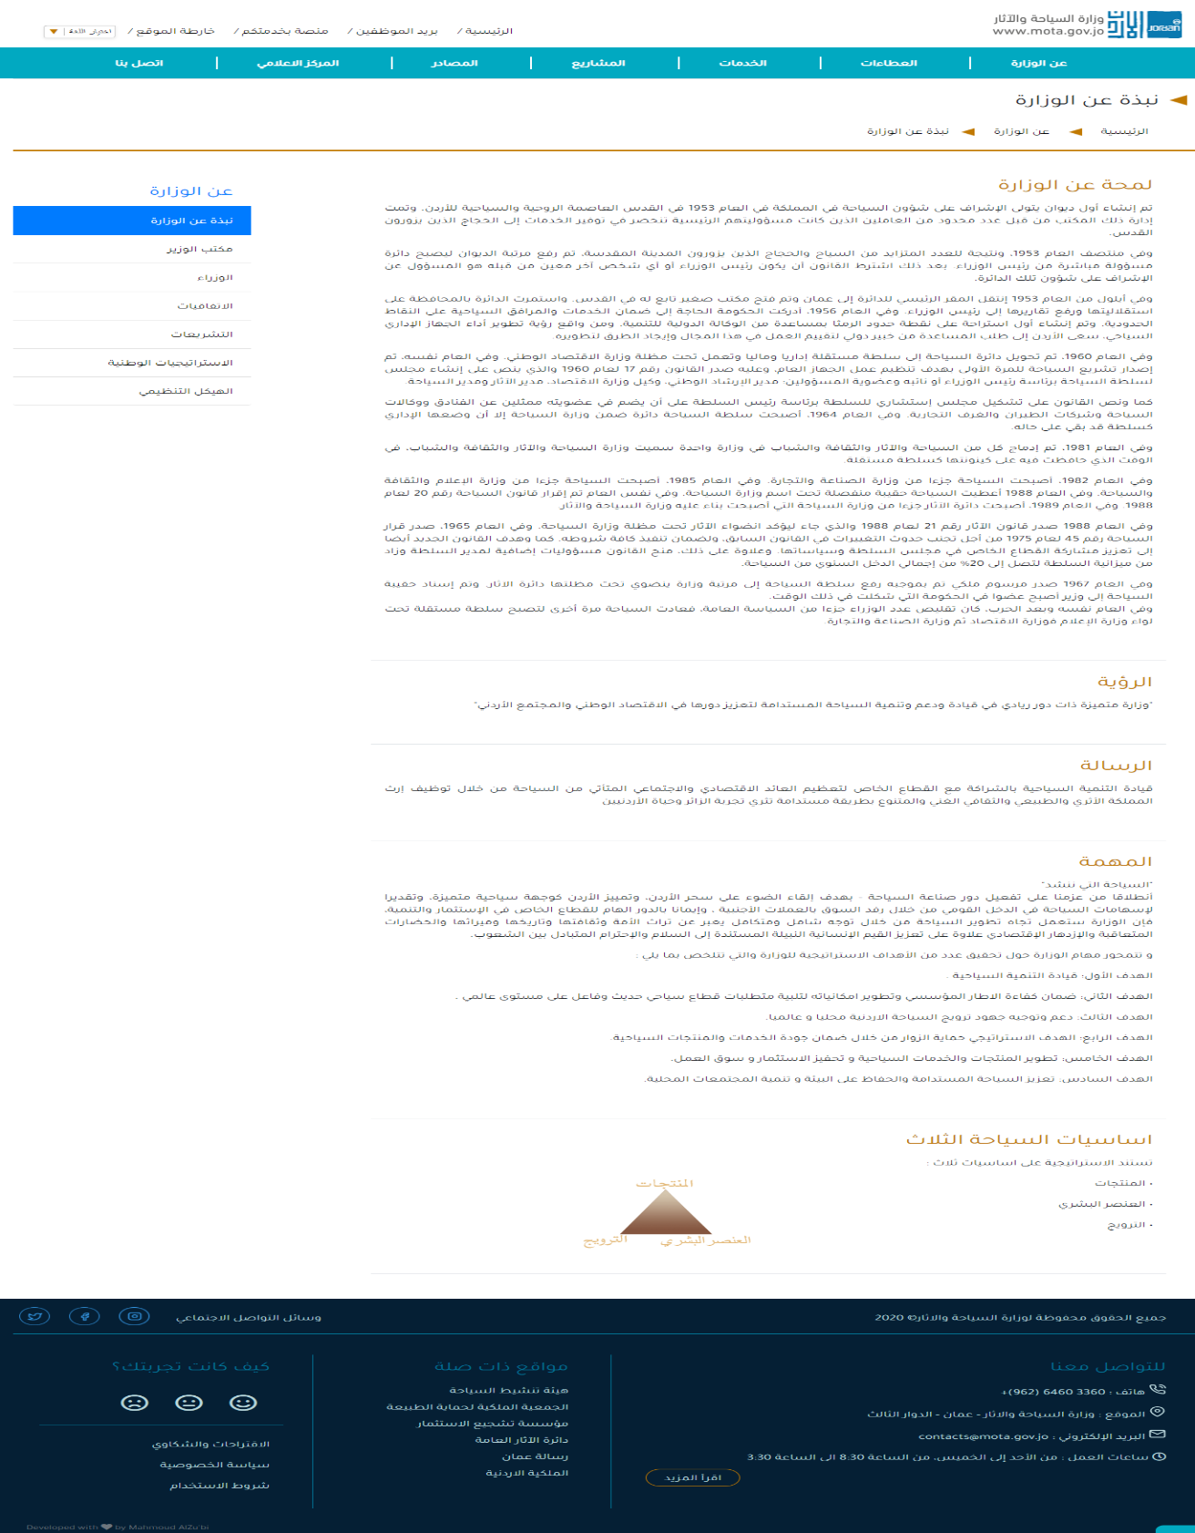

Figure : Screenshot for About the Ministry page from the website.

* 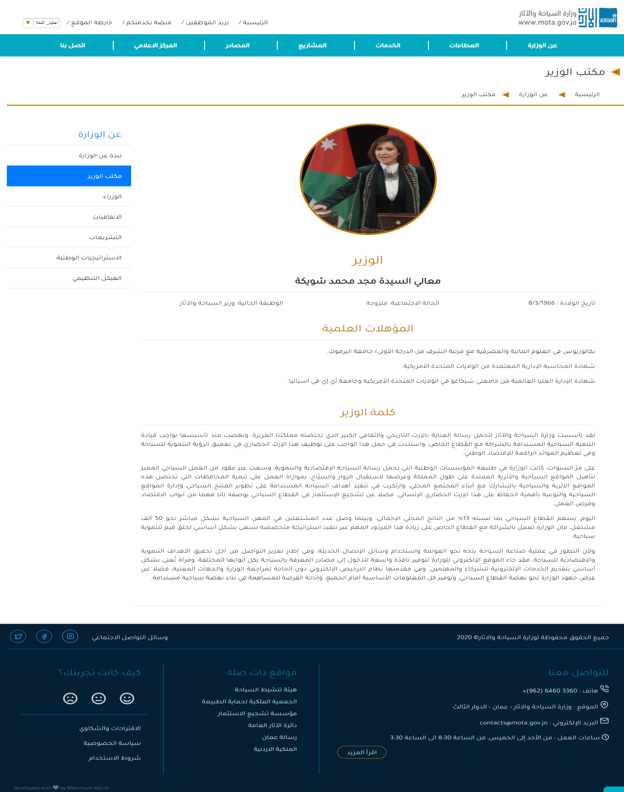Minister's Office page.

Figure : Screenshot for Minister's office page from the website.

* 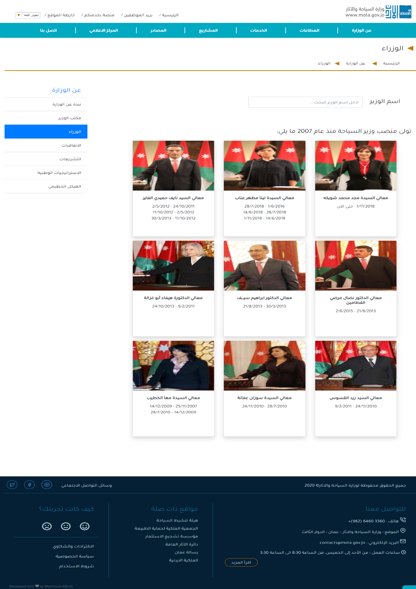Ministers page.

Figure : Screenshot for the Ministers page from the website.

* 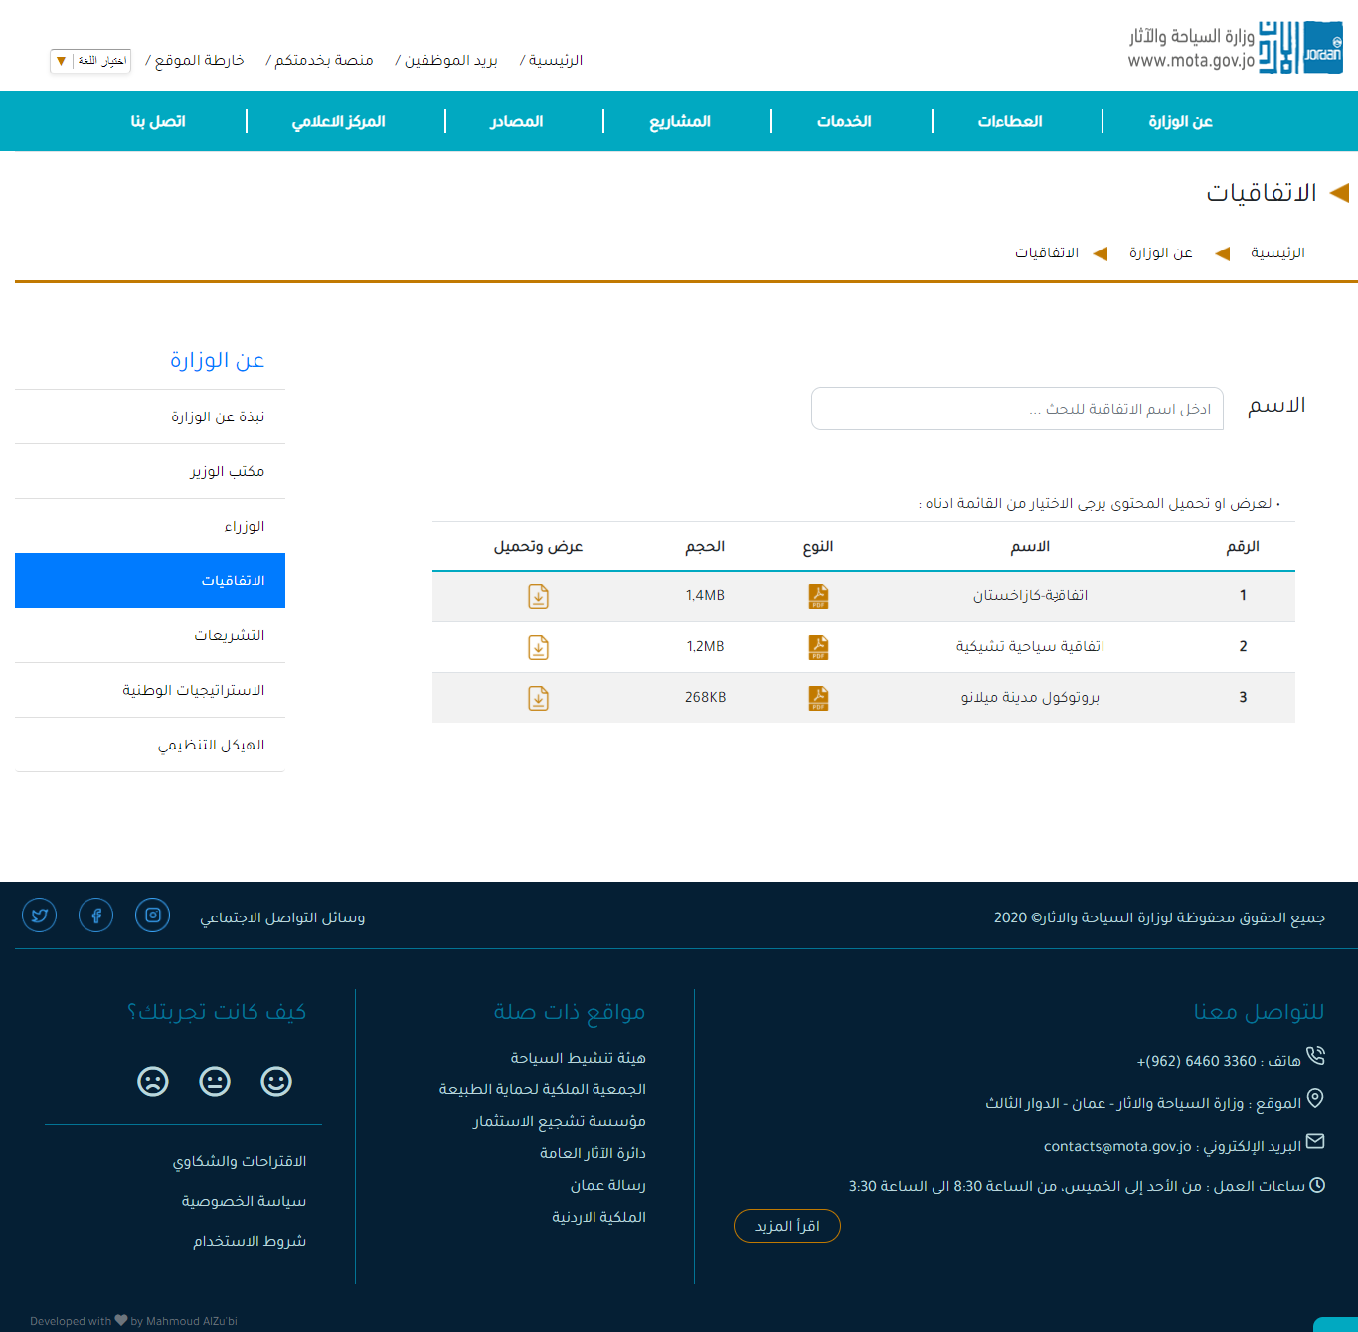Conventions page.

Figure :Screenshot for the Conventions page from the website.

* 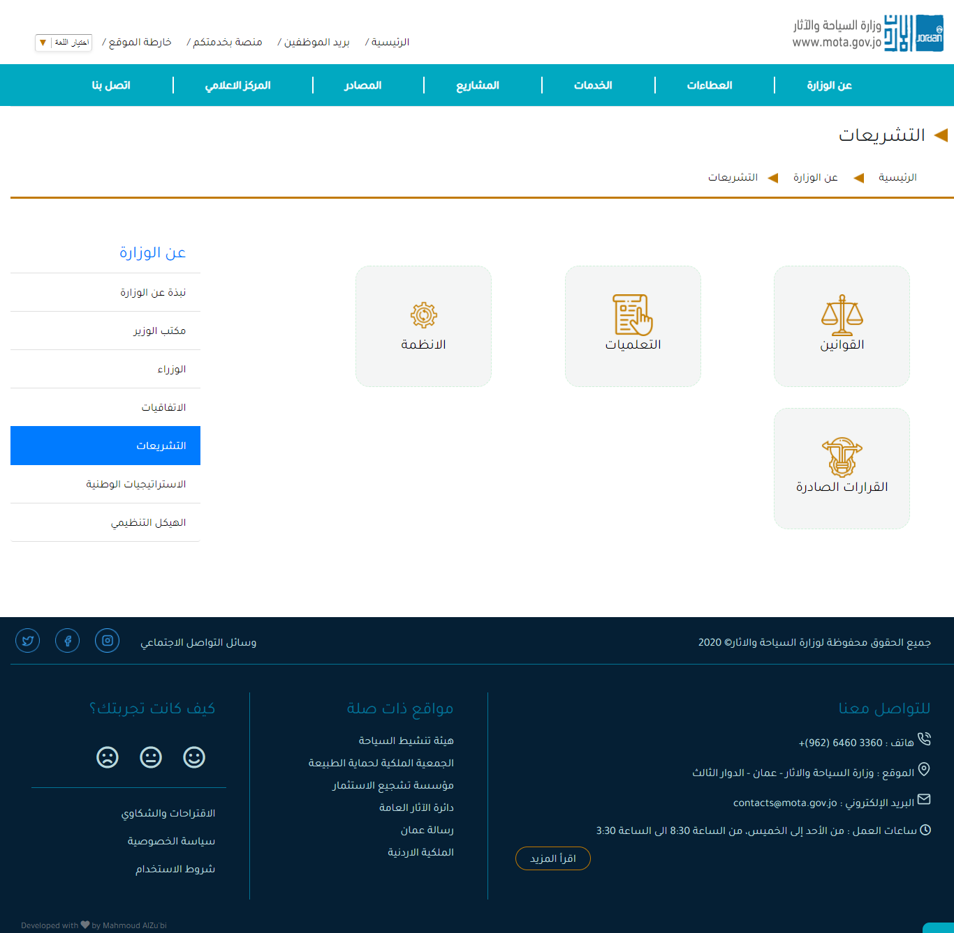Legislations page.

Figure : Screenshot for Legislations page from the website.

* 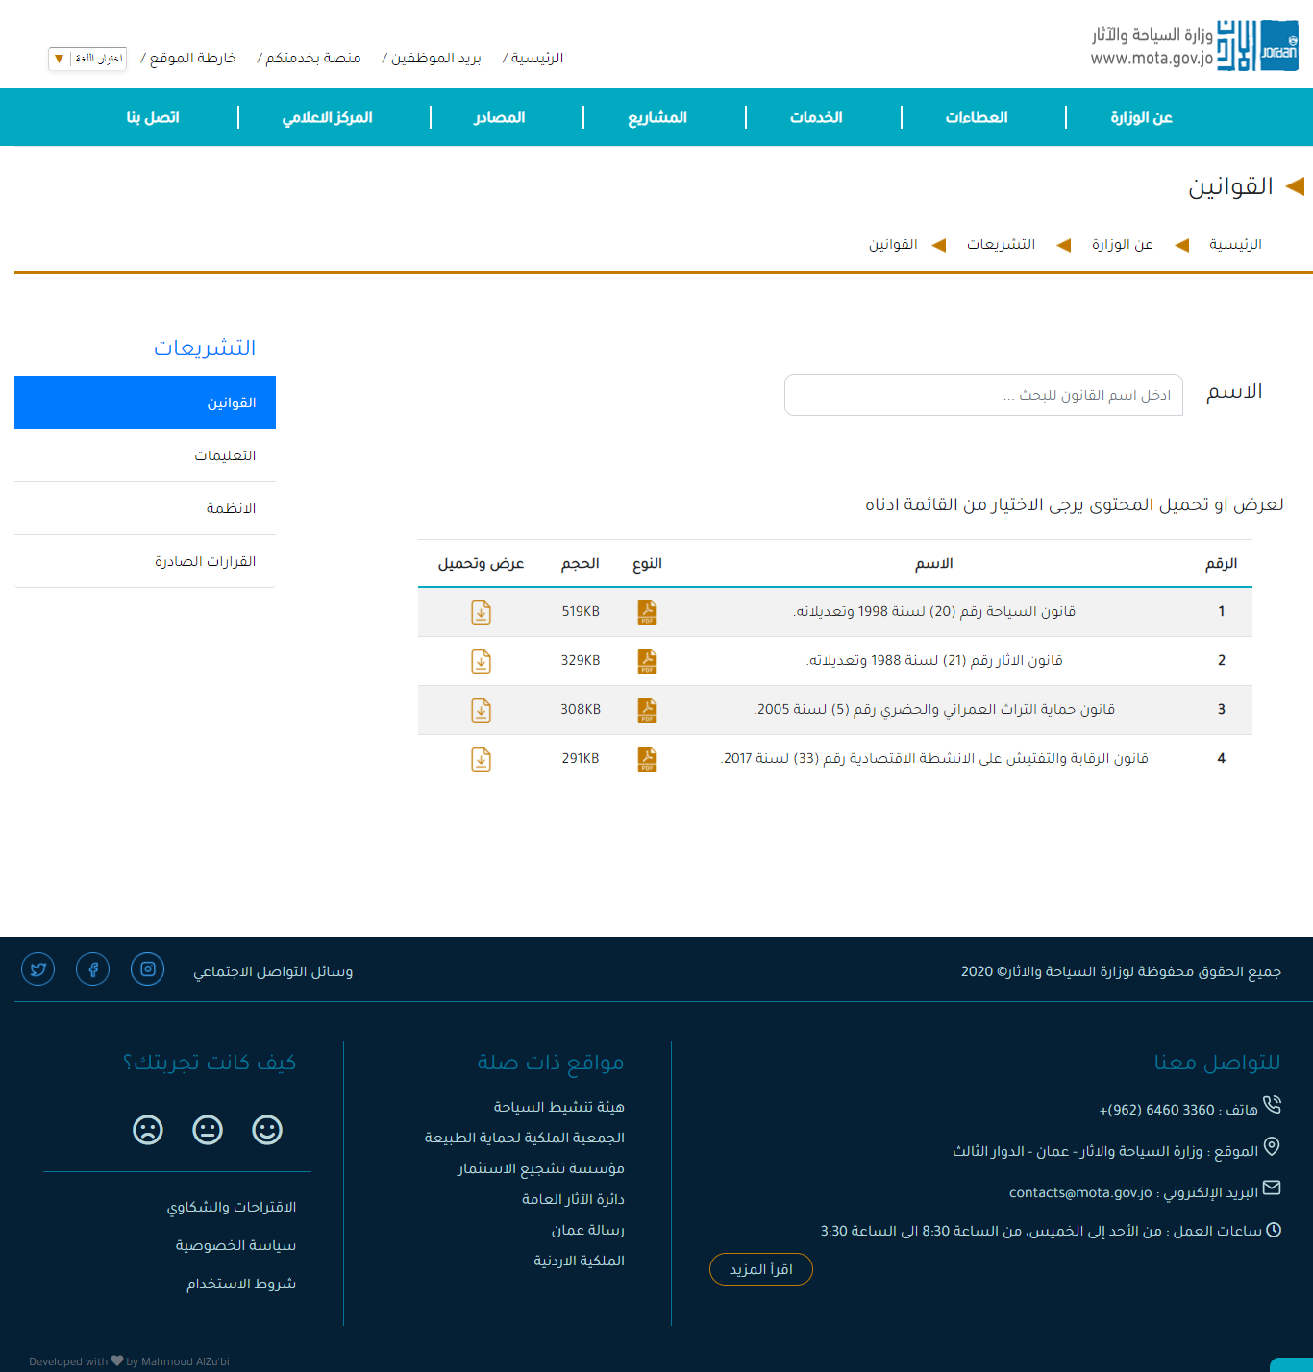Legislations – Laws page.

Figure : Screenshot for laws page from the website.

* 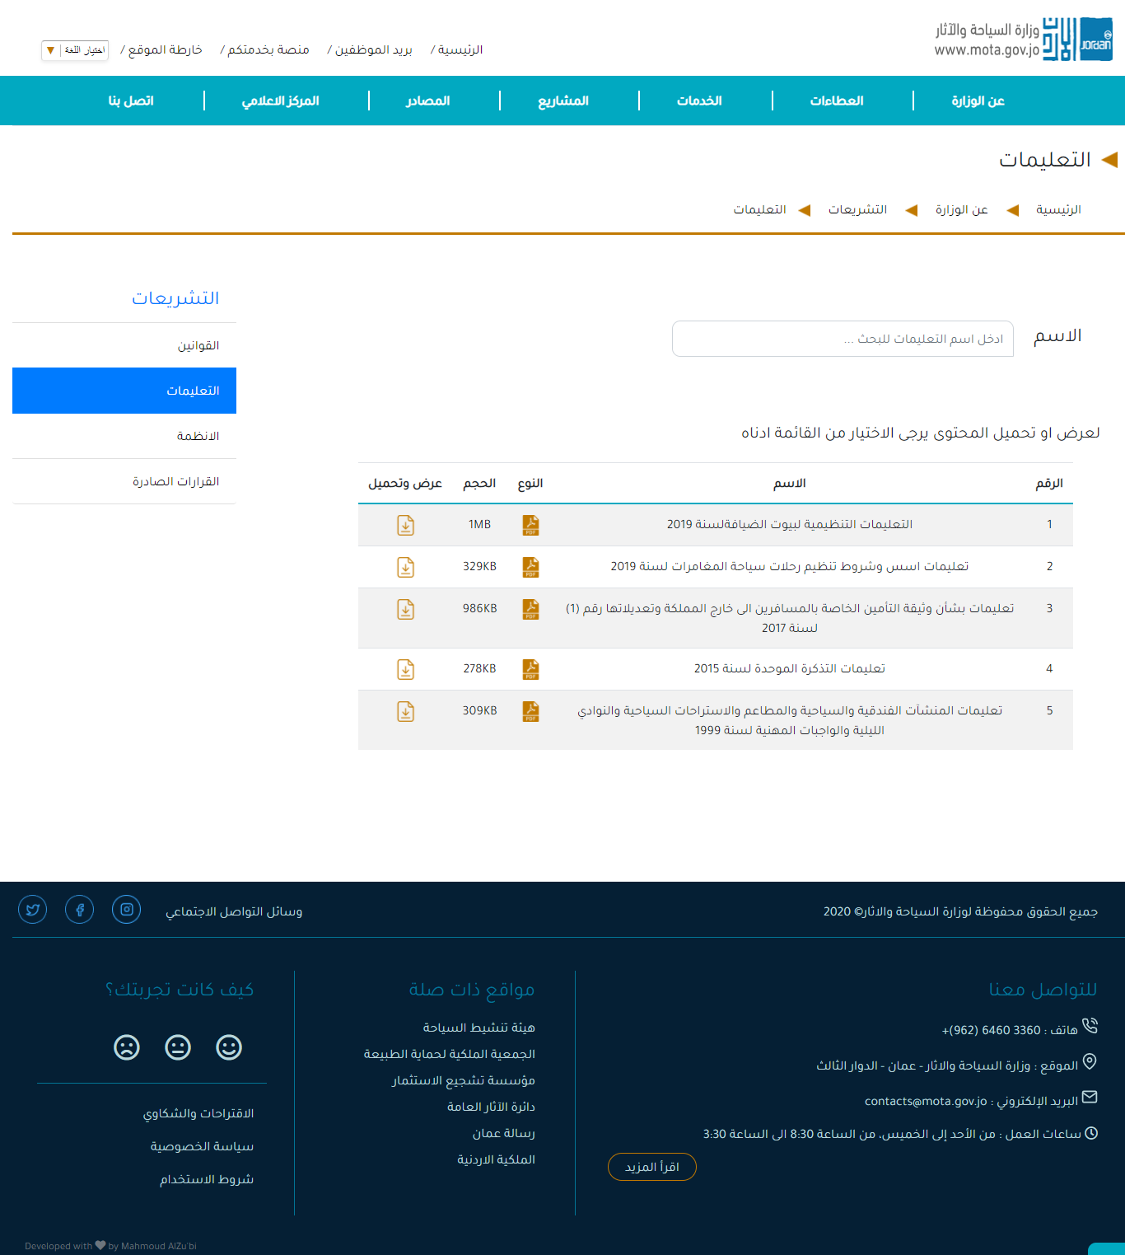Legislations – Instructions page

Figure : Screenshot for instruction page from the website.

* 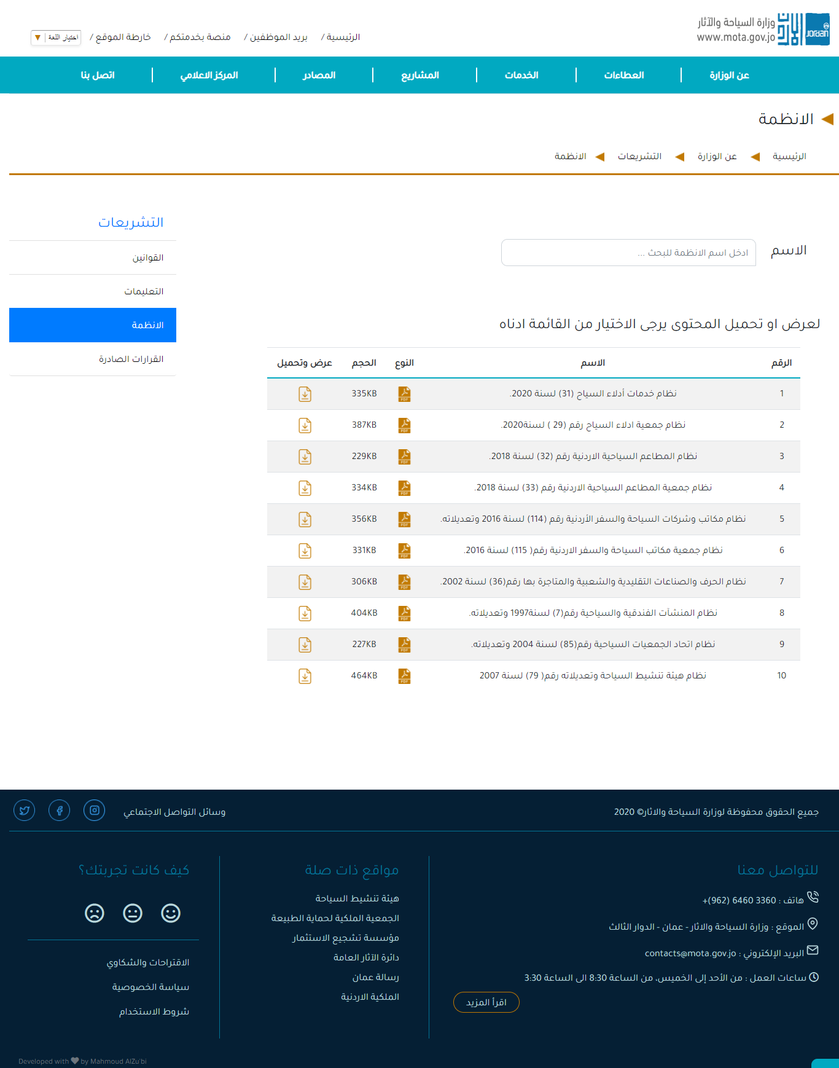Legislations – Systems page.

Figure : Screenshot for Systems page from the website.

* 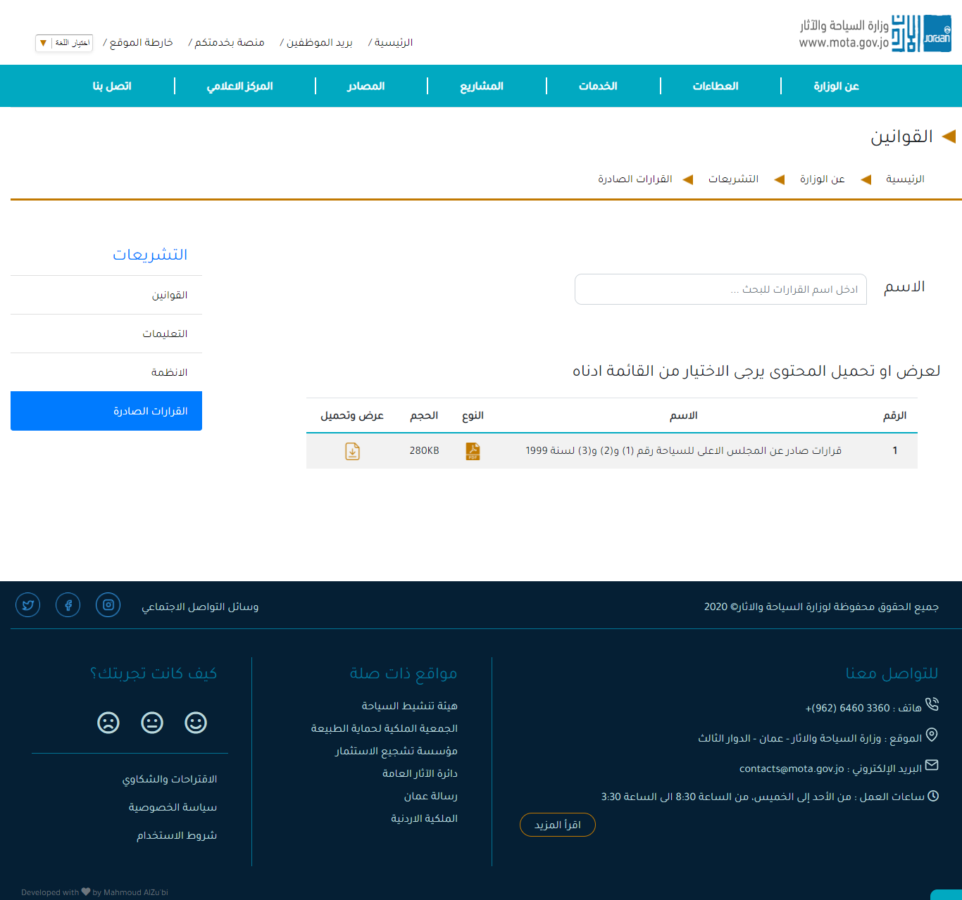Legislations - Decisions made page.

Figure : Screenshot for Decisions made page from the website.

* 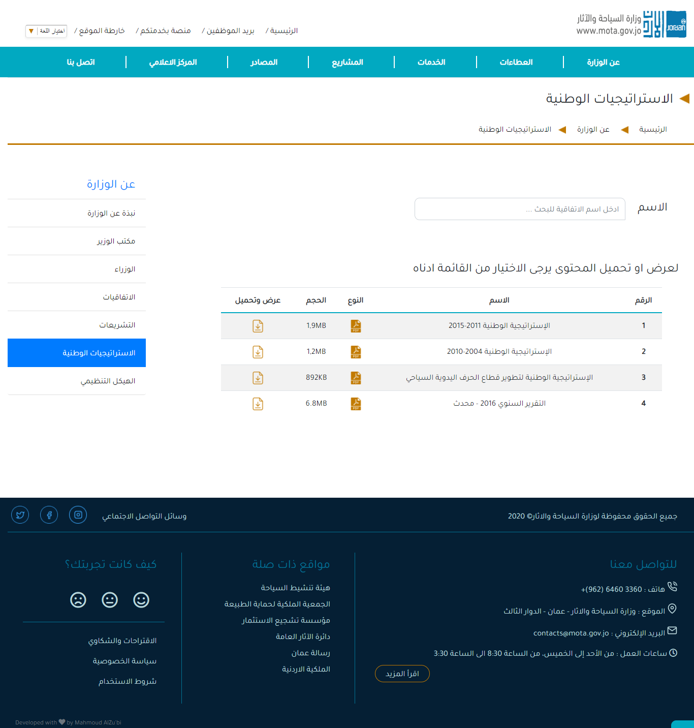National Strategies page.

Figure : Screenshot for National Strategies page from the website.

* 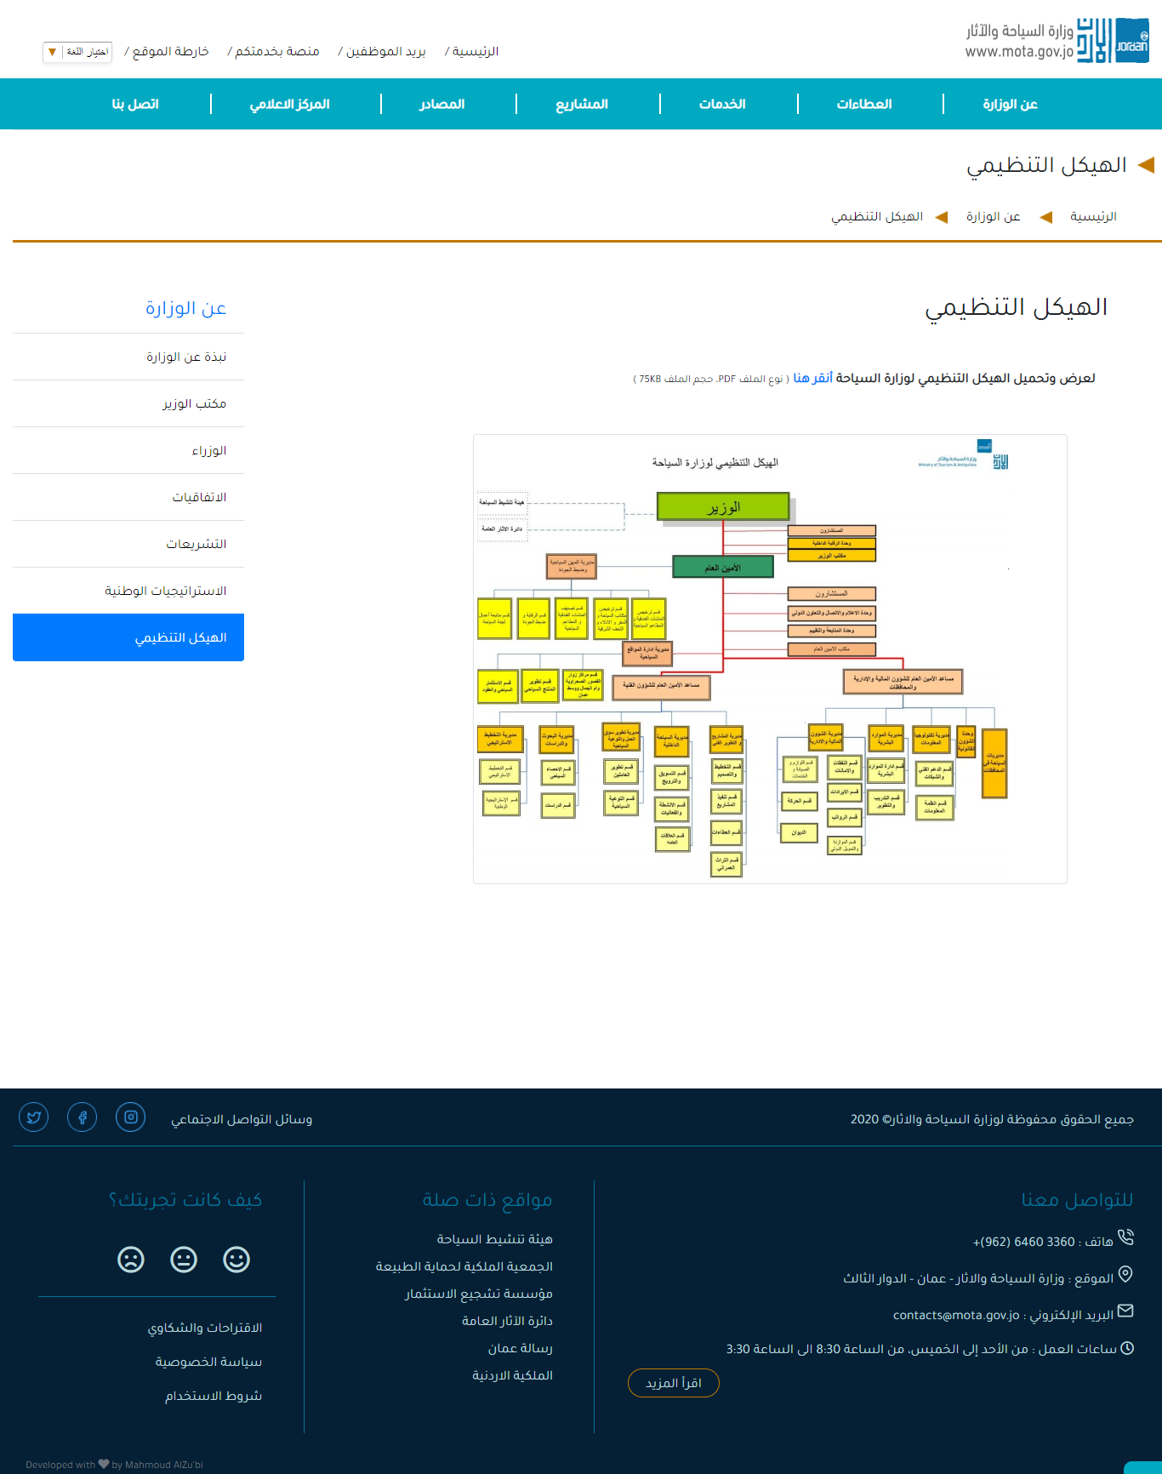Organizational Structure page

Figure : Screenshot for the Organizational Structure page from the website.

* 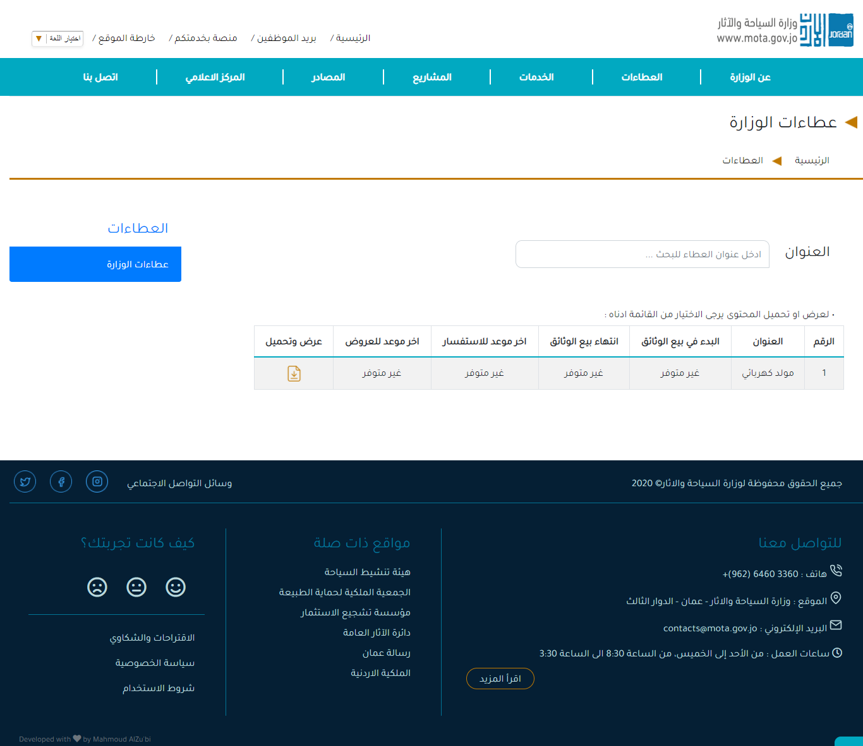Ministry Bids page

Figure : Screenshot for the Ministry Bids from the website.

* 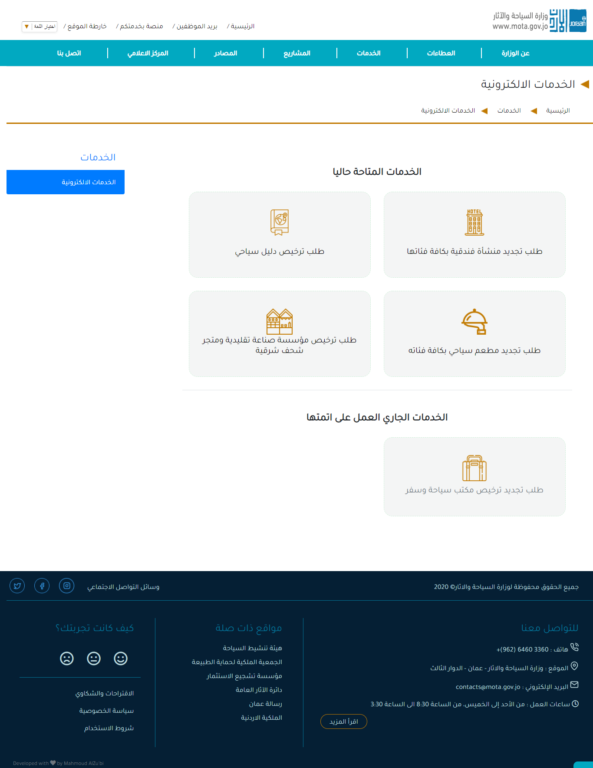E-services page

Figure : Screenshot for the E-Services page from the website.

* Service 1: Request to renew a hotel establishment of all categories page.

Figure : Screenshot for the Hotels service page from the website.

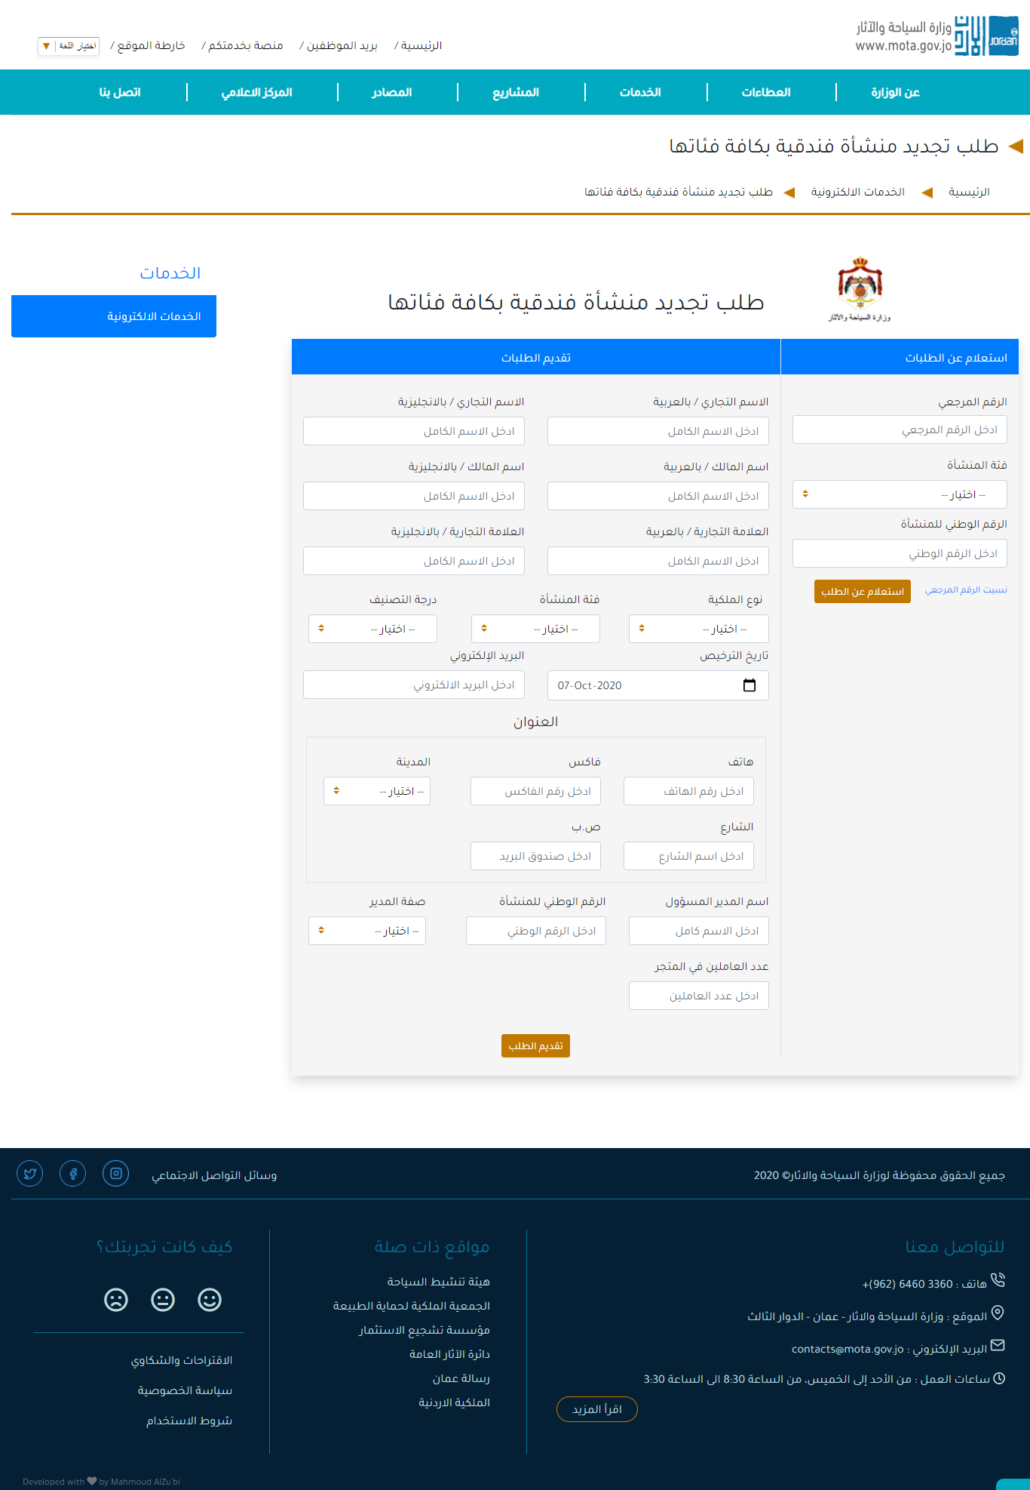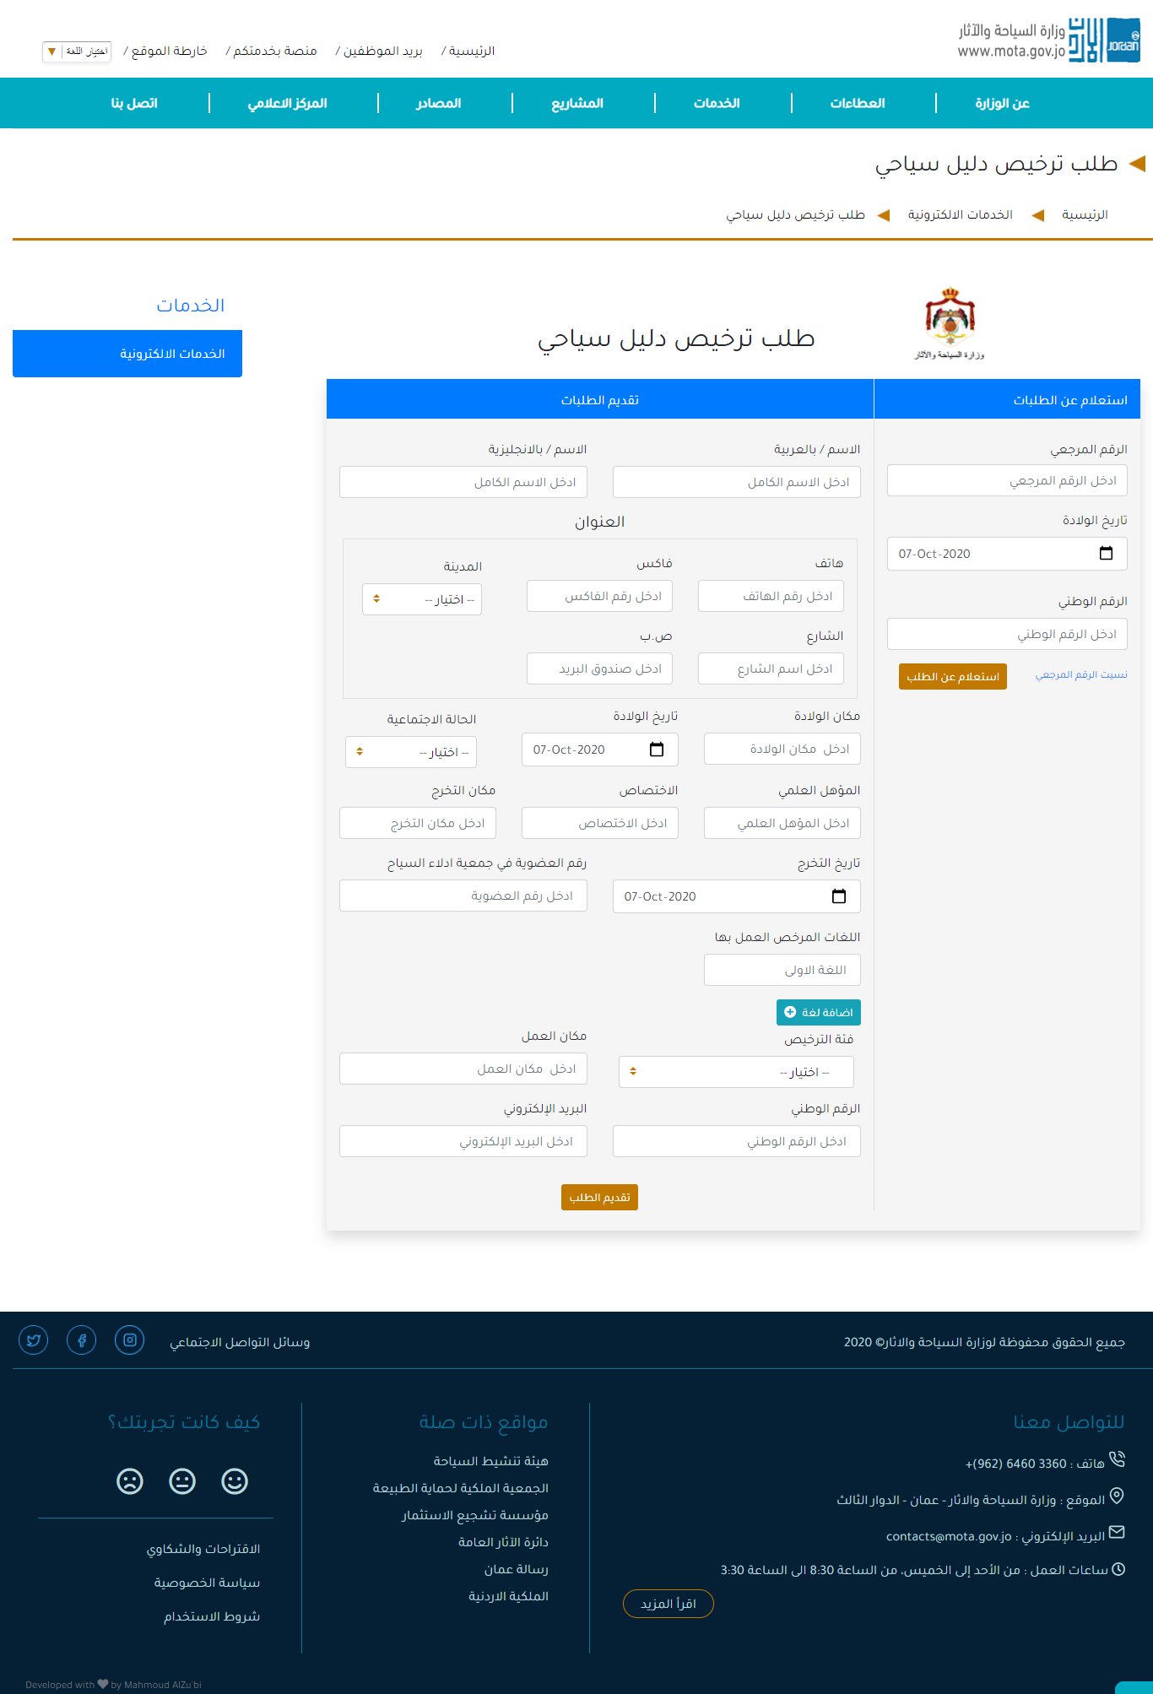Service 2: Tourist guide license requests page.

Figure : Screenshot for the Touris Guide service page from the website.

* 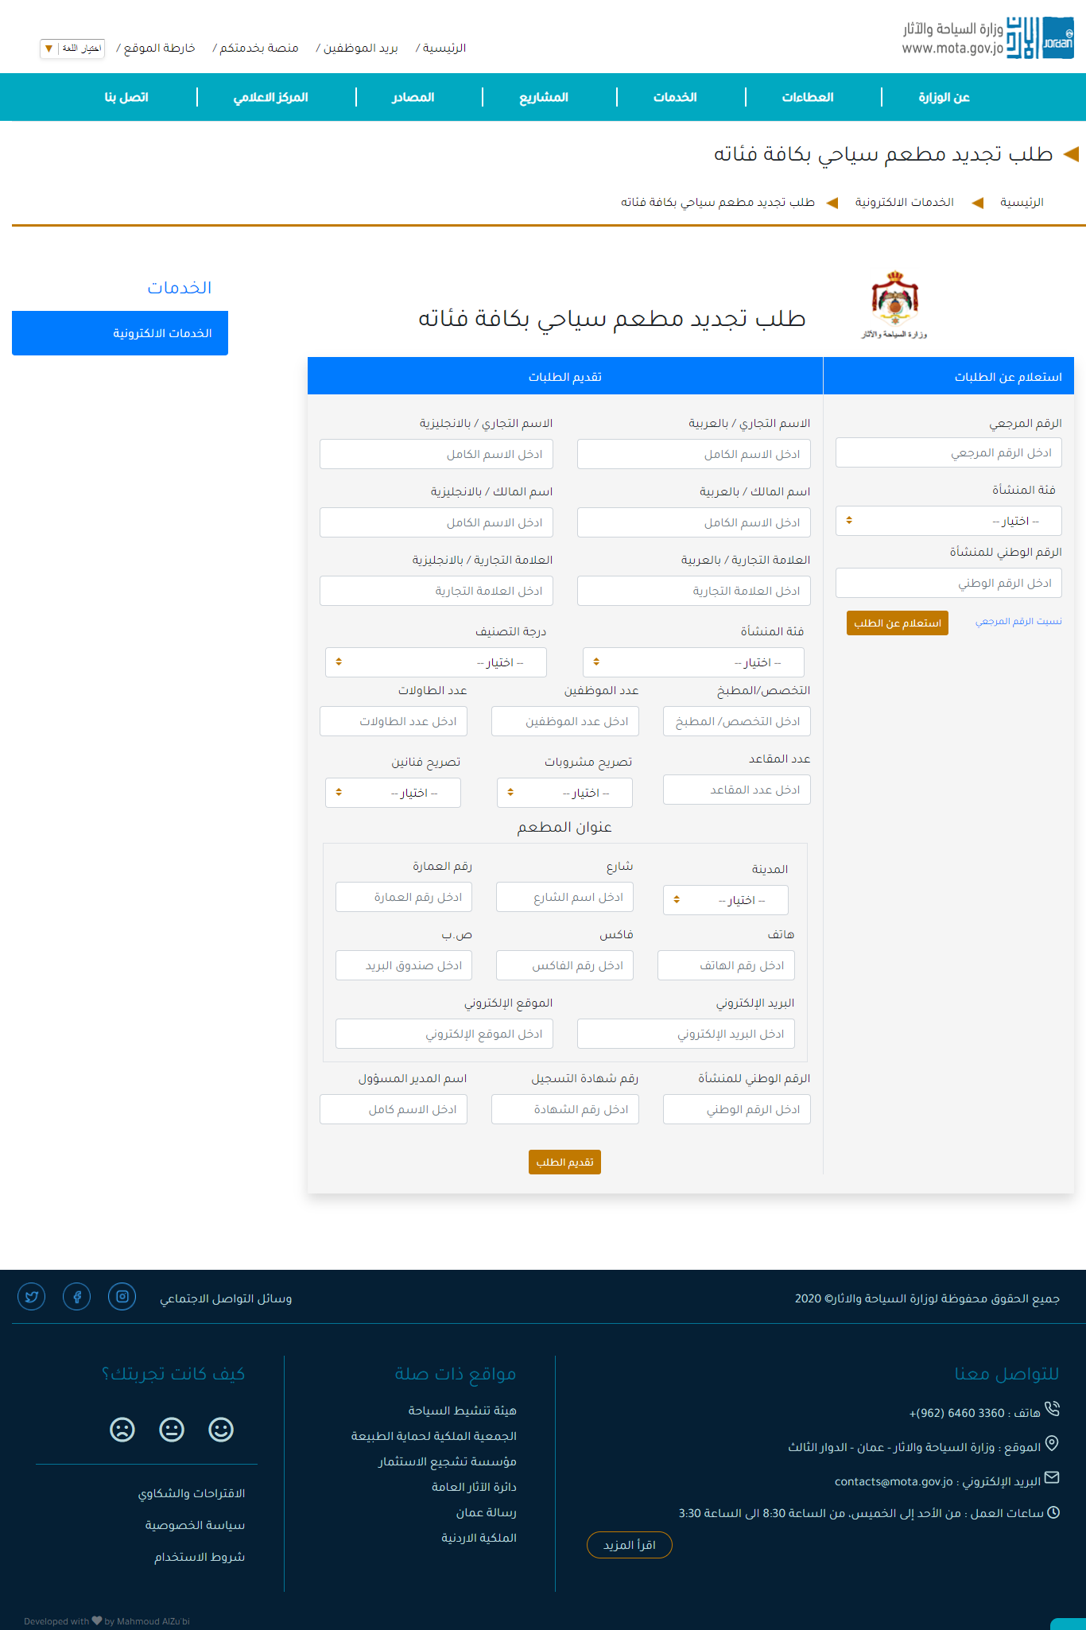Service 3: Request to renew a tourist restaurant of all categories page.

Figure : Screenshot for the Tourist Restaurant service page from the website.

* 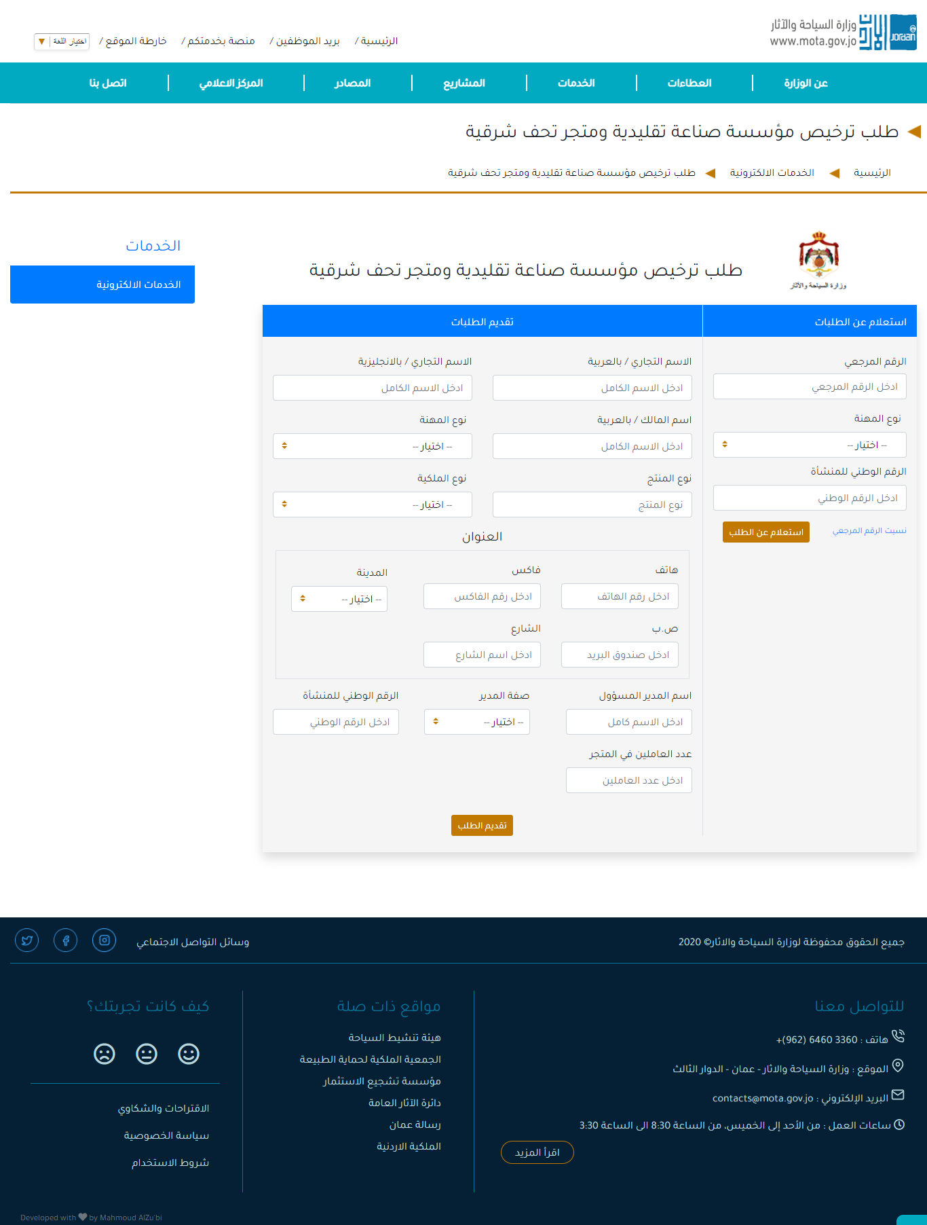Service 4: Applying for licensing a traditional industry establishment and an oriental antique store page.

Figure : Screenshot for the traditional industry establishment service page from the website.

* 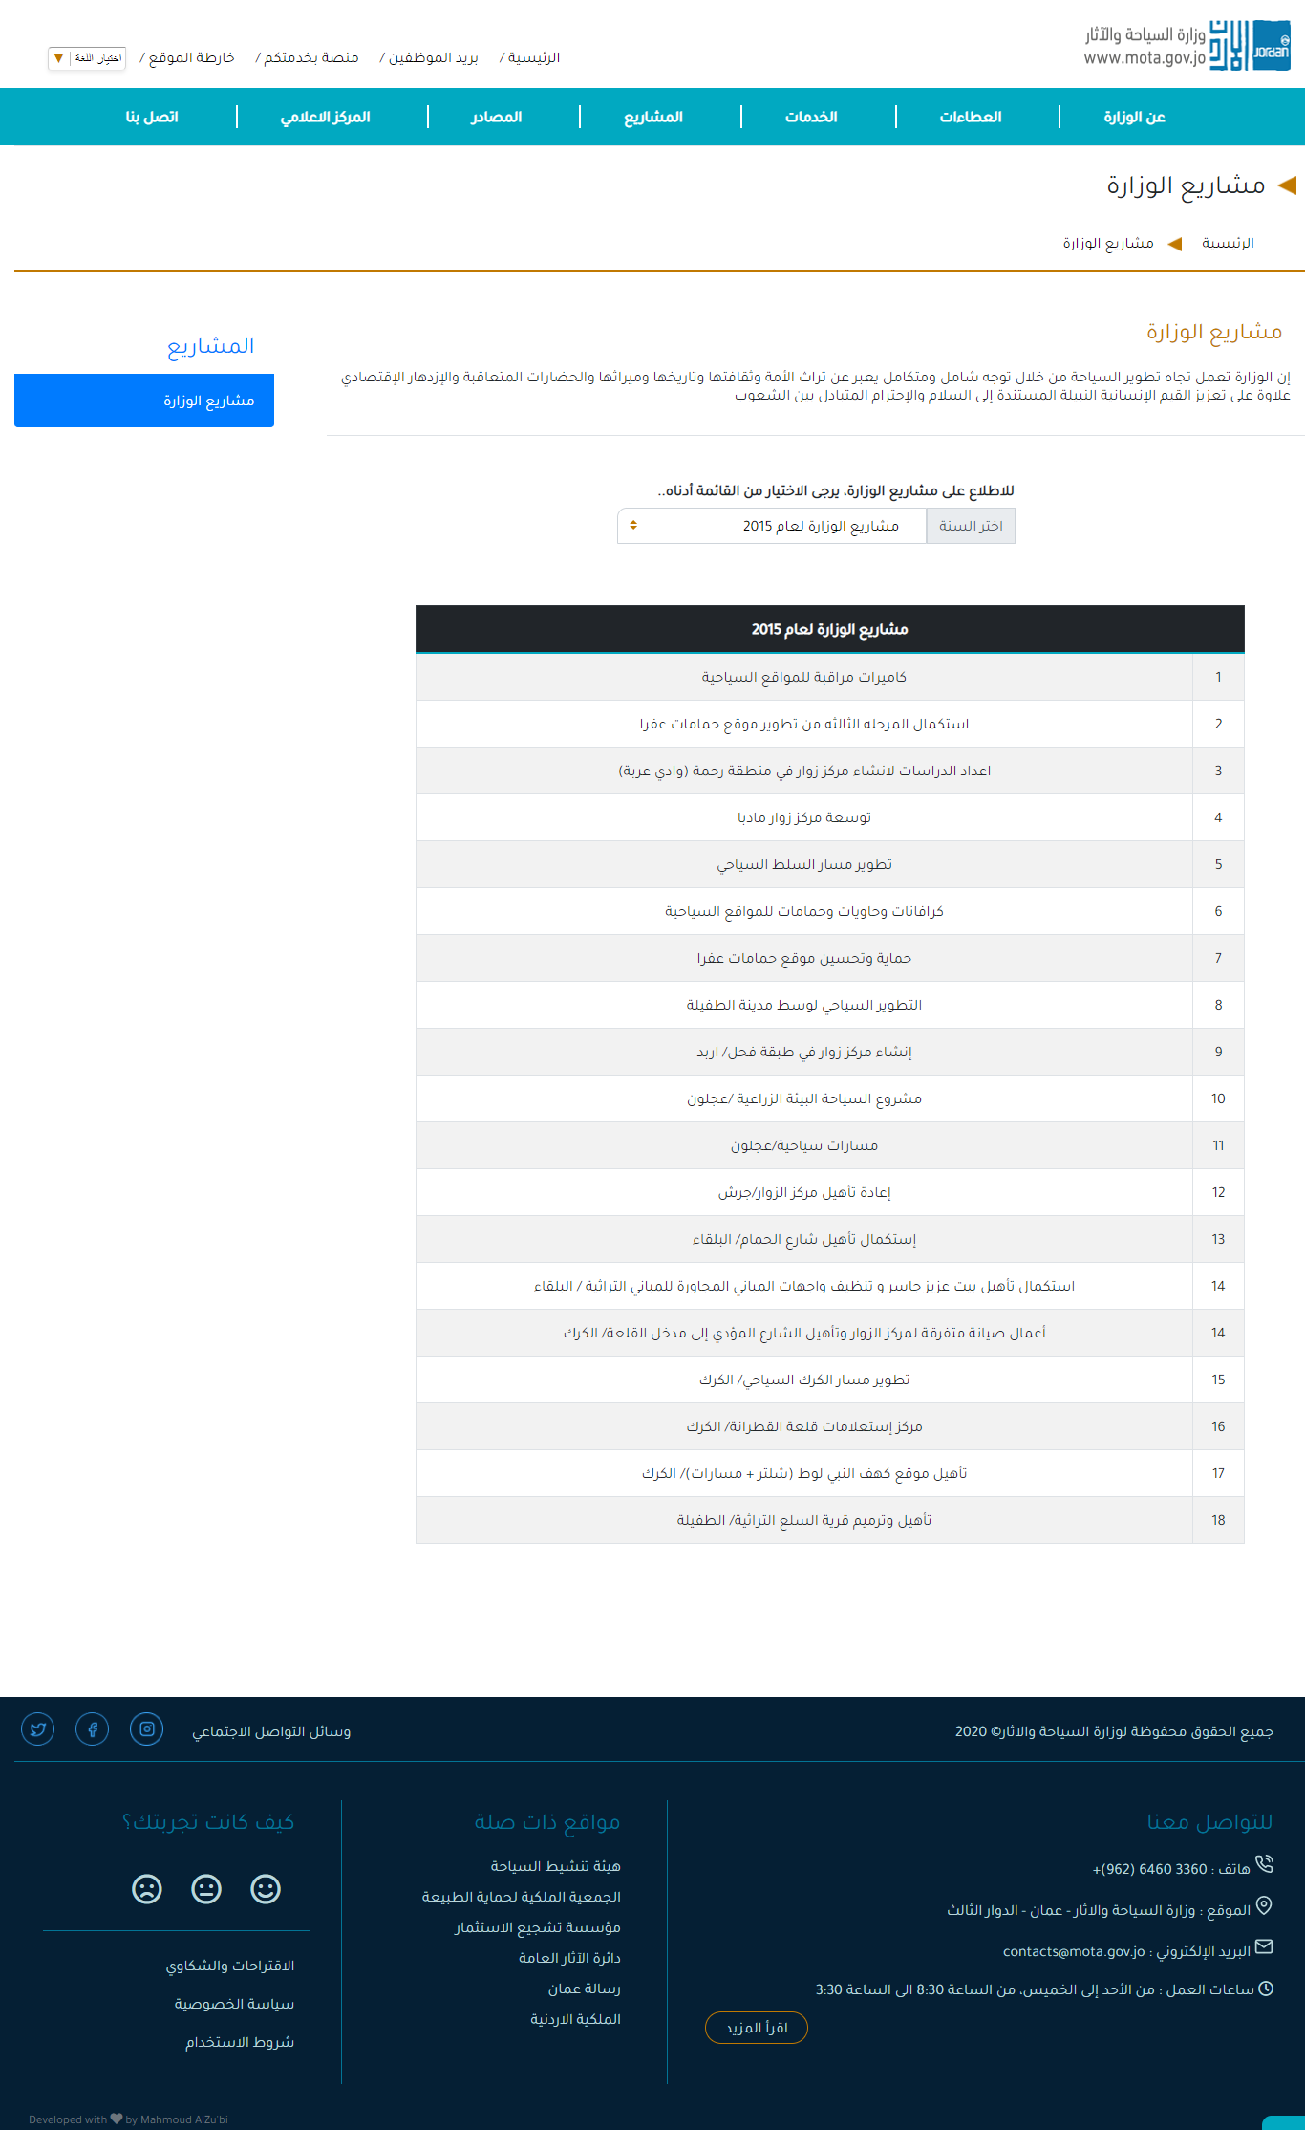Ministry’s Projects page.

Figure : Screenshot for the Ministry's projects page from the website.

* 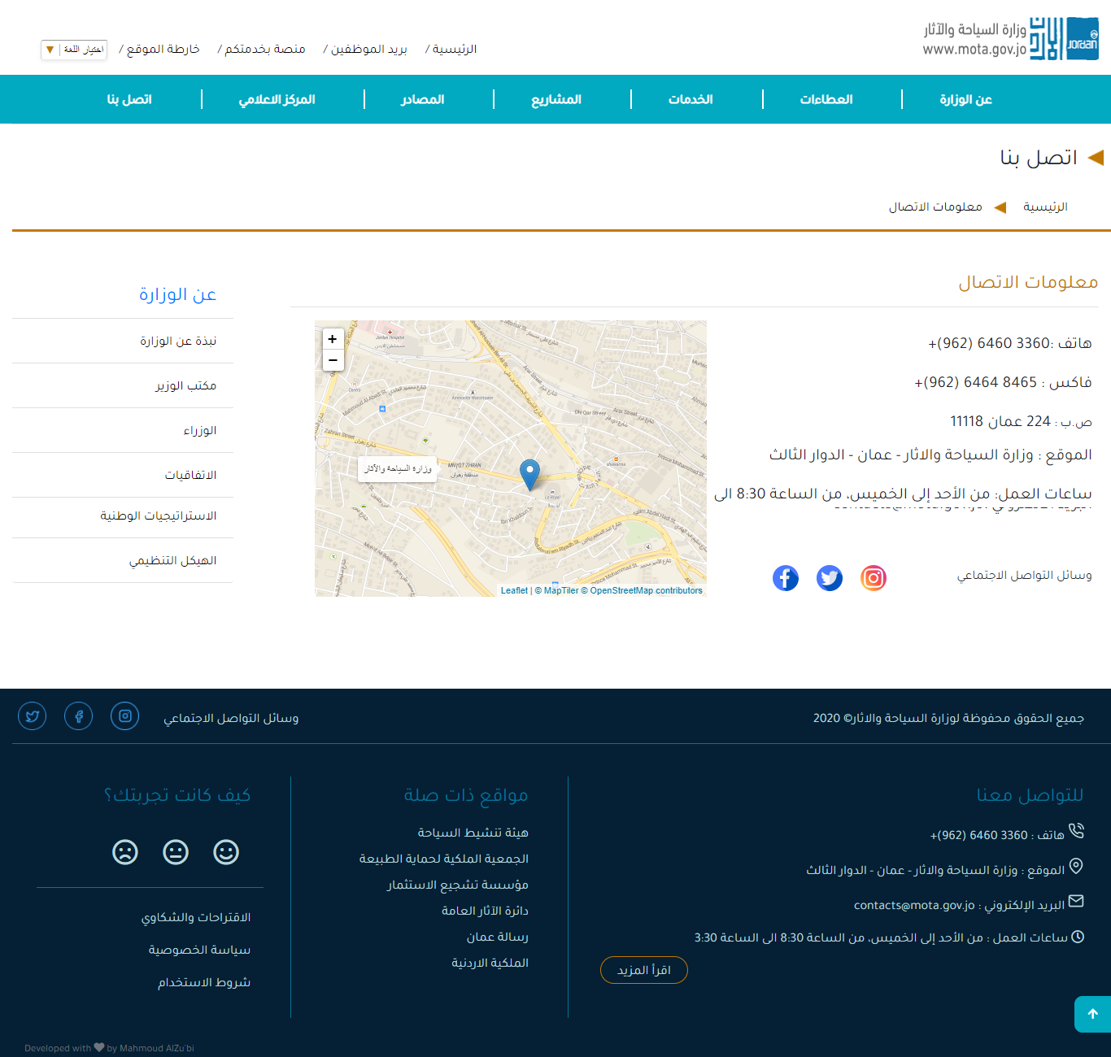Contact s page

Figure : Screenshot for Contact us page from the website.

* 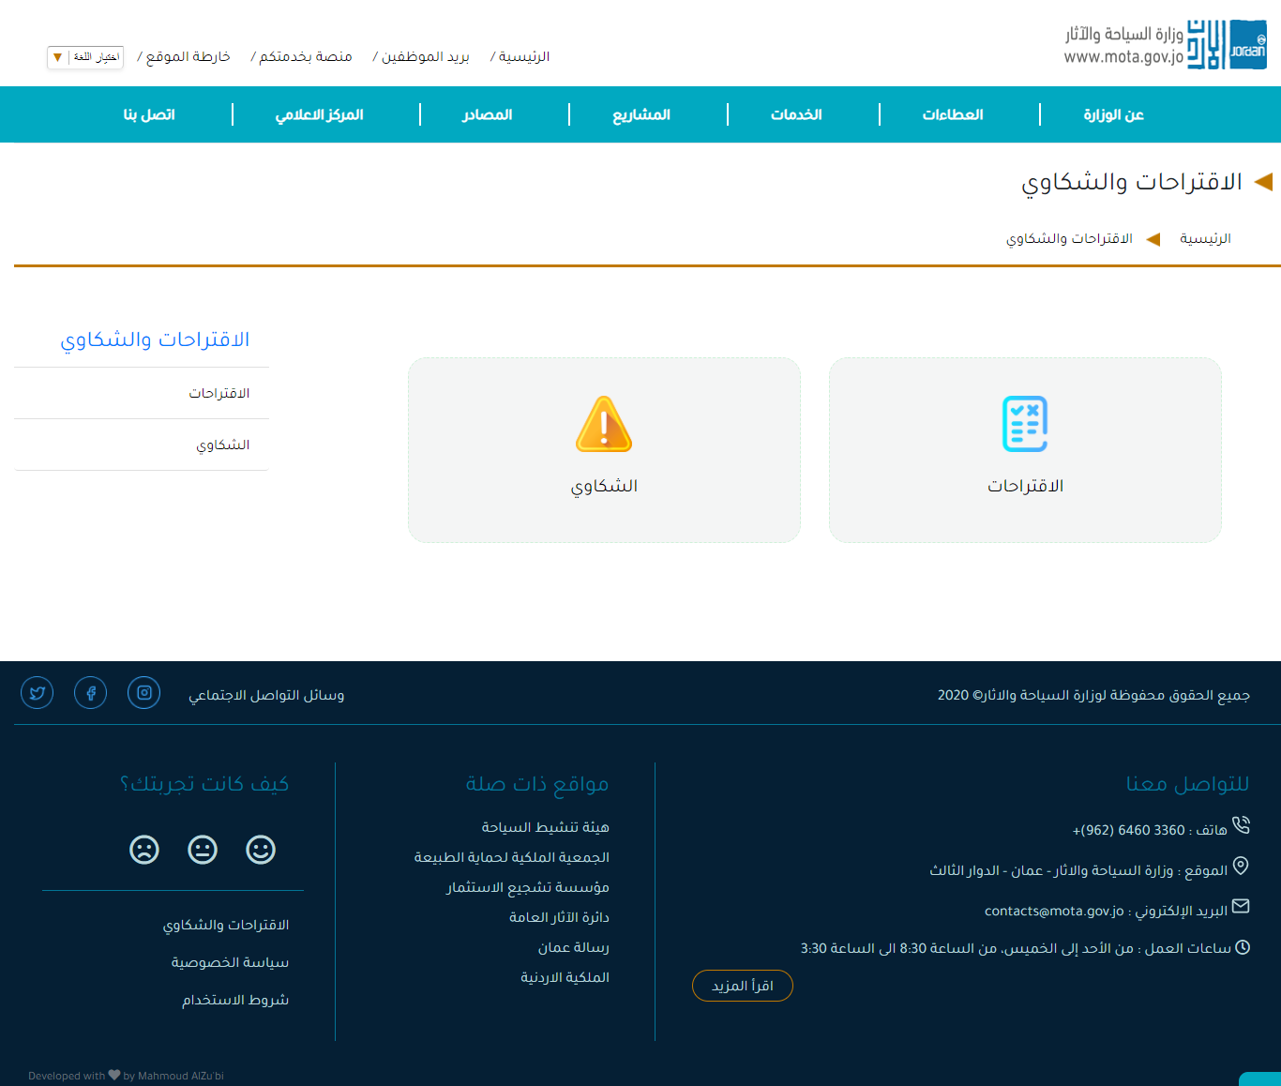Suggestions and Complaints page.

Figure : Screenshot for the Suggestions and Complaints page from the website.

* 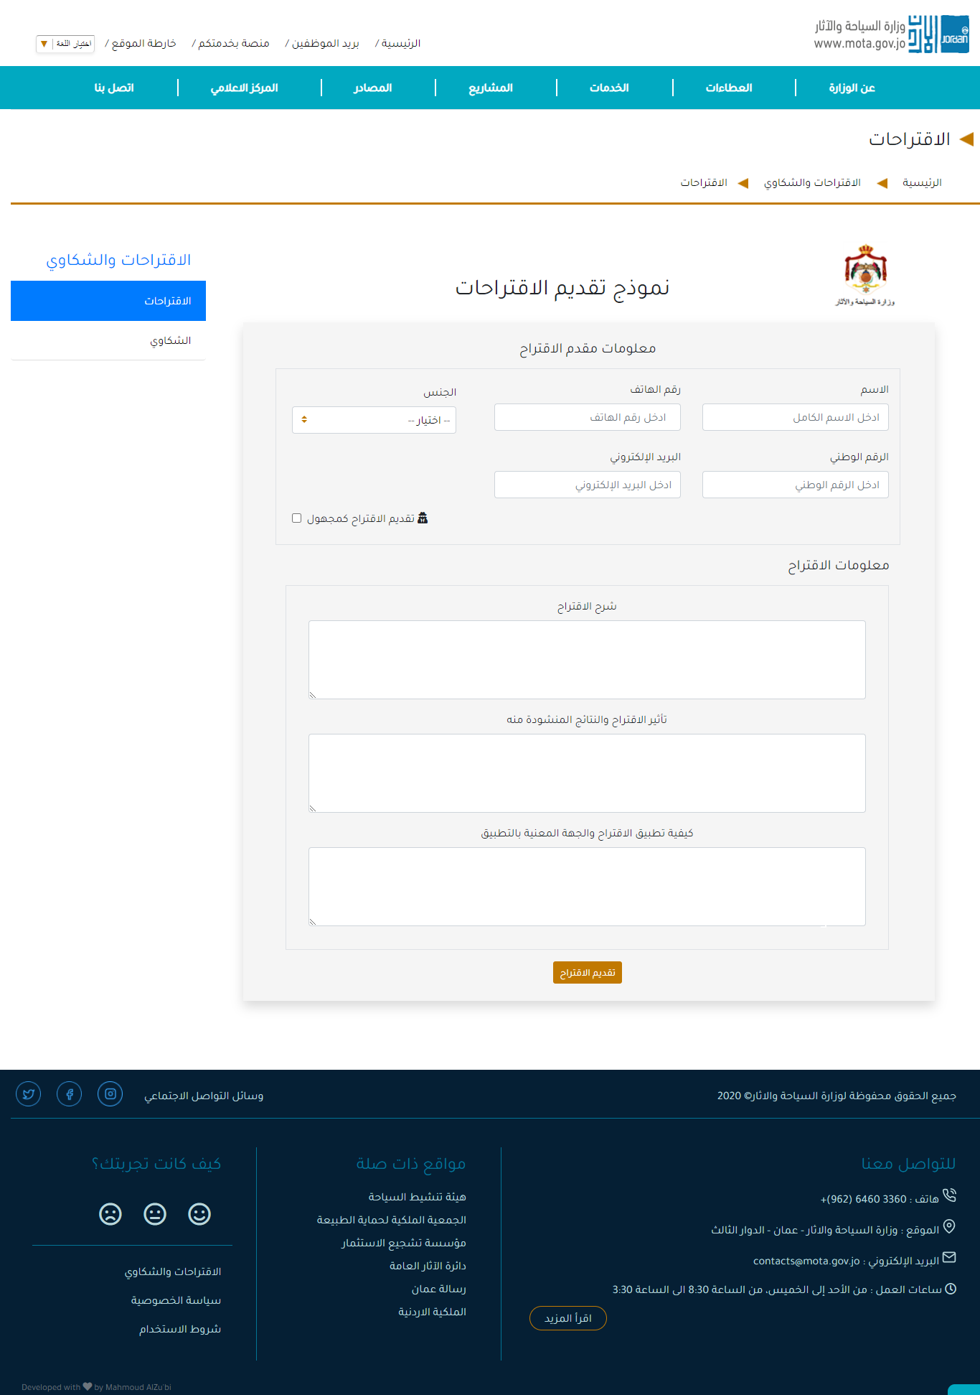Suggestions page

Figure : Screenshot for the Suggestion page from the website.

* 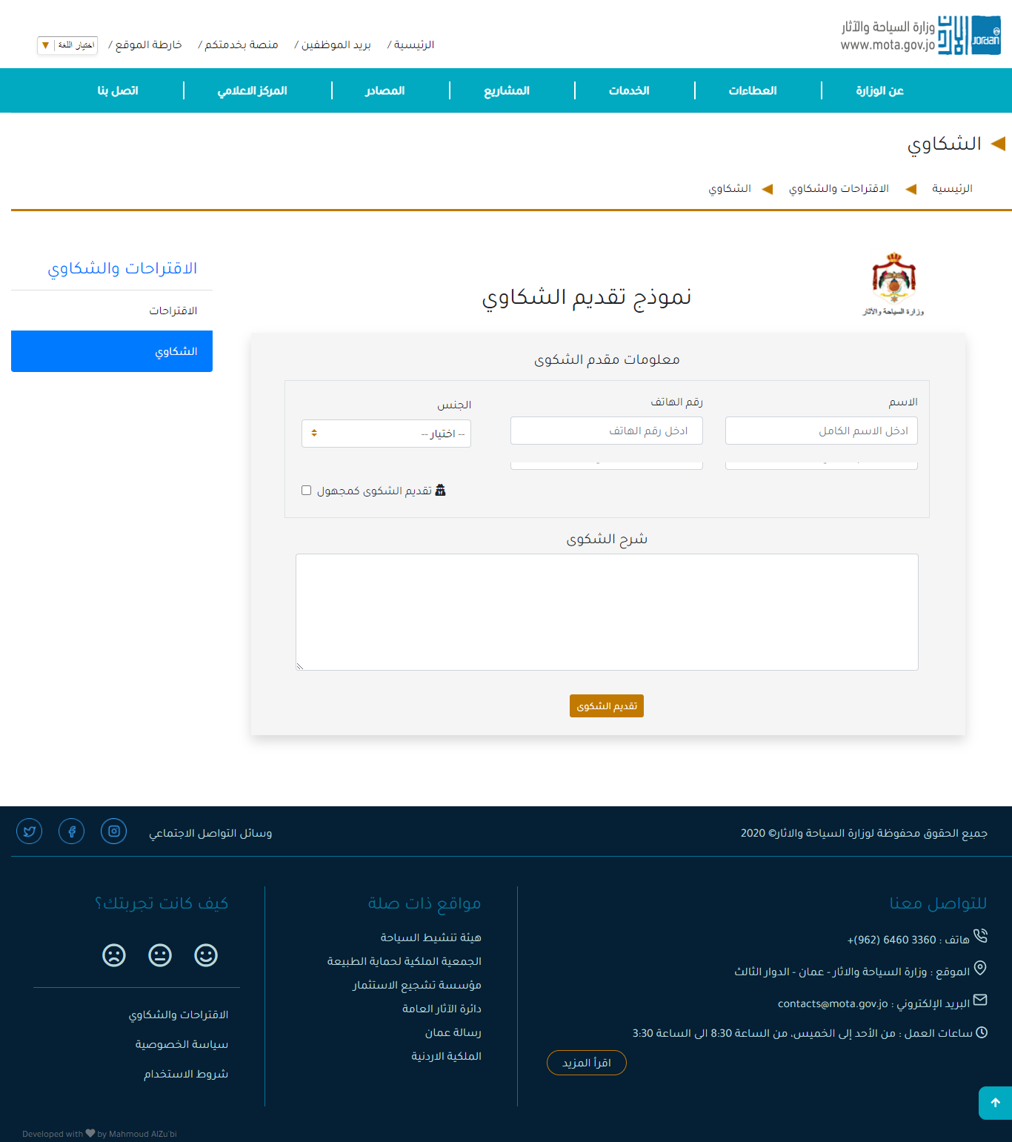Complaints page

Figure : Screenshot for the Complaints page from the website.

# Source Code excerpt

The following figure shows a snippet code for an embedded tweet timeline, which added to the website to display the latest tweet of the Ministry.

**Embedded Timelines:** Embedded timelines are an easy way to embed Tweets on your website in a compact, linear view. Display the latest Tweets from a Twitter account, lists, or your curated collections.

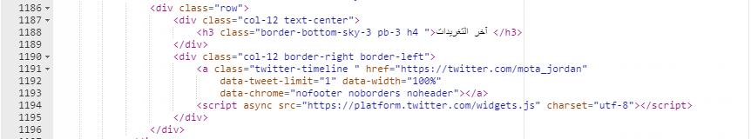

Figure : Embedded Tweet Timeline

Figure .88 Shows a snippet code for the website feedback section.

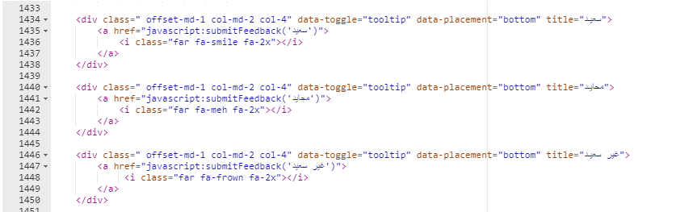

Figure : Snippet code for website feedback section.

# Conclusion

This modern interactive website makes it easy for facilities owners and tourist guides to complete their transactions remotely. Hence, reducing effort, time, and costs. Also, it gives the user the best navigation experience, and it fits with all devices. In future work, I would like to automate new services that serve a wide range of citizens (E.g., Request to renew a travel office license).

# References

<https://en.wikipedia.org/wiki/HTML5>

<https://en.wikipedia.org/wiki/JavaScript>

<https://en.wikipedia.org/wiki/CSS>

<https://en.wikipedia.org/wiki/Bootstrap_(front-end_framework)>

<https://en.wikipedia.org/wiki/JQuery>

<https://en.wikipedia.org/wiki/PHP>

<https://app.lucidchart.com/>

<https://tortoisegit.org/about/>

<https://git-scm.com/>

<https://en.wikipedia.org/wiki/GitHub>

<https://en.wikipedia.org/wiki/Site_map>

<https://www.smartdraw.com/entity-relationship-diagram/>

<https://en.wikipedia.org/wiki/Namecheap>

<https://www.draw.io/>

<https://en.wikipedia.org/wiki/Website_wireframe>

<https://en.wikipedia.org/wiki/Adobe_XD>

<https://en.wikipedia.org/wiki/Test_case>

<https://www.justinmind.com/blog/website-mockup/>

<https://developer.twitter.com/en/docs/twitter-for-websites/timelines/overview>